Puget Sound Energy

Meter and Billing Performance Annual Report

Annual Reporting Period:

January 1, 2016 - December 31, 2016

Filed on January 30, 2017

This Page Intentionally Left Blank

Table of Contents
Introduction 4
Summary Progress to Date 5
Meter and Billing Performance Summary 5
Resolution Results for Stopped Meters 6
Resolution Results for Unassigned Energy Usage 6
Zero Consumption 180-Day Customer Notification Report 7
Tracking and Reporting of Meter/Billing Issues 10
Issues Discussion 10
Process Improvement 11
Appendix A: Background, Definitions, and Standards 12
Background 12
Definitions 13
Meter and Billing Performance Standards 13
Appendix B: Zero Consumption 180- Day Investigation Customer Notice 14
Customer Notice 14

Introduction

This is Puget Sound Energy’s (“PSE’s”) fourth Meter and Billing Performance Annual Report under the revised Meter and Billing Performance Standards set forth in the Partial Settlement in Order 8 of consolidated Docket Nos. UE-111048 and UG-111049 (“Partial Settlement”) for the period of January 1, 2016 through December 31, 2016. With the exceptions noted and discussed in this report, PSE met all standards for the identification and the correction of the stopped meters and the meters with unassigned energy usage.

The meter and billing performance standards per Partial Settlement paragraph 13 (“Meter and Billing Performance Standards” or “Meter and Billing Standards”) are:
- PSE will identify and correct 98 percent of all stopped meter and unassigned energy usage meter problems for both natural gas and electric meters within 12 months from initial occurrence of the problem.
- PSE will identify and correct all stopped meter and unassigned energy problems for both natural gas and electric meters within 24 months from the initial problems report.

This report also discusses the results of the on-going zero Consumption 180-day customer notification requirement (per Partial Settlement paragraph 18).

The layout and elements of this report are consistent with the draft annual meter and billing report outline reviewed and discussed with the Commission Staff on September 27, 2013. Staff provided additional comments and suggestions via an e-mail on October 30, 2013, which have been incorporated in this report.

Summary Progress to Date

Meter and Billing Performance Summary
For the 2016 annual reporting period, PSE is in full compliance with both the 12-month threshold and 24-month threshold for the stopped meter cases. All 3,802 stopped meter problems were identified and corrected within the two thresholds. PSE met the Meter and Billing Performance Standard for unassigned energy usage (“UEU”) meter cases for the 12-month threshold at 100%; noting that two out of the 12,657 UEU cases were identified and corrected outside the 24-month threshold. The two outlier UEU meter issues will be discussed in the Tracking and Reporting of Meter/Billing Issues section of this report.
One of the key factors affecting PSE’s improved 2016 meter and billing performance is the Commission-revised billing requirements and payment date rules that became effective on March 25, 2016. WAC 480-90-178 and 480-10-178 (the “Rules”), for the electric and natural gas utilities respectively, set forth more rigorous and detailed meter and billing correction requirements than that of PSE’s Meter and Billing Performance Standards. In particular, the subsection (a) of section (5) Corrected bills of the Rules state:
The utility must issue the corrected bill within sixty days from the date the utility discovered that an account had been underbilled or overbilled. Except as provided in subsection (7) of this section, when a utility’s investigation finds that it has underbilled energy usage, it may not collect underbilled amounts for any period greater than six months from the date the error occurred.
In 2016, PSE revised its meter and billing operation and monitoring processes in order to meet the requirements of the enhanced state rules. In most cases, the Rules allow sixty days to investigate and correct a metering/billing issue and limit the billing correction to be no longer than six months. Both the sixty-day and six-month thresholds are much shorter than the 12-month and 24-month thresholds in PSE’s Meter and Billing Performance Standards.
Percentages shown in this report are rounded to the nearest whole percentages and reported to the accuracy of the decimal place of the Meter and Billing Performance Standards.

Resolution Results for Stopped Meters
The table below provides the total number of stopped meters that had been identified and correctly back billed between January 1, 2016, and December 31, 2016. The time measure is based on the starting date of the billing adjustment (i.e., the date when the commodity was accurately measured) to the end date of the billing adjustment (i.e., the date that the customer’s meter again accurately records usage) as prescribed in the paragraph 14 of the Partial Settlement.
 | Within 6 Months | Within 12 Months | Within 24 Months | Above 24 Months | Total Meters | Within 12 Months | Within 24 Months | Exceeds 24 Months | Total Results
Electric | 187 | 9 | 0 | 0 | 196 | 100% | 0% | 0% | 100%
Natural Gas | 3,552 | 54 | 0 | 0 | 3,606 | 100% | 0% | 0% | 100%
Total | 3,739 | 63 | 0 | 0 | 3,802 | 100% | 0% | 0% | 100%

Resolution Results for Unassigned Energy Usage
The table below provides the total number of meters with Unassigned Energy Usage that had been identified and correctly billed between January 1, 2016, and December 31, 2016. The time measure is based on the date the customer moved in to the location (i.e., the date of the customer’s initial unauthorized usage to the last billing-cycle date the adjustment (i.e., the date that the back bill was issued).
 | Within 6 Months | Within 12 Months | Within 24 Months | Above 24 Months | Total Meters | Within 12 Months | Within 24 Months | Exceeds 24 Months | Total Results
Electric | 6,466 | 73 | 5 | 0 | 6,544 | 100% | 0% | 0% | 100%
Natural Gas | 5,997 | 103 | 11 | 2 | 6,113 | 100% | 0% | 0% | 100%
Total | 12,463 | 176 | 16 | 2 | 12,657 | 100% | 0% | 0% | 100%

Zero Consumption 180-Day Customer Notification Report

As part of the PSE’s Partial Settlement commitments, PSE has carried out an on-going process to notify each customer with a meter showing zero consumption for 180 consecutive days. This section of the report summarizes the results of the customer notification process for the period of January 1, 2016, through December 31, 2016.
In the current customer notification process, started on October 1, 2014, a letter is sent to a customer whenever the 180-day zero consumption threshold is met. An example of the customer notification letter is included for reference in Appendix B: Zero Consumption 180-Day Customer Notice.
In 2016, PSE sent out 10,178 zero consumption 180-day notification letters; 4,433 electric cases and 5,745 natural gas cases. 7,439 of the 10,178 cases are customer confirmed valid zero usage cases and did not require any further PSE action.
 | Contact Cases Initiated | Confirmed Zero-usage Cases | Resolved Cases w/o Billing Adjustment | Resolved Cases with Billing Adjustments | On Going Cases
Electric | 4,433 | 3,329 | 24 | 0 | 1,080
Natural Gas | 5,745 | 4,110 | 48 | 7 | 1,580
Total | 10,178 | 7,439 | 72 | 7 | 2,660

The chart below shows the breakdown of customer notifications generated by fuel and by month
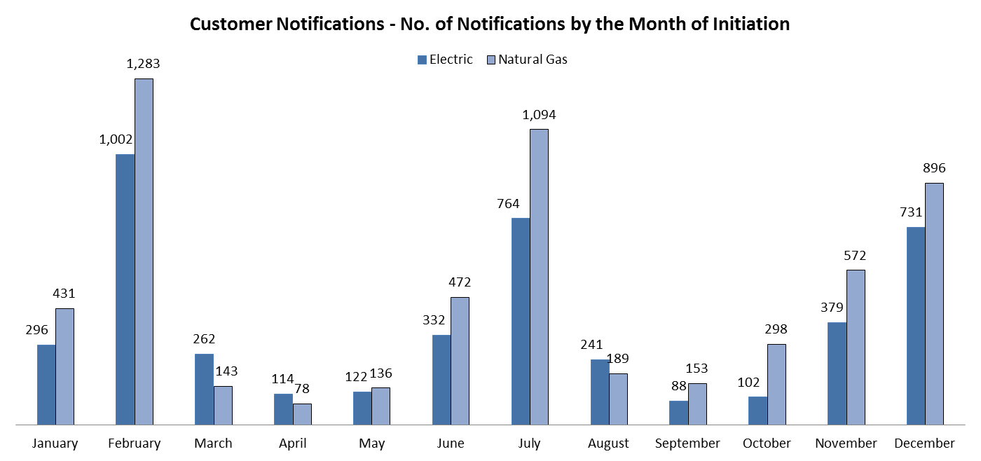

During the 2016 reporting period, 3,353 of the 4,433 electric notification cases were resolved, including 3,329 meters with customer-confirmed valid zero usage. 24 cases were resolved prior to mailing the customer notification letter. None of these 3,353 cases required a billing adjustment. 1,080 cases are still pending for resolution. The chart below shows the resolution status of these 3,353 electric cases by the month of completion.
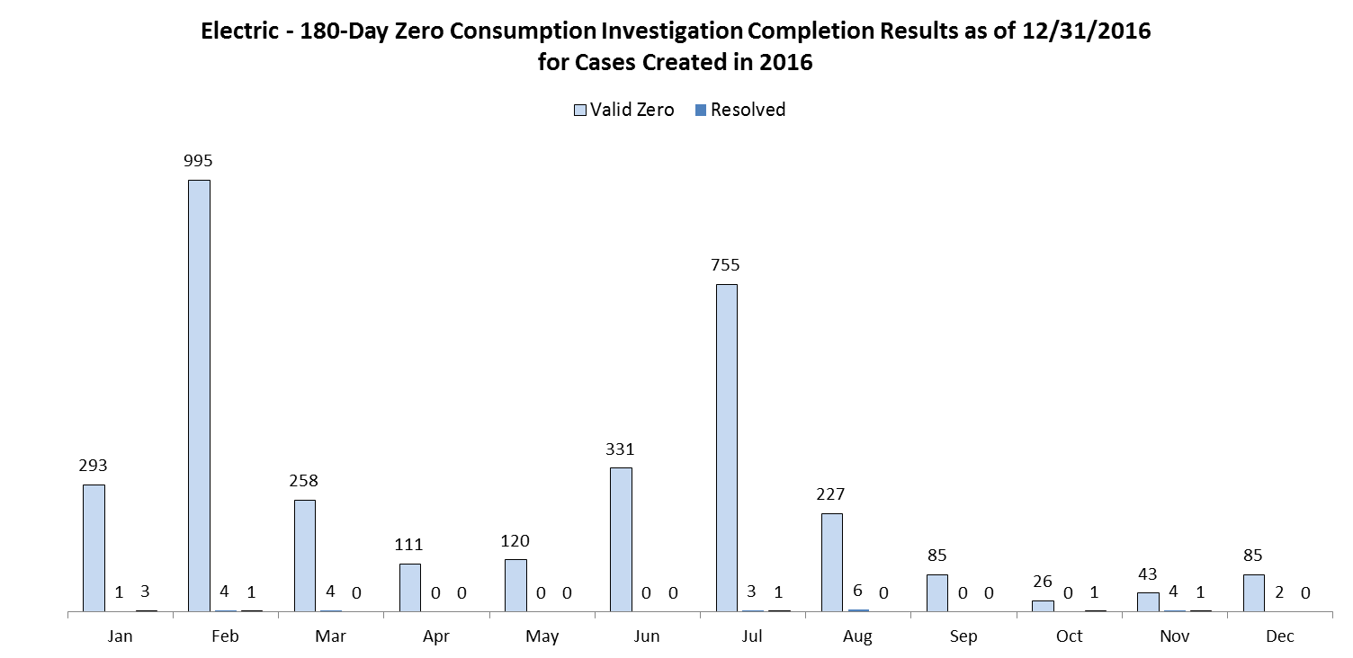
There was no electric adjustment therefore there is no chart of the average length of back bill and the average back bill dollar amount for the electric.

For the natural gas notification cases, 4,165 out of 5,745 were resolved during the 2016 reporting period. 1,580 cases are still pending for resolution. 4,110 of the completed cases are customer-confirmed zero-usage meters. 48 cases were resolved prior to mailing the customer notification letter. 7 cases or less than 0.2% of the 4,165 resolved natural gas cases required a billing adjustment.

The chart below shows the resolution status of the 2016 natural gas 180-day zero consumption notification cases by the month of completion.

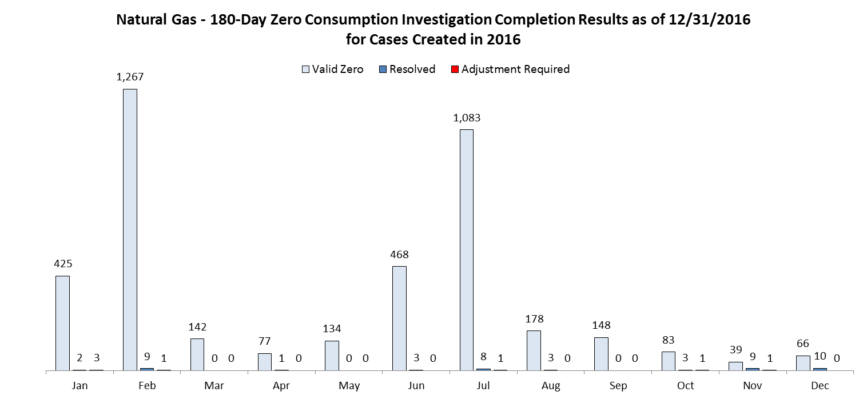
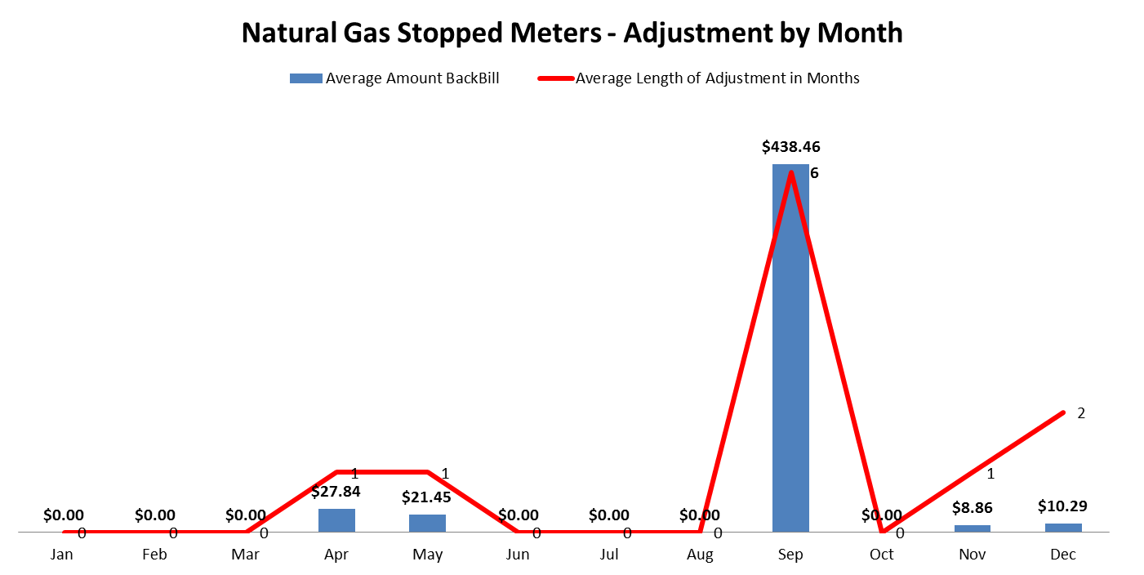
The Chart below shows the average length of back bill and the average back bill dollar amount for the 7 natural gas cases identified by the customer notification process that required a billing adjustment.

Tracking and Reporting of Meter/Billing Issues

Issues Discussion
This section explains the meter cases that were corrected outside the Meter and Billing Performance Standards and any other tracking and reporting issues.

Stopped Meters
There is no exceptional stopped meter case in this reporting period. All stopped meter cases were corrected within the Meter and Billing Performance Standards

Unassigned Energy Usage Meters
The table below summarizes the Unassigned Energy Usage meter results by energy and by Meter and Billing Performance Standards for the applicable reporting period of January 1, 2016 through December 31, 2016.
UEU Meter Results | Within 12 Months | Within 24 Months | Above 24 Months | Total
Electric | 6,539 | 5 | 0 | 6544
Natural Gas | 6,100 | 11 | 2 | 6113
Total | 12,639 | 16 | 2 | 12,657

The two meters that fell outside of the 24-month threshold were not identified as a meter with UEU for an extended period of time as the meters were using a very low amount of energy each month. As a result, they were not caught by PSE’s UEU usage thresholds. When the revised WAC 480-90-178 and 480-10-178 went into effect in March 2016, PSE’s UEU identification process was updated to reflect the new requirements. This revised PSE process eliminated the usage-based threshold for identification and replaced it with a time threshold to ensure compliance with the sixty-day requirement of the Rules, which prevents the scenario that resulted in the two exceptions.

Process Improvement
As discussed in the 2013, 2014, and 2015 Reports, PSE continues to look at ways to reduce the length of the backbilling and to address meter and billing performance issues.
In the Spring of 2016, PSE revised its metering and billing process in order to be in compliance with the rigorous requirements in the revised Rules, WAC 480-90-178 and 480-100-178, Billing Requirement and Payment Date.

Appendix A: Background, Definitions, and Standards

Background
This meter and billing performance annual reporting is designed to meet the terms and requirements of the Partial Settlement RE: Meter and Billing Performance Standards (“Partial Settlement”) in consolidated Docket Nos. UE-111048 and UG-111049 Order 08 (“Order 08”) dated May 7, 2012. The layout and elements of this report are consistent with the draft annual meter and billing report outline reviewed and discussed with the Commission Staff on September 27, 2013. Staff provided additional comments and suggestions via an e-mail on October 30, 2013, which have been incorporated in the report. The annual report is due no later than January 31 for the preceding calendar year.
The Partial Settlement dictates both the meter and billing performance standards and reporting requirements for the quarterly reporting periods 2012 Q2 through 2013 Q2 and the annual reporting periods starting 2013. The quarterly performance standards were included 2012 Q2 through 2013 Q2 reports. The on-going annual Meter and Billing Performance Standards per Partial Settlement paragraph 13 are outlined in the Meter and Billing Performance Standards section of this appendix.
For the meter cases that are corrected outside of the Meter and Billing Performance Standards, PSE will retain the following information for these cases:
- Stopped meters: the last date when the commodity was accurately billed, the date the customer's meter again accurately records usage and the date PSE issues the back-bill.
- Unassigned energy usage meters: the date of the customer's initial unauthorized usage and the date that PSE issues the back-bill.

In addition, there are two meter and billing processes that PSE committed to in the Partial Settlement to carry out after June 1, 2012.
- A one-time investigation process to identify and correct, if needed, meters with zero consumption for 365 consecutive days.
- An on-going process to notify each customer with a meter that showing zero consumption for 180 consecutive days.
The results of the one-time investigation process were included in the One Time Zero Consumption 365-Day Investigation Completion Report – Final Report section of PSE’s first annual reporting filed with the Commission on January 31, 214.
The results of the one-going process were included in the following section of this report: Zero Consumption 180-Day Investigation Report.

Definitions
For purposes of the Meter and Billing Performance Standards time measurement will be as follows:
- Stopped meters: The performance standard for stopped meters will be measured from the last date commodity was accurately measured (the "initial occurrence" for stopped meters) to the date the customer's meter again accurately records usage.
- Unassigned energy usage meters: The performance standard for meters with unassigned energy usage will be measured from the date of the customer's initial unauthorized usage (the "initial occurrence" for unassigned energy usage) to the date the back bill was issued.

Meter and Billing Performance Standards
Effective starting June 1, 2013, and continuing until changed, the two Meter and Billing Performance Standards (“Meter and Billing Performance Standards”) are:
- PSE will identify and correct 98 percent of all stopped meter and unassigned energy usage meter problems for both natural gas and electric meters within 12 months from initial occurrence of the problem.
- PSE will identify and correct all stopped meter and unassigned energy problems for both natural gas and electric meters within 24 months from the initial problem.

Appendix B: Zero Consumption 180- Day Investigation Customer Notice

Customer Notice
The following is an example of the customer notice PSE is sending to any customer with a meter that did not register any usage for 180 consecutive days.
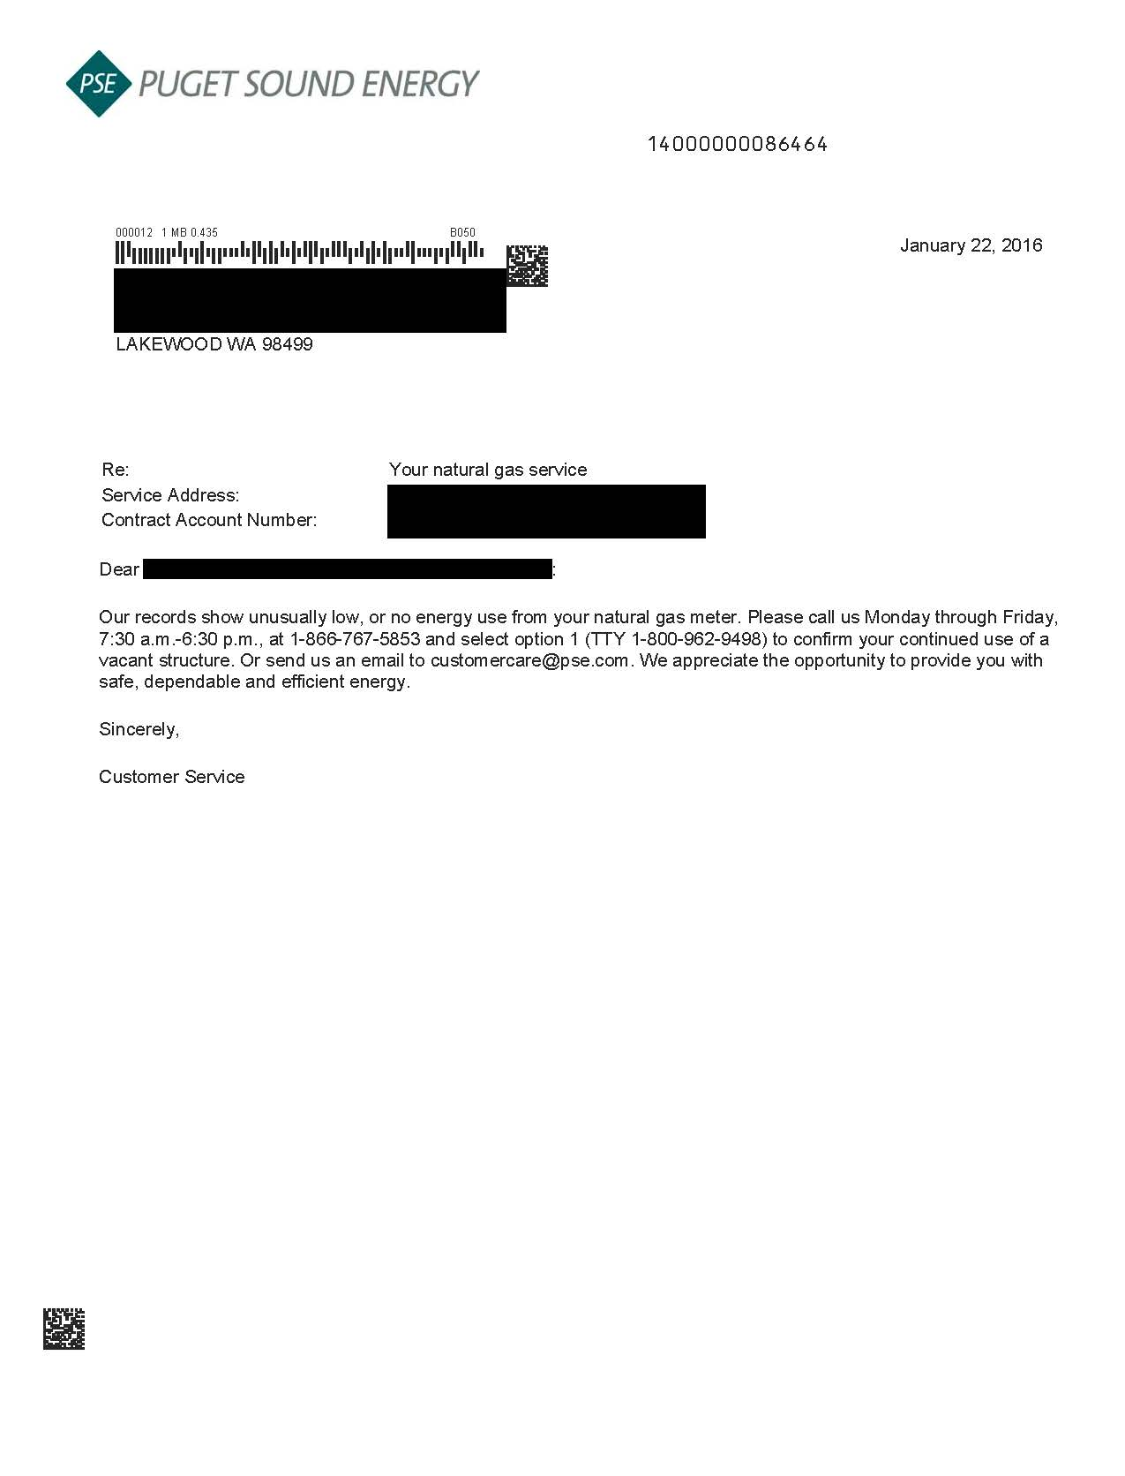

99.86% before rounding to the nearest whole percentage
https://www.utc.wa.gov/_layouts/15/CasesPublicWebsite/GetDocument.ashx?docID=129&year=2014&docketNumber=144155
https://www.utc.wa.gov/_layouts/15/CasesPublicWebsite/GetDocument.ashx?docID=133&year=2014&docketNumber=144155

