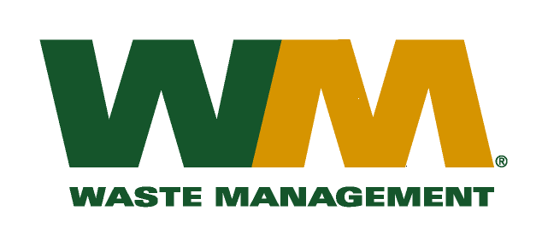
June 29, 2017
Washington Utilities and Transportation Commission
Chandler Plaza Building
1300 S. Evergreen Park Drive SW
P.O. Box 47250
Olympia, WA. 98504-7250
Dear Sirs:
Subject: Waste Management of Spokane, a division of Waste Management of Washington, Inc. (G-237); Tariff # 18
Enclosed are revised pages 2, 22, and 26 to the above-referenced tariff. The purpose of these tariff revisions is to reflect the change in the commodity credits for residential and multi-family customers receiving recycling collection services. These tariff revisions reflect an increase of the current commodity credit from $1.44 to $2.65 per month for residential customers and an increase to the rebate of $0.23 per yard to $0.43 per yard for multi-family customers. We request that the effective date of these tariff revisions be August 1, 2017 in accordance with WAC 480-70-262 which requires only seven-day notice to the commission where the purpose of the rate filing is to reduce rates to customers.
Enclosed for your review are our accounting work papers. Customers will be notified of the change in their commodity credit adjustment on their next regularly scheduled billing after the approval of the Commission. In addition, the county has been notified of these proposed tariff changes.
If you have any questions or need additional information, please contact me at (425) 814-7840.
Very truly yours,

Michael A. Weinstein
Senior Pricing Manager, Pacific Northwest Market Area

cc: Jesse Granado
Joe Krukowski
Tami Yager
Clerk of the Board, Spokane County Chair

