Qwest Corporation d/b/a CenturyLink QC

WN U-40 Section 5
Washington First Revised Sheet M-39
Cancels Original Sheet M-39

HOODSPORT
Exchange Map
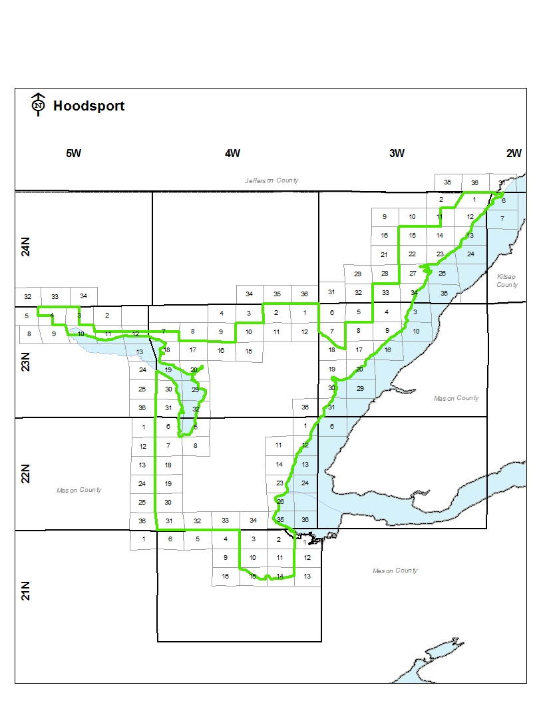

Advice No. 3728T
Issued by Qwest Corporation d/b/a CenturyLink QC Effective: April 25, 2019
By Phil Grate, Director – Washington
WA2019-007

Qwest Corporation d/b/a CenturyLink QC

WN U-40 Section 5
Washington First Revised Sheet M-78
Cancels Original Sheet M-78

SHELTON
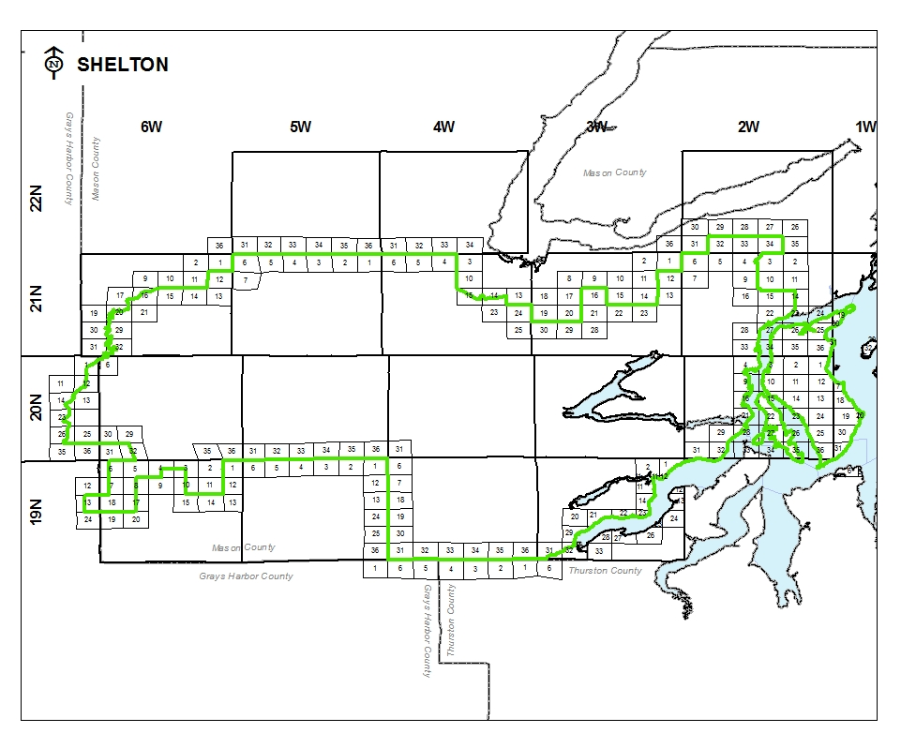
Exchange Map

Advice No. 3728T
Issued by Qwest Corporation d/b/a CenturyLink QC Effective: April 25, 2019
By Phil Grate, Director – Washington – Washington
WA2019-007

