Agenda Date: October 28, 2010
Item Number: B4

Docket: TG-101545
Company Name: Murrey’s Disposal Company, Inc. G-9

Staff: David Gomez, Deputy Assistant Director – Water and Transportation

Recommendation
Staff recommends that the commission:
1. Allow the proposed recycling commodity adjustments filed by the company on September 15, 2010, in Docket TG-101545 to become effective November 1, 2010, by operation of law.
2. Grant the company’s request to retain fifty percent of the revenue received from the sale of recyclable commodities subject to conditions set forth staff’s memo.
Background
On September 15, 2010, Murrey’s Disposal Company, Inc. (Murrey’s or company) filed with the Utilities and Transportation Commission (commission):
- Revisions to its currently effective Tariff No. 25, designated as Tariff pages 1, 21, 25, 27, 28, 30, 46, 47, 48 and 49 with a stated effective date is November 1, 2010;
- A request to retain fifty percent of the revenue Murrey’s receives from the sale of recyclable materials that it collects in its residential single and multi-family recycling collection service;
- A copy of its "2010-11 Company Recycling Plan: Pierce County Single-Stream Recycling Program Updated September 2010"; and
- A letter dated September 16, 2010, signed by Stephen C. Wamback, Solid Waste Administrator, Pierce County Department of Public Works and Utilities.
In its filing, Murrey’s proposes to increase the amount it pays to single-family and multi-family customers for the value of the recyclable materials that it collects in its residential recycling collection service. The monthly credit for single-family customers would increase from $0.14 to $1.31 and the monthly credit for multi-family customers would increase from $0.24 per yard to $0.67 per yard for each pickup.
RCW 81.77.185 states that the commission shall allow a solid waste collection company collecting recyclable materials from residential single-family and multi-family customers to retain “up to fifty percent of the revenue paid” to the company for the material if the company submits a plan to the commission that is certified by the appropriate local government authority as being consistent with the local government solid waste plan and that demonstrates how the revenues will be used to increase recycling. The remaining revenue must be passed through to residential single-family and multi-family customers.
Murrey’s "2010-11 Company Recycling Plan: Pierce County Single-Stream Recycling Program Updated September 2010" sets forth specific actions that Murrey’s will take to increase recycling using recyclable commodity revenues retained by the company. The plan calls for fifty percent of the retained recyclable commodity revenue to be awarded to the company on the basis of:
- Ongoing implementation of the single-stream recycling program – up to 5 percent awarded;
- Meeting or exceeding data monitoring and reporting requirements – up to 4 percent awarded;
- Achieving and demonstrating a recycling increase of twenty-five percent per household pounds per month compared to a 2004 baseline, as well as year-over-year improvement compared to a 2009 baseline – up to 21 percent awarded; and
- Achieving additional goals as agreed upon by Pierce County (County) and the company in 2010 – up to 20 percent awarded.
The letter signed by Stephen C. Wamback states that the company's performance in the past year had achieved the goals and objectives identified in the county's solid waste management plan and ordinance and Murrey’s is therefore entitled to retain thirty percent of recyclable commodity revenues it withheld from customers. Additionally, the county's letter certifies the plan submitted by the company for the upcoming year (2010 to 2011) is consistent with the local government solid waste management plan and that the new plan demonstrates how the revenues will be used to increase recycling.
In its Order 01, Docket TG-091463, the commission authorized Murrey’s to retain thirty percent of the revenue it receives from the sale of recyclable materials until its next deferred accounting commodity filing, which would become effective on November 1, 2010. The company was ordered to make its commodity adjustment effective November 1, 2010, and report to the commission no later than September 15, 2010, the amount of revenue it retained, the amount of money it spent on the activities identified in the company's recycling plan, and the effect the activities had on increasing recycling.
Staff provided technical assistance by sending the company a reminder of the requirements specified in Order 01, TG-091463, including an example report provided by another company in a recent filing with the commission. The reminder, with an example report, was sent to the company on July 19, 2010.
Staff reviewed the documentation provided by Murrey’s and found it to be deficient in providing the commission a report of money the company spent on the activities identified in the company's recycling plan.
Staff again provided technical assistance to the company. On October 22, 2010, the company provided staff with a list of expenditures related to the previous year's plan (Table 1 below). Staff compared these expenditures against the plan filed by the company for the 2009-2010 period and has submitted a data request to fully understand the nature of these expenses and how they relate to the revenue sharing plan.
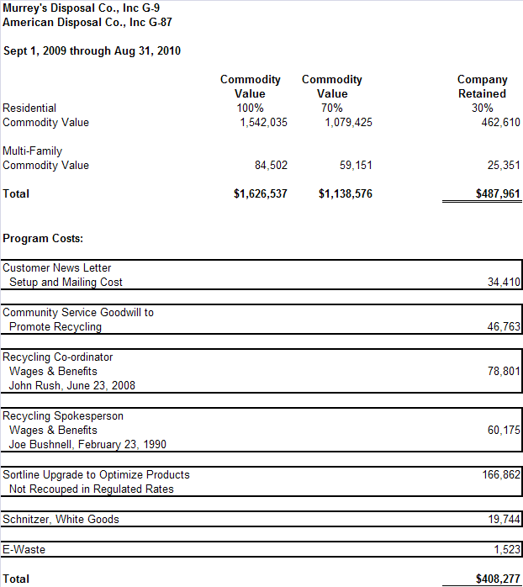
Table 1; 2009-2010 Murrey's and American Disposal Revenue Retained and Expenditures
Staff recommends that the commission accept the county’s recommendation that Murrey’s retain fifty percent of the revenue it will receive from the sale of recyclable materials and require the company to report to the commission the amount of revenue it retained, the amount of money it spent on the activities identified in the company’s recycling and revenue sharing plan and the effect the activities had on increasing recycling. Staff also recommends that the commission require the company to meet the performance requirements set forth in the plan, and consider whether to reduce the revenue share the company retained if the company fails to meet those performance requirements. Finally, staff recommends that the commission require revenues that Murrey’s retained but did not spend during the previous plan period to be carried over into the next year, and revenues from this plan period that are not spent to be carried over to the following year, unless the commission orders some other treatment.

Conclusion
Staff recommends that the commission:
- Allow the proposed recycling commodity adjustments filed by the company on September 15, 2010, in Docket TG-101545 to become effective November 1, 2010, by operation of law.
- Grant the company’s request to retain fifty percent of the revenue received from the sale of recyclable commodities subject to conditions set forth staff’s memo.

