June 20, 2014

Steven V. King, Executive Director and Secretary
Utilities and Transportation Commission
1300 S. Evergreen Park Dr. SW
P.O. Box 47250
Olympia, WA 98504-7250

RE: Washington Utilities and Transportation Commission v. Local Access LLC

Commission Staff’s Response to Application for Mitigation of Penalties UT-140897

Dear Mr. King:

On May 30, 2014, the Utilities and Transportation Commission issued a $1,000 Penalty Assessment in Docket UT-140897 against Local Access LLC for 10 violations of Washington Administrative Code (WAC) 480-120-382, which requires telecommunications companies to furnish annual reports to the commission no later than May 1 each year.¹

On June 9, 2014, Local Access LLC wrote the commission requesting mitigation of penalties (Mitigation Request).² In its Mitigation Request, Local Access LLC does not dispute that the violation occurred. The company states, “The third party that had reporting responsibilities said they filed the report that was filled out in a timely manner. When proof of filing was requested, they had none. They no longer work with Local Access. Thank you for your assistance and I apologize for the failure and will ensure the 2014 filing is done timely.”

It is the company’s responsibility to ensure that the regulatory fee is paid and the annual report is filed by the May 1 deadline. On February 28, 2014, Annual Report packets were mailed to all regulated telecommunication companies. The instructions for annual report completion page of
the annual report informed the regulated company that it must complete the annual report form, pay the regulatory fees, and return the materials by May 1, 2014, to avoid enforcement action.

On June 6, 2014 Local Access LLC filed its annual report with no regulatory fee due. The company has been active since August 14, 2013. Staff supports the company’s request for

UTC Annual Reports
June 20, 2014
Page 2

mitigation as this is the first delinquent annual report filing. Staff recommends a reduced penalty assessment of $200.

If you have any questions regarding this recommendation, please contact Amy Andrews, Regulatory Analyst, at (360) 664-1157, or aandrews@utc.wa.gov.

Sincerely,

Sondra Walsh, Director
Administrative Services

ATTACHMENT A
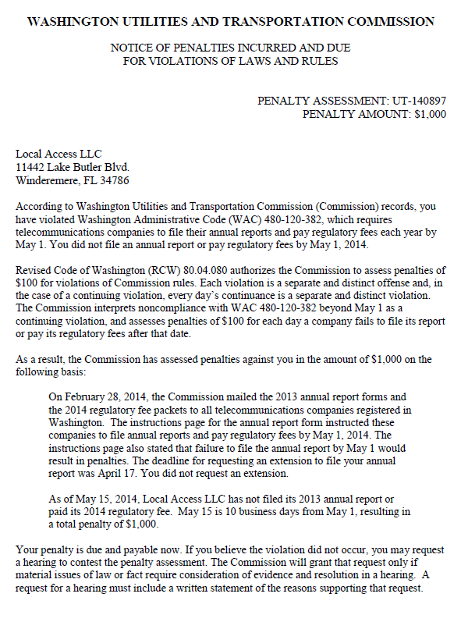

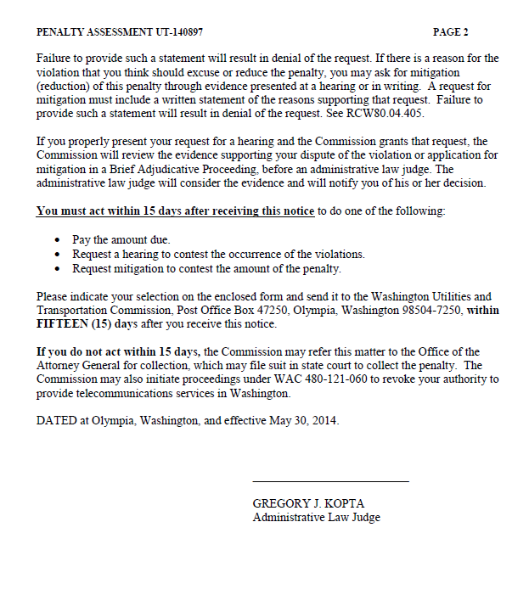

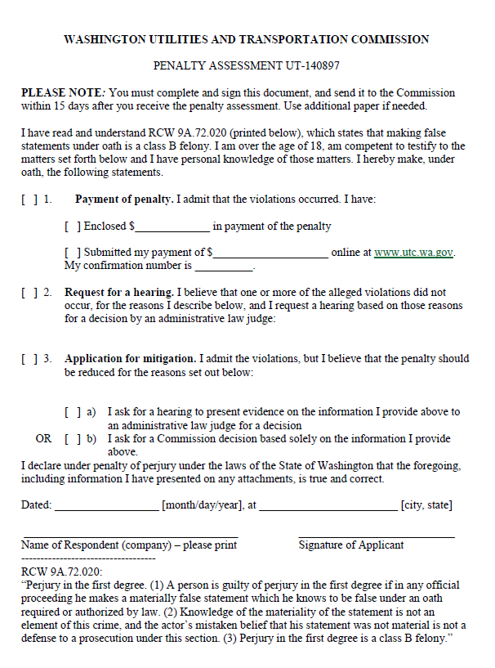

ATTACHMENT B
