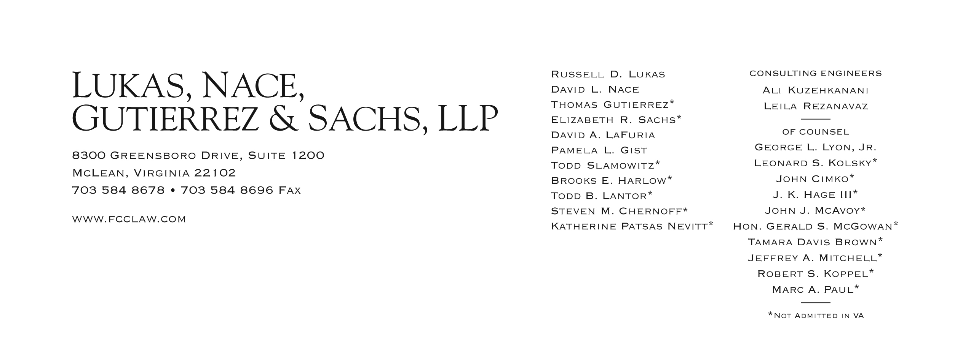

May 30, 2012

VIA WUTC Web Portal and Overnight FedEx

David S. Danner
Secretary and Executive Director
Washington Utilities and Transportation Commission
1300 S. Evergreen Park Drive, S.W.
Olympia, WA 98054-7250

Re: Application of Budget PrePay, Inc. for Limited Designation as an Eligible Telecommunications Carrier in Washington;
Docket No. UT-111570

Dear Mr. Danner:

On May 25, 2012, the Federal Communications Commission (“FCC”) approved Budget PrePay, Inc.’s (“Budget PrePay” or the “Company”) Compliance Plan. In its Compliance Plan filed with the FCC, Budget PrePay asked that the FCC forbear from applying the “own facilities” requirement contained in section 214(e)(1)(A) of the Communications Act, 47 C.F.R. § 214(e)(1)(A), consistent with the FCC’s determination to forbear from applying the “own facilities” requirement to Low Income-only (e.g., Lifeline) ETC applications that comply with the conditions set forth in the FCC’s Lifeline Reform Order.

Because Budget PrePay has now been granted forbearance from the “own facilities” requirement of the Communications Act of 1934, as amended, in order to be eligible to participate in the Universal Service Fund’s (“USF”) Low Income program, any issues regarding Budget PrePay’s eligibility for ETC designation in Washington based upon the Company’s “own facilities” have now been rendered moot.

Budget PrePay will be further updating the record in this proceeding shortly pursuant to Staff’s request. Upon submission of the remaining requested information, we respectfully request the Commission’s expeditious processing and approval of its pending ETC application, filed on August 29, 2011, in order to allow the Company to be eligible to participate in the USF’s Low Income program and provide the benefits of the USF Low Income program, in accordance with all applicable Commission rules, to qualified Washington residents.

Please do not hesitate to contact the undersigned with additional questions regarding the FCC’s approval of Budget PrePay’s Compliance Plan or pending ETC application.

Respectfully submitted,

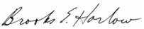

Brooks E. Harlow
Todd B. Lantor

Counsel for Budget PrePay, Inc.

Attachments

cc: Mr. William Weinman
Ms. Jing Liu

Attachment A

Attachment B

See Wireline Competition Bureau Approves the Compliance Plans of American Broadband & Telecommunications, Budget PrePay, Consumer Cellular, Global Connection, Terracom and Total Call, FCC Public Notice, WC Docket Nos. 09-197 and 11-42, DA 12-828 (rel., May 25, 2012) (Attachment A). Also attached (Attachment B) is a copy of Budget PrePay’s May 1, 2012 Compliance Plan approved by the FCC.
See In the Matter of Lifeline and Link Up Reform and Modernization, Report and Order and Further Notice of Proposed Rulemaking, WC Docket No. 11-42, FCC 12-11 (rel. Feb. 6, 2012) (“Lifeline Reform Order”).
See Application of Budget PrePay, Inc. for Limited Designation as an Eligible Telecommunications Carrier in Washington, Docket No. 111570 (filed August 29, 2011); see also First Amendment to Application of Budget PrePay, Inc. for Limited Designation as an Eligible Telecommunications Carrier in Washington, Docket No. 111570 (filed September 19, 2011); Letter Supplement to Application of Budget PrePay, Inc. for Limited Designation as an Eligible Telecommunications Carrier in Washington, Docket No. 111570 (filed March 8, 2012); and Letter Response to Request for Update with Regard to Budget PrePay, Inc.'s ETC Petition in Washington, Docket No. 111570 (filed April 25, 2012).

