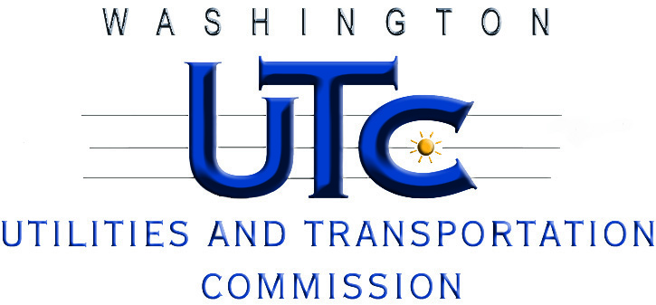

A G E N D A

April 16, 2015

Attrition Workshop - Docket U-150040

Investigation of Possible Ratemaking Mechanisms to
Address Utility Earnings Attrition

- Welcome and Introductions

- Commission’s “Modified” Historical Ratemaking Approach
- Is it sufficient for addressing attrition?

- Attrition Allowance
- When, if ever, is it appropriate?

- Future Test Year
- When, if ever, is it appropriate?

- Other Ratemaking Mechanisms

- Next Steps – Closing

