Report to the Washington Utilities and Transportation Commission

Electric Service Reliability - Major Event Report

Event Date: November 17-18, 2015
Date Submitted: January 27, 2016
Primary Affected Locations: Yakima and Walla Walla
Primary Cause: Wind and Rain Storm
Exclude from Reporting Status: Yes
Report Prepared by: April Brewer
Report Approved by: Heide Caswell / David O’Neil / Steve Henderson / Kevin Putnam

Event Description
On November 17, 2015, the Yakima and Walla Walla area experienced a severe wind and rain storm. The storm brought high winds and rain to the northwest. Yakima sustained 63% of all the outages that occurred during the major event. Pole fire-related outages accounted for approximately 32% of all outages, affecting more than 2,200 customers, with a total of over 970,000 customer minutes lost. Tree related outages accounted for approximately 27% of all incidents, affecting over 1,800 customers, with over 445,000 customer minutes lost.

During the storm two significant outages occurred. The most substantial outage occurred at 6:14 pm in Walla Walla when a large tree fell on a primary overhead line. The outage affected 1,611 customers, with 924 customers restored at 9:34 pm, and 687 customers restored at 10:07 pm. In Yakima, circuit 5Y607 sustained the greatest impact during the event due to a pole fire, experiencing a total of 450,349 minutes lost.

Event Outage Summary
# Interruptions (sustained) | 106
Total Customer Interrupted (sustained) | 6,870
Total Customer Minutes Lost | 1,839,623
State Event SAIDI Impact | 13.4 Minutes
CAIDI | 268
Major Event Start | 11/17/15 11:13 AM
Major Event End | 11/18/15 5:30 PM

Wind Gust November 16-18, 2015 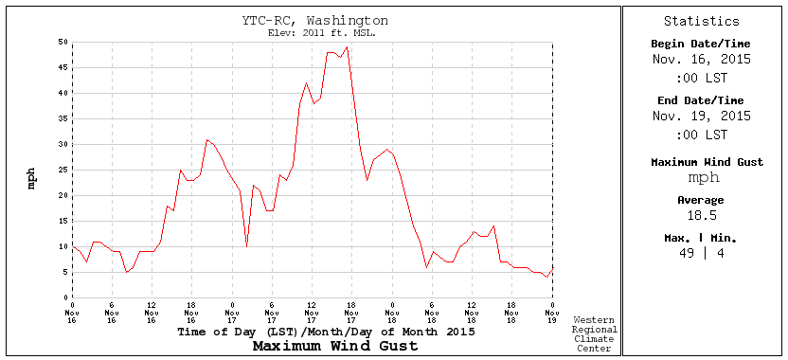 http://www.raws.com

Restoration Summary
During the storm a total of 106 sustained outages occurred, and at its peak 4,077 customers were without power. Restoration activities utilized 49 operations personnel. A total of 35 journeymen took part in the restoration efforts, replacing approximately 8,000 feet of conductor, 29 insulators, 25 cutouts, 28 crossarms, and five transformers. During the duration of the major event, 27% of customers interrupted were restored within 3 hours; no customers were off supply for more than 24 hours.
There were no company or commission customer complaints made regarding the major event.

Restoration Intervals
Total Customers Sustained | < 3 Hrs. | 3 - 24 Hrs. | 24+ Hrs.
6,870 | 1,873 | 4,997 | 0

Restoration Resources
Personnel Resources
Service Coordinators | 3
Mechanics | 1
Metermen | 2
Plant Journeymen | 3
Collectors | 2
Estimators | 1
General Foreman | 2
Journeyman | 35
TOTAL | 49

Materials
Insulators | 29
Pole top extender | 8
Cutouts | 25
Approximate Line Feet (conductor) | 8,000 ft
Crossarms | 28
Transformers (pole mounted) | 5

Estimated Major Event Costs
Estimate $ | Labor | Contracts | Materials | Total
Capital | $13,000 | $25,000 | $27,000 | $65,000
Expense | $119,000 | $123,000 | $24,000 | $266,000
Total | $132,000 | $148,000 | $51,000 | $331,000

Major Event Declaration
Pacific Power is requesting designation of this event and its consequences to be classified as a “Major Event” for exclusion from network performance reporting with the IEEE 1366-2003/2012. This major event exceeded the company’s current Washington threshold of 1,299,474 customer minutes lost (9.46 state SAIDI minutes) in a 24-hour period.

Event Detail
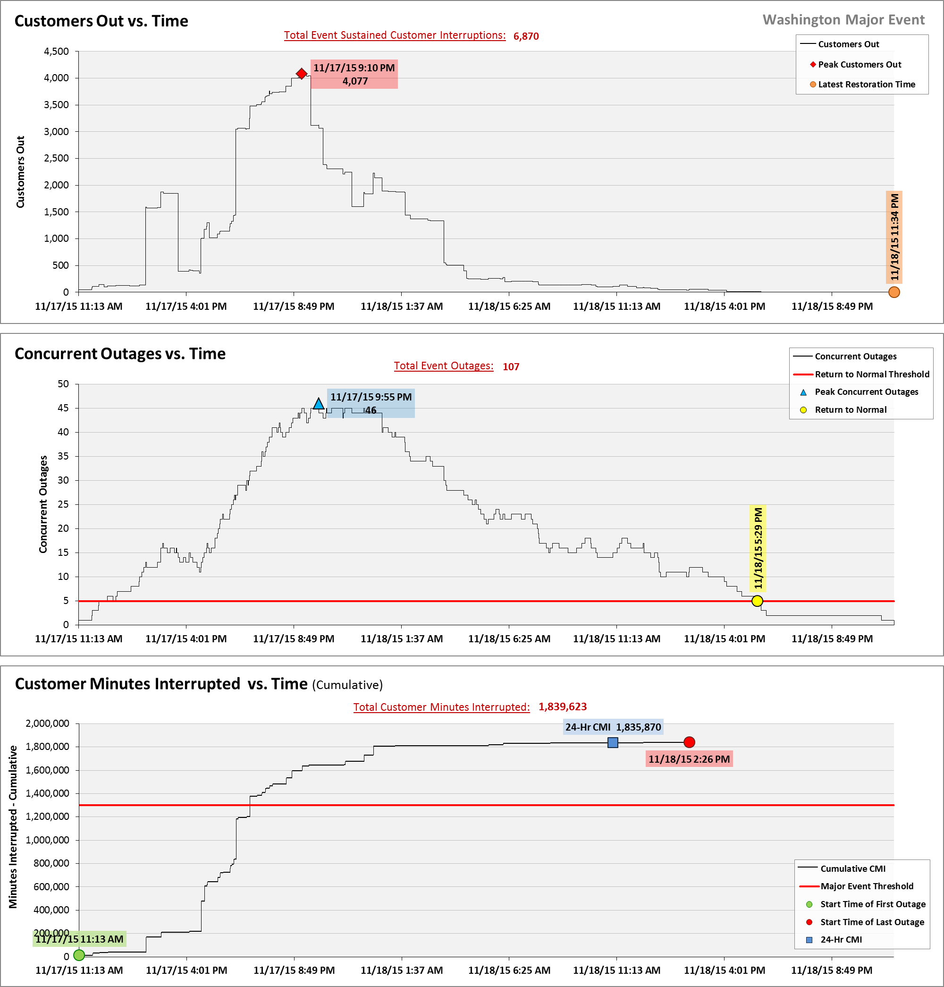

SAIDI, SAIFI, CAIDI by Reliability Reporting Region
Please see the attached system-generated reports.

Pole fires occur when atmospheric conditions with light misting rain bonds with contaminants resulting in a breakdown of insulation, which leads to leakage current. If this leakage current passes through a dry wood pocket on its path to ground, it can ignite the crossarm or pole.

