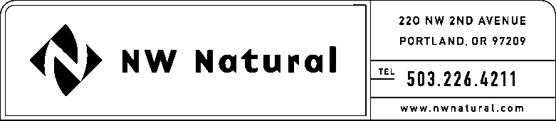

Onita R. King
Rates & Regulatory Affairs
Tel: 503.721.2452
Fax: 503.721.2516
email: ork@nwnatural.com

December 16, 2014 NWN WUTC Advice No.14-8A / UG-143897

Steven V. King, Executive Director & Secretary
Washington Utilities and Transportation Commission
1300 S Evergreen Park Drive SW
Post Office Box 47250
Olympia, Washington 98504-7250

Re: Docket UG-143897. Supplemental Filing:
Revisions to Schedule T – Imbalance Penalties and Overrun/Underrun Charges

Northwest Natural Gas Company, dba NW Natural (NWN or the “Company”) files herewith the following revision to its Tariff WN U-6, stated to become effective with service on and after January 1, 2015, as follows:

Second Revision of Sheet T-5,
Schedule T,
“Customer-Owned Natural Gas Transportation Service (continued).”

All other tariff sheets proposed in the Company’s filing NWN WUTC Advice No. 14-8 dated November 17, 2014 do not change and are requested to become effective as filed.

The purpose of this supplemental filing is to revise the last two paragraphs on Sheet T-5 so that the description of the overrun charge calculation is better aligned with the language used in Northwest Pipeline’s Tariff as approved by FERC for Northwest Pipeline (“Pipeline”) on October 23, 2014 in Docket No. RP14-1283-000.

The Company respectfully requests that the tariff sheets filed herewith be approved to become effective with service on and after January 1, 2015.

As required by WAC 480-80-103(4)(a), I certify that I have authority to issue tariff revisions on behalf of NW Natural.

Copies of this letter and the attached filing are available in the Company’s main office in Portland, Oregon, and on its website at www.nwnatural.com.

Please address correspondence on this matter to me at ork@nwnatural.com, with copies to the following:

eFiling

Rates & Regulatory Affairs
NW Natural
220 NW Second Avenue

Portland, Oregon 97209
Telecopier: (503) 721-2516

Telephone: (503) 226-4211, ext. 3589
eFiling@nwnatural.com

Sincerely,

NW NATURAL

/s/ Onita R. King

Onita R. King
Rates & Regulatory Affairs

