https://www.seattletimes.com/business/local-business/seattle-based-holland-america-line-announces-2000-layoffs-other-measures-as-coronavirus-halts-cruise-sailings-worldwide/

Seattle-based Holland America Line lays off 2,000 workers, makes other cuts as coronavirus halts cruises
May 14, 2020 at 11:12 am Updated May 15, 2020 at 2:39 pm
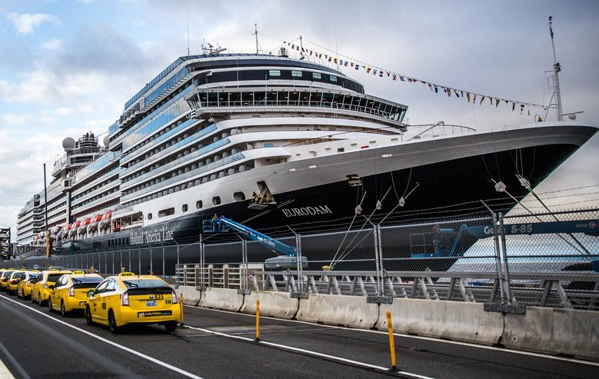Most of Holland America’s landbound staff work in Seattle and Santa Clarita, California. Nearly half the company’s workforce in... (Rebekah Welch / The Seattle Times) More
By
Katherine Khashimova Long
Seattle Times business reporter
Cruise line Holland America, headquartered in Seattle, will lay off close to 2,000 employees and will furlough or reduce the hours or pay of its remaining shoreside employees, the company announced Thursday.
The company did not respond immediately to questions about how many employees will be furloughed.
Most of Holland America’s landbound staff work in Seattle and Santa Clarita, California. A company spokesperson declined to say how many employees Holland America has in the Seattle area, but said nearly half its workforce in the state has been laid off or furloughed.
A no-sail order from federal health officials means the company is not generating revenue, Holland America Line said in a statement. It’s not yet clear when the U.S. moratorium on cruising, or similar measures in Canada, will be lifted. The cruise line canceled all of its voyages out of Seattle last week.
“These difficult decisions were necessary because our pause in global ship operations has extended well beyond what we could have ever predicted,” the statement read.

RELATED
MORE ON MARITIME INDUSTRY »
- For crew of 2,100-passenger cruise ship, frenetic ‘turnaround day’ in Seattle starts and ends the journey (2018)
- Feds will send $50 million in coronavirus relief to Washington seafood firms, fishermen, tribes, charter boat operators
- Port of Seattle delays controversial new cruise terminal as it pares spending due to coronavirus
More
The staff reductions are the latest in a series of cutbacks by parent company Carnival Corp., the world’s largest cruise company, which announced Thursday morning it planned to institute wide-ranging layoffs and furloughs across its brands.
ADVERTISING
“I make this decision knowing our best plan forward is to be in a position to ride out this adversity — in order to rise again as a vibrant firm that can call back those on furlough, restore salaries and bonuses, and regenerate the positive economic impact we have on so many of our other stakeholders that depend on our company,” Carnival president and CEO Arnold Donald said in a letter to employees.
The company shed 1,300 workers in its Florida offices Thursday, about 45% of its shoreside workforce. Nearly two-thirds of those were laid off, The Miami Herald reported.
Holland America President Orlando Ashford announced Tuesday he would be out of the job by the end of the month, after sitting at the company helm for more than five years. The same day, Carnival laid off 450 employees of brands Cunard Line and P&O cruises in its United Kingdom offices, the BBC reported. Remaining employees took a 20% salary cut through November. The president of another Seattle-based Carnival cruise line, Seabourn, will also leave his post at the end of May.
In his letter, Donald noted other cruise lines acted more swiftly to lay off staff.
Royal Caribbean Cruises shed 26% of its shoreside staff in mid-April, followed by Norwegian Cruise Line Holdings, which furloughed 20% of its workers April 30.
The cruise industry as a whole has been pummeled by travel restrictions due to the novel coronavirus. Most large lines have canceled many of their sailings through the end of the year, in part due to the Centers for Disease Control and Prevention’s March 14 ban on cruising, the first time the agency has ever ordered the cruise industry to halt operations. The ban is in place until at least July 24.
ADVERTISING
More than 30 vessels have reported outbreaks of the novel coronavirus, according to the CDC. At one point, infections among passengers returning from cruise voyages accounted for approximately 17% of total reported U.S. cases.
Meanwhile, 96,000 cruise workers remain stranded aboard ship as companies struggle to repatriate them while complying with international travel restrictions, Bloomberg reported.
Even as earnings plummet, cruise lines insist they are resilient. Passengers will return in the latter half of the year and into 2021, they say.

Sign up for Evening Brief
Delivered weeknights, this email newsletter gives you a quick recap of the day's top stories and need-to-know news, as well as intriguing photos and topics to spark conversation as you wind down from your day.
Sign up

Norwegian, which has canceled all sailings until June 30, reported a net loss of $1.88 billion in the first three months of 2020, compared with net income of $118.2 million over the same period last year.
But in its quarterly earnings call Thursday, Norwegian executives sounded an optimistic tone, describing cruise demand “within historical ranges” starting from autumn onward, The Miami Herald reported.
“Our guests continue to demonstrate their desire for cruise vacations, and we continue to experience demand for voyages further in the future across our three brands,” CEO Frank Del Rio said.
Like many cruise lines, including Holland America, Norwegian is offering passengers on canceled voyages the choice between a full refund or future cruise credit worth well over the amount of the fare paid on the canceled trip. Passengers on vessels still scheduled to sail by Sept. 30 can cancel their trips, but aren’t eligible for a refund — only future credit.
Cruise company stocks have fallen about 75% so far this year.
Katherine Khashimova Long: 206-464-3229 or kalong@seattletimes.com; on Twitter: @_katya_long.

