October 20, 2016  Via Electronic Filing and FedEx  Mr. Steven V. King  Executive Director  Washington Utilities & Transportation Commission  1300 S. Evergreen Pk. Dr. S.W.  P. O. Box 47250  Olympia, WA 98504-7250 |  | Elizabeth Thomas  liz.thomas@klgates.com  T 1 206 370 7631

Re: | Docket No. UE-161123 – Puget Sound Energy Schedule No. 451: Large Customer Retail Wheeling, Advice No. 2016-28
Dear Mr. King:
Enclosed for filing in the above-referenced docket, please find the following on behalf of Microsoft Corporation:
- Notice of Appearance of Microsoft Corporation.
Thank you for your assistance. Please do not hesitate to call if you have any questions.
Sincerely yours,
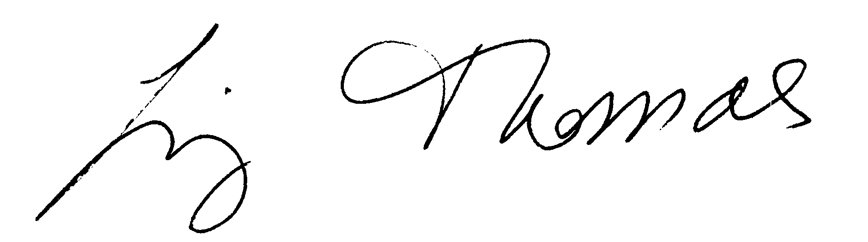
Elizabeth Thomas

Enclosures

CERTIFICATE OF SERVICE

I HEREBY CERTIFY that I have this day served the attached Notice of Appearance of Microsoft Corporation upon all parties of record (listed below) in this proceeding by electronic mail and by mailing a copy properly addressed with first class postage prepaid.
Ken Johnson  Director – Rates & Regulatory Affairs  Puget Sound Energy  P.O. Box 97034, PSE-08N  Bellevue, WA 98009-9734  ken.s.johnson@pse.com | Sheree Carson  Perkins Coie, LLP  10885 N.E. Fourth St.  Bellevue, WA 98004-5579  scarson@perkinscoie.com | Jason Kuzma  Perkins Coie, LLP  10885 N.E. Fourth St.  Bellevue, WA 98004-5579  jkuzma@perkinscoie.com
Jennifer Cameron-Rulkowski  Assistant Attorney General  WUTC  P.O. Box 40128  Olympia, WA 98504-0128  jcameron@utc.wa.gov | Jennifer Snyder  Regulatory Analyst  WUTC  P.O. Box 40128  Olympia, WA 98504-0128  jsnyder@utc.wa.gov | Lisa Gafken  Office of the Attorney General  800 Fifth Avenue STE 2000  Seattle, WA 98104-3188  LisaW4@atg.wa.gov
Industrial Customers of Northwest Utilities  818 SW 3rd Avenue #266  Portland, OR 97204 | Tyler C. Pepple  Davison Van Cleve, P.C.  333 S.W. Taylor, Suite 400  Portland, OR 97204  tcp@dvclaw.com  Telephone: (503) 241-7242 | Simon J. ffitch  The Energy Project  321 High School Rd. NE, Suite D3, Box 383  Bainbridge Island, WA 98110  simon@ffitchlaw.com  Telephone: (206) 669-8197
Dated this 20th day of October, 2016.
/s/ Liz Thomas
Liz Thomas
Kari L. Vander Stoep
K&L Gates LLP
925 Fourth Avenue, Suite 2900
Seattle, WA 98104
Email: liz.thomas@klgates.com
kari.vanderstoep@klgates.com
Telephone: (206) 370-7631

Of Attorneys for
Microsoft Corporation

