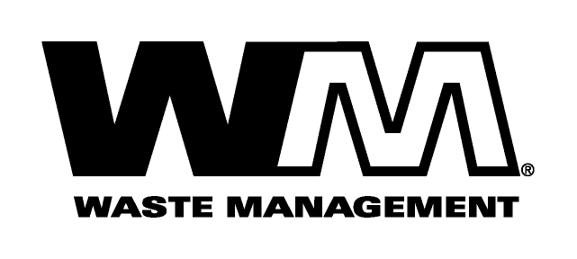

January 14, 2009

Washington Utilities and Transportation Commission
Chandler Plaza Building
1300 S. Evergreen Park Drive SW
P.O. Box 47250
Olympia, WA. 98504-7250

Subject: Waste Management-Northwest, a division of Waste Management of Washington, Inc. (G-237); Tariff No. 17
Enclosed herein, you will find our new Tariff No.17 for the above-referenced company. This tariff replaces Waste Management-Northwest Tariff No.16. In this new tariff, we are requesting an increase in our rates attributed to the increase in Snohomish County disposal fees from $89.00 per ton to $105.00 per ton effective March 1, 2009. In addition, this filing is requesting further increases to reflect significant changes in our operating expenses, including recycle and yard waste processing fees, maintenance, labor, fuel and other operating and administrative costs since our last general rate increase nearly four years ago. These increased rates, if approved by the commission, would increase Company revenue by approximately $6,900,000 and collectively, residential and commercial rates by 19%. This new tariff is being filed with a proposed effective date of March 1, 2009.
Also enclosed for your review are our proposed customer notices. An electronic copy of our accounting workpapers will be submitted shortly. Customer notices will be mailed on or before January 29th.
We are also requesting that all financial data submitted with this filing which is stamped “Confidential” be treated as such per WAC 480-09-015 as its release may adversely affect non-regulated Waste Management operations and entities.
If you have any questions or need additional information, please contact me at (425) 814-7840.
Respectfully,

Michael A. Weinstein
Senior Pricing Manager, Pacific Northwest Market Area

cc: Tim Crosby
Adam Winston
Dean Kattler
Tom Leland
Joe Krukowski
Clerk of the Board, Snohomish County

