8113 W. GRANDRIDGE BLVD., KENNEWICK, WASHINGTON 99336-7166
TELEPHONE 509-734-4500 FACSIMILE 509-737-9803
www.cngc.com

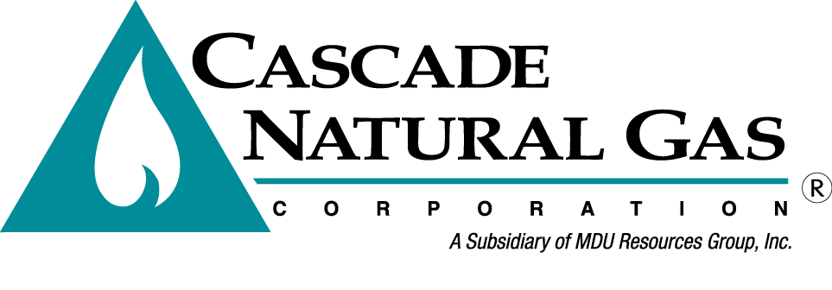
February 27, 2015

Mr. Steven V. King
Executive Director and Secretary
Washington Utilities & Transportation Commission
Post Office Box 47250
Olympia, Washington 98504-7250

Re: Revisions to tariffs impacting gas scheduling operations and balancing
Advice No. CNGC/W15-02-02

Dear Mr. King:

Cascade Natural Gas Corporation (Cascade or the “Company”) files herewith the revisions to its Tariff WN U-3, stated to become effective with service on and after March 30, 2015, as follows:

Fifth Revision Sheet No. 21-A Canceling Fourth Revision Sheet No. 21-A
Fourth Revision Sheet No. 21-B Canceling Third Revision Sheet No. 21-B
Third Revision Sheet No. 21-C Canceling Second Revision Sheet No. 21-C
Second Revision Sheet No. 24 Canceling First Revision Sheet No. 24
First Revision Sheet No. 24-A Canceling Original Sheet No. 24-A
Original Sheet No. 24-B

The purpose of this filing is to revise these tariff sheets to better align with the pipeline overrun and underrun charges and the monthly imbalance threshold changes approved by FERC for Northwest Pipeline ("Pipeline") on October 23, 2014, in Docket No. RP14-1283-000. Additionally, Cascade seeks to update the gas scheduling and balancing provisions of our tariffs to better reflect current industry practice. Prior to this filing many of these provisions have not been updated in over ten years.

The Pipeline proposed, and FERC agreed, that to maintain operational integrity of the system, the penalty for unauthorized overrun gas must be higher than the then current daily price of gas. Cascade agrees with this position and expects that the increase proposed in this filing will serve to mitigate the same potential for transportation customers to threaten the Company's distribution system operations by choosing to pay a lower penalty rate rather than pay for the delivery of higher priced gas supplies.

As the principle upstream transporter delivering natural gas to Cascade’s distribution system, Cascade has historically attempted to mirror the Pipeline's tariff provisions for imbalances and overrun and underrun charges in our tariffs.

“Optional Firm Services Customers” option originally on Third Revision Sheet No.21-B carried thru Second Revision Sheet No. 21-C no longer exists.

The Company respectfully requests that the tariff sheets filed herewith be approved to become effective with service on and after March 30, 2015.

Any questions regarding this filing may be directed to me at (509) 734-4593.

Sincerely,

Michael Parvinen
Director, Regulatory Affairs

Attachments

