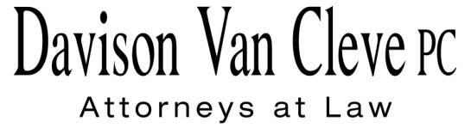
TEL (503) 241-7242 ● FAX (503) 241-8160 ● mail@dvclaw.com
Suite 400
333 S.W. Taylor
Portland, OR 97204

December 20, 2013

Via Electronic Mail

Mr. Steven V. King
Executive Secretary
Washington Utilities & Transportation Commission
1300 S. Evergreen Pk. Dr. S.W.
P. O. Box 47250
Olympia, WA 98504-7250

Re: Comments of ICNU Regarding Proposed Changes to WAC§ 480-07-100 – WAC § 480-07-180
Docket No. A-130355

Dear Mr. King:

Enclosed for filing in the above-captioned proceeding, please find the Comments of the Industrial Customers of Northwest Utilities.

Thank you for your assistance, and please don’t hesitate to contact our office with any questions.

Sincerely yours,

/s/ Karen A. Zolka
Karen A. Zolka
Enclosures

