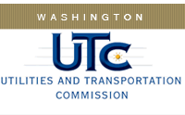

Memorandum
May 7, 2015

To: TR-143595 - File

From: Lori Halstead, Transportation Specialist, Rail Safety

Subject: TR-143595 – Western Washington Railroad
Completion of Grade Crossing Protective Fund (GCPF) Project
To Install No Trespass Signs Along Railroad Right-of-Way

On October 30, 2014, the Washington Utilities and Transportation Commission (Commission) awarded a GCPF grant totaling $3684.60 to Western Washington Railroad for a project related to installation of No Trespass signs along railroad right-of-way.

On April 22, 2015, Western Washington Railroad submitted a request for reimbursement for the project. Rail Safety staff received pictures of the sign placement and that the project was completed according to the specifications outlined in the order approving the grant. The total cost was $3667.15.

Please close this docket.

