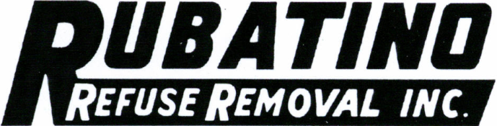

June 7, 2017

Secretary
Washington Utilities & Transportation Commission
PO Box 47250
Olympia WA 98504-7250

RE: Certificate #G-58

Dear Secretary:

Enclosed please find the Solid Waste Collection Companies Annual Affiliated Interest and Subsidiary Report filing for the year ended December 31, 2016.
Per WAC 480-07-160 Financial Statements for Reclamation Inc.,Truckcare, LLC., RG Real Estate LLC. and ETJ, LLC must remained “Confidential” as they contained sensitive financial information. Please feel free to call me if you have any questions or need further information.

Sincerely,

Anna A Taylor
Accountant

(425) 259-0044
anna@rubatino.com

Encl

