September 28, 2010

David Lykken
Director, Pipeline Safety
Utilities & Transportation Commission
1300 S. Evergreen Park Dr. S.W
PO Box 47250
Olympia, WA 98504-7250

Subject: WAC 480-93-020 - Request for Approval - 1482 Slater Rd. Ferndale.

Dear Mr. Lykken:

Cascade requests permission to install and operate a new gas pipeline and pressure regulating station (R-166) at a maximum allowable operating pressure (MAOP) of 380 psig within 100’ of an existing building intended for human occupancy.

The project will be located inside City Limits of Ferndale, Whatcom County, Washington, at 1482 Slater Rd. The proposed facilities are shown on the enclosed drawing.

The project is necessary as an existing customer, Hiltner Combustion Systems, is requesting an increase in their delivery pressure to 80 psig. The existing regulator station (R-161) at the site is approximately 23’ from the building. That device cannot supply a pressure greater than 60 psig, and a new regulating device is required. The existing regulator station would remain to serve a small distribution system. The customer is eagerly awaiting the project as their business will be significantly impacted until they are able to obtain the higher delivery pressure.

The project will include the following:
- A tap of an existing 2” high pressure (HP) line using a 2" Mueller Service Stop Tee, Fig #H-17656 (rated to 1440 psig).
- Approximately ten feet of 2” steel pipe.
- An above ground regulator station, which will consist of a single pressure cut and remote relief device.
The new facilities will be installed approximately 20 feet from the building occupied by Hiltner Combustion Systems.

The regulator station will utilize an existing valve (V-200) approximately 20 feet upstream which will allow remote shut-off of the station in the event of an emergency.

The MAOP of the new facilities would be 380 psig between the 8” Central Whatcom HP Line tap and the regulator device. The MAOP will be 150 psig downstream of the regulator device.

There are no practical alternatives to reduce the pressure and still serve Hiltner Combustion Systems at the requested pressure of 80 psig. Placing the new regulator station 100 feet from the building will expose the piping to Slater Rd vehicular traffic. To lower the pressure, Cascade would be required either to extend a 250 psig pipeline several miles to the site, or downrate the existing line from 380 psig to 250 psig, which would affect service to a large portion of Whatcom County.

Sincerely,

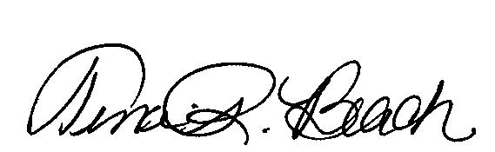
Tina R. Beach
Pipeline Safety Specialist

