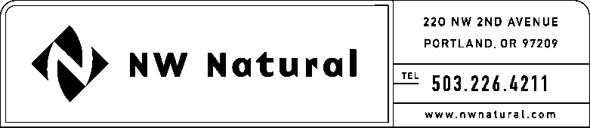

GAIL A. HAMMER
Tariffs and Regulatory Compliance
Tel: 503.226.4211, ext. 5865
Fax: 503.721.2516
email: gail.hammer@nwnatural.com

March 27, 2017

VIA ELECTRONIC FILING

Steven King, Executive Director and Secretary
Washington Utilities and Transportation Commission
1300 S. Evergreen Park Drive, S.W.
P.O. Box 47250
Olympia, Washington 98504-7250

RE: Request for Extension of Affiliated Interest and Subsidiary Transactions Report

Northwest Natural Gas Company, dba NW Natural, respectfully requests an exemption from WAC 480-90-264 for the 2016 Affiliated Interest and Subsidiary Transactions Report. NW Natural would like additional time to prepare the filing and requests an extension to file this report on June 1, 2017.

Thank you for your consideration of this matter. If you have any questions, please contact me at (503) 226-4211, extension 5865.

Sincerely,

/s/ Gail A. Hammer

Gail A. Hammer
Rates & Regulatory Affairs

