July 11, 2014

Steven V. King, Executive Director and Secretary
Utilities and Transportation Commission
1300 S. Evergreen Park Dr. SW
P.O. Box 47250
Olympia, WA 98504-7250

RE: Washington Utilities and Transportation Commission v. American Moving Co Inc.

Commission Staff’s Response to Application for Mitigation of Penalties TV-140942

Dear Mr. King:

On June 4, 2014, the Utilities and Transportation Commission issued a $1,000 Penalty Assessment in Docket TV-140942 against American Moving Co Inc. for 10 violations of Washington Administrative Code (WAC) 480-15-480, which requires household goods carrier companies to furnish annual reports to the commission no later than May 1 each year.¹

On June 30, 2014, American Moving Co Inc. wrote the commission requesting mitigation of penalties (Mitigation Request).² In its Mitigation Request, American Moving Co Inc. does not dispute that the violation occurred. The company states, “We are requesting that the penalty for late annual report filing be reduced as American Moving Co Inc., did not have intrastate authority until June of 2014. We have nothing to report so weren’t aware of the filing. Our office was closed for 2 weeks for vacation, as to why our letter is just being sent.”

It is the company’s responsibility to ensure that the regulatory fee is paid and the annual report is filed by the May 1 deadline. On February 28, 2014, Annual Report packets were mailed to all regulated household goods companies. The instructions for annual report completion page of the annual report informed the regulated company that it must complete the annual report form, pay the regulatory fees, and return the materials by May 1, 2014, to avoid enforcement action.

On June 30, 2014, American Moving Co Inc. filed its 2013 annual report with no regulatory fees due. The company filed its original application with the commission on July 28, 2011. American Moving Co Inc. remained active until suspended for insurance on January 21, 2014

UTC Annual Reports
July 11, 2014
Page 2

and was reinstated on February 14, 2014 in Docket TV-140100. Additionally, American Moving Co Inc. was delinquent in filing the 2012 annual report and received partial mitigation. Staff does not support the company’s request for mitigation due to previous violations of WAC 480-15-480 with prior mitigation and no new and compelling reasons provided to support its request.

If you have any questions regarding this recommendation, please contact Amy Andrews, Regulatory Analyst, at (360) 664-1157, or aandrews@utc.wa.gov.

Sincerely,

Sondra Walsh, Director
Administrative Services

ATTACHMENT A
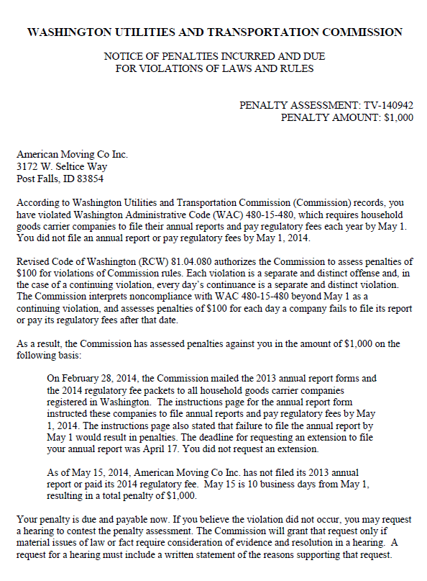

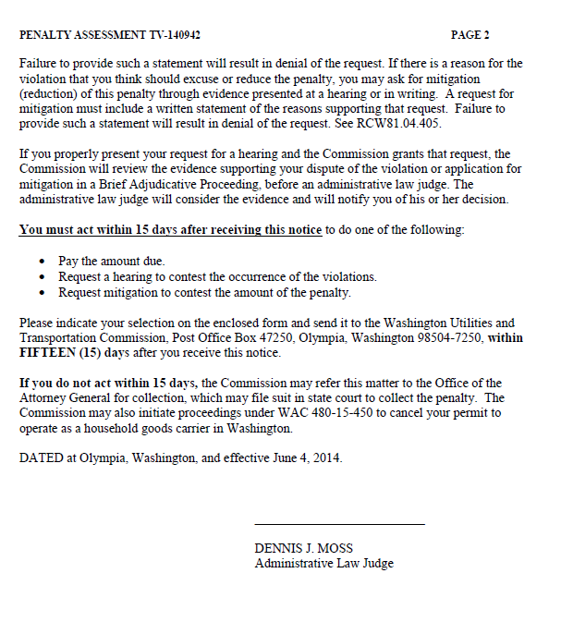

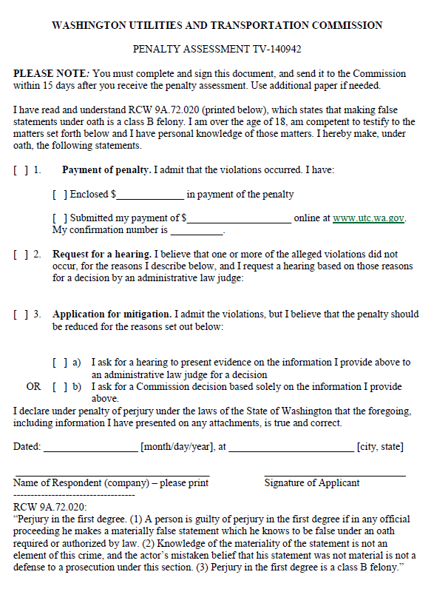

ATTACHMENT B
