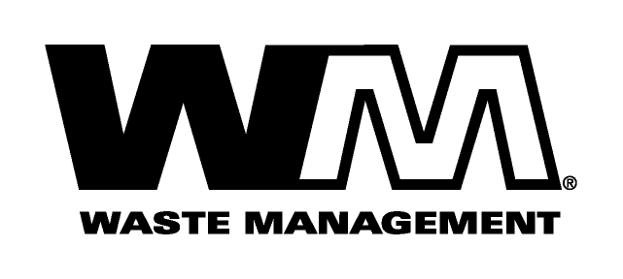

Company Address

December 31, 2009

Dear Valued Customer,
Waste Management is pleased to be your recycling and solid waste services collection provider. We value your business and welcome your feedback on our services.

Like all of us, the garbage industry is faced with many challenges today. Rising costs for labor, fuel, maintenance and office expenses have resulted in increased costs for us to provide collection services. All of the above-mentioned costs have risen considerably since our last general rate increase, nearly four years ago. Accordingly, we have applied for an increase in rates, subject to the review and approval of the Washington Utilities and Transportation Commission (UTC). The UTC, upon completing its investigation, could approve rates that may vary from the proposed rates shown on the back of this letter. If approved, the new rates would become effective February 1, 2010.

Rates and the Impact of Fuel Cost
Three years ago, Waste Management began a pilot project to itemize the cost of fuel on our invoices. Fuel makes up a large portion of our costs, and the volatility of fuel prices has a significant impact on our operating expenses. Accordingly, for the past three years, your invoices have reflected a separate line item for fuel, with the amount fluctuating based upon actual fuel cost during the previous year. All pricing has been monitored by the UTC and adjusted based on documented fuel prices and usage.
The pilot project will end this month. With the conclusion of this pilot program, Waste Management will begin to include the cost of fuel in the overall rates on February 1, 2010.

Due to the lower prices of fuel in 2009, you will see a change in the overall cost on your invoice as we fold the fuel cost back into your overall rates instead of including them as a separate line item on your invoice. This will partially offset increases in rising costs associated with labor, maintenance and office expenses since our last general rate case over four years ago.

To comment on this filing, be added to the UTC’s mailing list, or ask questions about the ratemaking process, please use the comment information below. You may also comment in person at the UTC’s open meeting in Olympia at 9:30 a.m. on January 28, 2010, or by using the “Public Comment” feature at the UTC.’s web site at http://www.utc.wa.gov/comments. The UTC is scheduled to make a decision at its open meeting on January 28, 2010.

If you are unable to attend an open meeting in person, the UTC has a bridge line that enables you to participate or listen by telephone. Call (360) 664-1234 for instructions the day before the open meeting.

Washington Utilities and Transportation Commission
Post Office Box 47250, Olympia, WA 98504-7250

E-mail: comments@utc.wa.gov
Telephone: 1-888-333-9882 Fax: 1-360-586-1150

Waste Management is committed to finding new and innovative ways to provide high quality solid waste services at cost effective rates. As the industry’s leader, we will continue to work diligently to develop and implement the most efficient collection systems available. For questions about your service, please call us at 1-800-592-9995. Thank you for your continued business.

Jeff McMahon, District Manager, Waste Management – Sno-King

