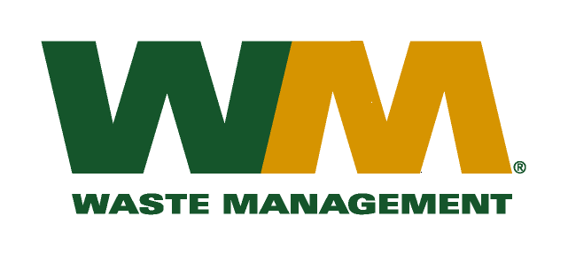

June 25, 2010
Washington Utilities and Transportation Commission
Chandler Plaza Building
1300 S. Evergreen Park Drive SW
P.O. Box 47250
Olympia, WA. 98504-7250
Dear Sirs:
Subject: Waste Management of Spokane, a division of Waste Management of Washington, Inc. (G-237); Tariff # 16
Enclosed are revised pages 2, 21, and 25 to the above-referenced tariff. The purpose of these tariff revisions is to reflect the change in the commodity credits for residential and multi-family customers receiving recycling collection services. These tariff revisions reflect an increase of the current commodity credit from $0.19 to $0.24 per month for residential customers and an increase from $0.03 to $0.13 per yard for multi-family customers. We are requesting that the proposed effective date of these tariff revisions be August 10, 2010.
Enclosed for your review are our accounting work papers. . Also enclosed for your consideration is a request for LSN treatment of these revised tariff pages, in order that these revised commodity price credits may become effective as of August 1, 2010. Customers will be notified of the change in their commodity credit adjustment on their next regularly scheduled billing after the approval of the Commission. In addition, the county has been notified of these proposed tariff changes.
If you have any questions or need additional information, please contact me at (425) 814-7840.
Very truly yours,

Michael A. Weinstein
Senior Pricing Manager, Pacific Northwest Market Area

cc: Marco Gonzales
Joe Krukowski
Clerk of the Board, Spokane County Chair

