June 13, 2014

Steven V. King, Executive Director and Secretary
Utilities and Transportation Commission
1300 S. Evergreen Park Dr. SW
P.O. Box 47250
Olympia, WA 98504-7250

RE: Washington Utilities and Transportation Commission v. Council on Aging & Human Services

Commission Staff’s Response to Application for Mitigation of Penalties TN-141039

Dear Mr. King:

On May 23, 2014, the Utilities and Transportation Commission issued a $1,000 Penalty Assessment in Docket TN-141039 against Council on Aging & Human Services for 10 violations of Washington Administrative Code (WAC) 480-30-080, which requires nonprofit special needs transportation provider companies to furnish annual reports to the commission no later than May 1 each year.¹

On June 2, 2014, Council on Aging & Human Services wrote the commission requesting mitigation of penalties (Mitigation Request).² In its Mitigation Request, Council on Aging & Human Services does not dispute that the violation occurred. The company states, “Due to an internal office errors, the report was not routed to the appropriate person at our agency and, therefore, never received the attention required for its timely completion and submission. As soon as I was informed of our tardiness to report/pay, I immediately completed the report, paid the regulatory fees, and am now asking forgiveness of the $1000 penalty assessment”. The request continues “You can understand the financial impact that such an amount would have on our small, non-profit agency.”

It is the company’s responsibility to ensure that the regulatory fee is paid and the annual report is filed by the May 1 deadline. On February 28, 2014, Annual Report packets were mailed to all regulated nonprofit special needs transportation provider companies. The instructions for annual report completion page of the annual report informed the regulated company that it must

UTC Annual Reports
June 13, 2014
Page 2

complete the annual report form, pay the regulatory fees, and return the materials by May 1, 2014, to avoid enforcement action.

On May 28, 2014, Council on Aging & Human Services filed the 2013 annual report and paid the required regulatory fees. The company has been active since June 12, 2007. No previous violations of WAC 480-30-080 are on commission record. Staff supports the company’s request for mitigation. Staff recommends a reduced penalty assessment of $100 as this is Council on Aging’s first late filing.

If you have any questions regarding this recommendation, please contact Amy Andrews, Regulatory Analyst, at (360) 664-1157, or aandrews@utc.wa.gov.

Sincerely,

Sondra Walsh, Director
Administrative Services

ATTACHMENT A
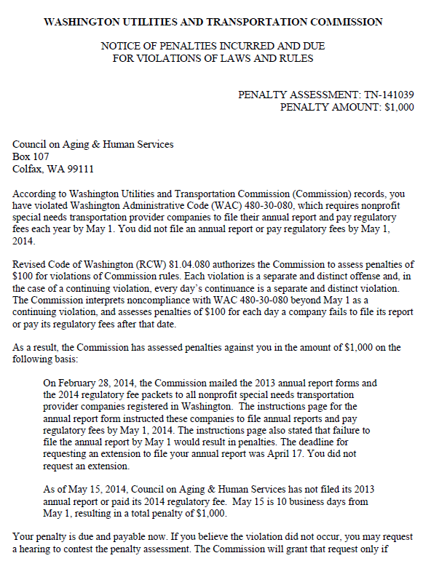

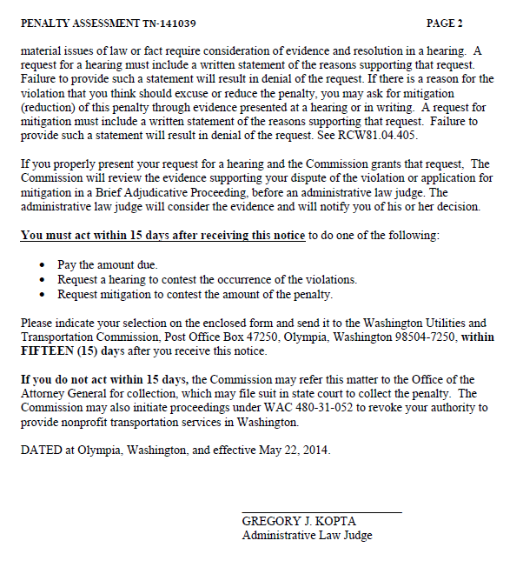

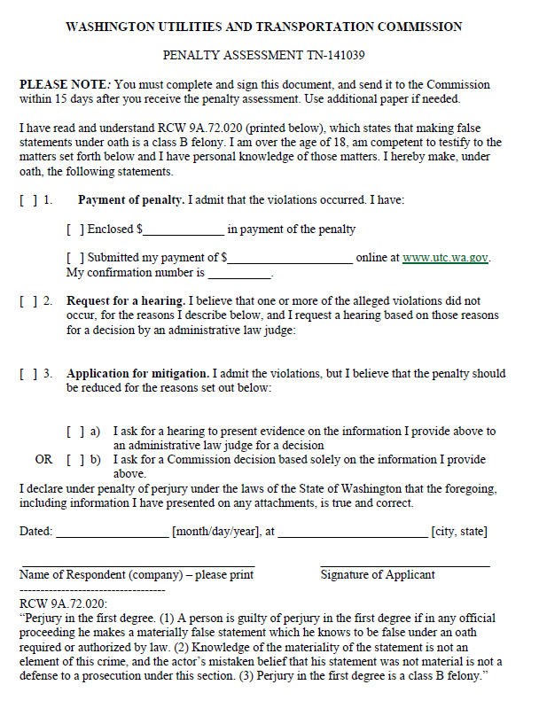

ATTACHMENT B
