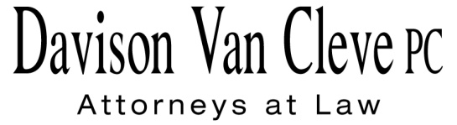
TEL (503) 241-7242 ● FAX (503) 241-8160 ● mail@dvclaw.com
Suite 400
333 SW Taylor
Portland, OR 97204

November 5, 2010

Via Email and Federal Express

Carole J. Washburn
Secretary
Washington Utilities and Transportation Commission
PO Box 47250
1300 S Evergreen Park Drive, SW
Olympia WA 98504-7250

Re: In the matter of WUTC v. PacifiCorp

Docket No. UE-100749

Dear Ms. Washburn:

Enclosed please find an original and 17 copies of the Cross Answering Confidential Testimony of Randall Falkenberg, the original and 1 copy of the Cross Answering Redacted Testimony Randall Falkenberg, and the original and 17 copies of the Cross Answering Testimony of Michael Gorman, and Donald Schoenbeck.

Thank you for your assistance.

Sincerely yours,

/s/ Jacqueline E. Smith
Jacqueline E. Smith

Enclosures
cc: Service List

CERTIFICATE OF SERVICE

I hereby certify that I have this day served the Cross Answering Testimony of Randall Falkenberg, Michael Gorman, and Donald Schoenbeck, on behalf of Industrial Customers of Northwest Utilities upon all parties of record in this proceeding by mailing a copy thereof in a sealed, first-class postage prepaid envelope to each individual’s last-known address, as listed below. Confidential versions were sent only to individuals who signed the protective order.
DATED this 5th day of November, 2010.
Davison Van Cleve, P.C.

/s/ Jacqueline E. Smith
Jacqueline E. Smith

McDowell, Katherine  McDowell Rackner & Gibson PC  419 SW 11th Avenue  Portland, OR 97205 | Walmart Stores, Inc.  2001 SE 10th Street  Bentonville, AR 72716-0550
Trotter, Don  Assistant Attorney General  WUTC  PO Box 40128  Olympia, WA 98504-0128 | The Energy Project  3406 Redwood Ave.  Bellingham, WA 98225
Mishoe, Michelle R  Legal Counsel  PacifiCorp  825 NE Multnomah  Portland, OR 97232 | Butler, Arthur  Ater Wynne LLP  601 Union Street  Seattle, WA 98101-3981
ffitch, Simon  AAG  Office of the Attorney General  800 Fifth Avenue  Seattle, WA 98104-3188 | Shifley, Sarah A  Office of the Attorney General  800 5th Ave  Seattle, WA 98104-3188
Purdy, Brad M
Attorney at Law
2019 N. 17th St.
Boise, ID 83702

