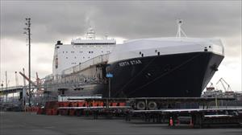

NORTH STAR
https://www.marinetraffic.com/en/ais/details/ships/shipid:455858/mmsi:369285000/imo:9232280/vessel:NORTH_STAR

ADD TO FLEET
CREATE NOTIFICATIONS
Voyage Information
UNLOCK VOYAGE INFORMATION
US TIWTACOMA
US ANCANCHORAGE
ATD: 2020-04-30 01:22 LT (UTC -7)
ETA: 2020-05-03 02:30 LT (UTC -8)
PAST TRACK
ROUTE FORECAST

Reported ETA: 2020-05-03 02:30 LT (UTC -8)
Calculated ETA:
••••••••••
Calculated ETA at:
••••••••••
Predictive ETD:
••••••••••
Reported Destination: ANCHORAGE

Distance Travelled:
••••••••••
Distance to Go:
••••••••••
Total Voyage Distance:
••••••••••
Time to Destination:
••••••••••

Draught (Reported/Max): 9.2 m /
••••••••••
Load Condition:
••••••••••
Speed recorded (Max / Average): 23.8 knots / 21.3 knots

EVENTS TIMELINEPOSITION HISTORY
Reported Destination and ETA Received 2020-04-30 23:59 UTC
Summary
Where is the ship?
Ro-Ro/Container Carrier NORTH STAR is currently located at WCCAN - West Coast Canada at position 50° 54' 40.608" N, 130° 8' 2.4" W as reported by MarineTraffic Terrestrial Automatic Identification System on 2020-05-01 03:30 UTC (17 hours, 58 minutes ago)
The wind in this area at that time blows from East direction at force 5 Beaufort.

Where is this vessel going to?
The vessel departed from TACOMA, US on 2020-04-30 01:22 LT (UTC -7) and is currently sailing at 21.9 knots with Northwest direction heading to ANCHORAGE, US with reported Estimated Time of Arrival at 2020-05-03 03:30 LT (UTC -7) local time (in 1 day, 13 hours )

What kind of ship is this?
NORTH STAR (IMO: 9232280) is a Ro-Ro/Container Carrier that was built in 2003 (17 years ago) and is sailing under the flag of USA.
It’s carrying capacity is 65314 Gross Tonnage and her current draught is reported to be 9.2 meters. Her length overall (LOA) is 255.73 meters and her width is 35.97 meters.
Vessel Information
General
IMO: 9232280
Name: NORTH STAR
Vessel Type - Generic: Cargo
Vessel Type - Detailed: Ro-Ro/Container Carrier
Status: Active
MMSI: 369285000
Call Sign: KIYI
Flag: USA [US]
Gross Tonnage: 65314
Summer DWT: 24788 t
Length Overall x Breadth Extreme: 255.73 x 35.97 m
Year Built: 2003
Home Port: FALLING WATERS WV
Classification Society:
••••••••••
Builder:
••••••••••
Owner:
••••••••••
Manager:
••••••••••
Ownership & Associated Parties
Structure & Machinery
Dimensions
Tonnage, Capacity & Loadline
Ex Names History
UNLOCK VESSEL INFORMATION
Recent Port Calls
No data available at the moment
UNLOCK MORE DATA
Events Timeline
Get access to vessel events for NORTH STAR
UNLOCK EVENTS TIMELINE
Service Areas
Trade AreasCountriesPorts
Since 2015Last Year
Trade Area | No Port Calls recorded | Years Observed
•••••••••• | •••••••••• | ••••••••••
•••••••••• | •••••••••• | ••••••••••
•••••••••• | •••••••••• | ••••••••••
•••••••••• | •••••••••• | ••••••••••
•••••••••• | •••••••••• | ••••••••••
UNLOCK SERVICE AREAS
Similar Vessels
See vessels similar to NORTH STAR, based on the type, capacity, dimensions.
UNLOCK SIMILAR VESSELS
In the News
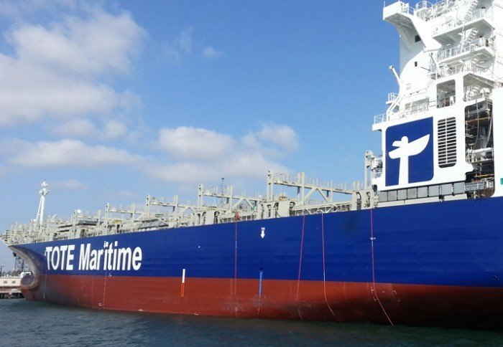

Tote-owned vehicle carrier spent more than half a day adrift off Canada

2015-11-26 09:46:25

