Investors Find TIPS Appealing Once More

Rally by inflation-protected Treasurys signals worries about deflation have been alleviated
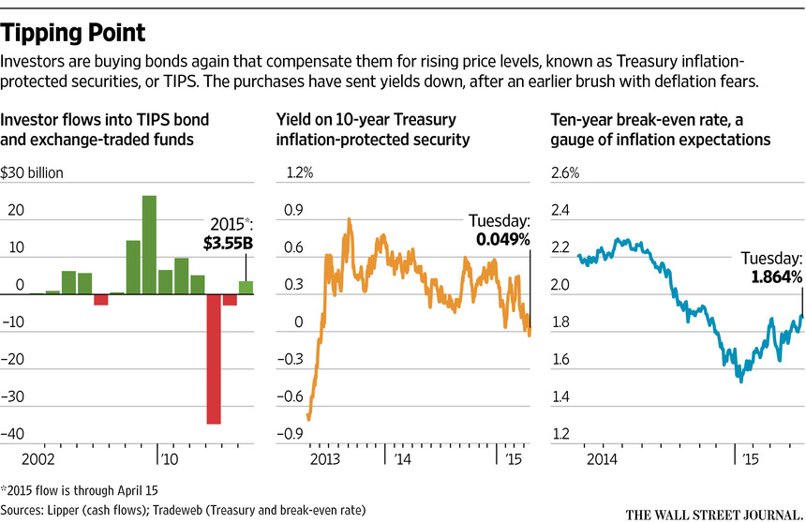
By
Min Zeng

April 21, 2015 7:36 p.m. ET
Investors are piling into U.S. government bonds that protect against inflation at the fastest pace in three years, a sign of diminishing fears over falling consumer prices.
Money managers poured $3.55 billion into U.S. bond mutual funds and exchange-traded funds focusing on Treasury inflation-protected securities, according to fund-tracker Lipper data for 2015 through April 15. That follows two consecutive years of net outflows.
The rush into TIPS suggests that aggressive central-bank stimulus programs, a stabilization in oil prices and a pause in the dollar’s rally have alleviated investors’ worries about deflation, a cycle of declining consumer prices and deferred consumption that some economists say could lead to economic contraction.
“The big picture is that the deflation scare may be behind us,’’ said Gemma Wright-Casparius, senior bond-fund manager at Vanguard Group, which has over $3.26 trillion in global assets under management. “The overall sentiment will be inflation moving higher over the next 12 months.”
If the rate of inflation in the U.S. breaches a certain threshold, holders of TIPS are repaid more than the face value of the bonds when the principal comes due. Rising prices can erode the value of regular bonds.
Advertisement
It was the prospect of steadily falling prices that stoked worries about growth earlier in the year, especially in Europe. In the eurozone, consumer prices have fallen every month since November. To battle the threat of deflation, the European Central Bank, led by President Mario Draghi, unleashed a bigger-than-expected bond-buying program last month. The Bank of Japan 8301 4.79 % expanded its own program in October.
In Europe, ECB President Mario Draghi launched a bond-buying program last month to battle the threat of deflation. Photo: Andrew Harrer/Bloomberg News
In the past month, oil prices have rebounded from six-year lows and the dollar’s appreciation against major currencies has stalled. Both factors have lessened the likelihood that the U.S. could tip into deflation.
The consumer-price index rose a seasonally adjusted 0.2% in March from a month earlier, but fell 0.1% on an annualized basis. Core CPI, which excludes volatile food and energy items, rose to 1.8% on an annualized basis last month. Strategists at Credit Suisse CS -0.08 % forecast core CPI will accelerate to 2% by the end of September 2016.
At the same time, Federal Reserve officials have played down the possibility of an increase in short-term benchmark interest rates this summer. That has bolstered the buying of TIPS because some investors see rising inflation risks down the road the longer the Fed maintains a loose monetary policy.
On Friday, the yield on 10-year TIPS dipped to negative-0.03%, the lowest level since June 2013. Bond yields fall as prices rise.
Yields have risen since then. On Tuesday, the yield on 10-year TIPS was 0.049%, still down from 0.506% at the end of 2014. The regular 10-year Treasury note yielded 1.913%.
Even as concerns about deflation fade, few investors see consumer prices rising rapidly, which limits TIPS’ appeal. The gap between yields on TIPS and regular 10-year Treasurys was 1.864 percentage point Tuesday.
This “break-even rate” is a measure of investors’ inflation expectations and suggests they see inflation running at a 1.864% annualized rate on average in a decade. The break-even rate hit 1.53 percentage point in January, the lowest level since 2010.
TIPS had a big selloff in the second half of 2014 as plunging oil prices galvanized deflation fears. TIPS funds saw net outflows of $2.98 billion in 2014 and $34.77 billion in 2013, according to Lipper. The recent rally in TIPS reflects investors’ struggle to obtain bonds that offer a good mix of income and safety. The $1.07 trillion TIPS market is part of the broader $12.6 trillion U.S. government-debt market.
More than a quarter of government bonds in Europe are now trading with negative yields, according to analysts. The ECB’s bond purchases are forcing money managers to scramble for alternatives outside the eurozone.
“Global demand has elevated valuation in U.S. Treasury markets, including TIPS,’’ said James Ong, a portfolio manager at asset-management firm Invesco Ltd. IVZ 0.82 % , which has $798.3 billion of assets under management. “We recommended buying TIPS.
TIPS overall have handed investors a total return—including price gains and interest payments—of 2.81% for this year through Monday, beating a 1.8% return on regular Treasury debt, according to Barclays BCS 0.39 % PLC.
“We still find TIPS attractive” even after their recent good performance, said Jeremie Banet, a portfolio manager focusing on inflation-bond investments at Pacific Investment Management Co., with $1.59 trillion in assets under management at the end of March. Pimco, one of the largest investors in TIPS, has boosted its exposure this year.
Write to Min Zeng at min.zeng@wsj.com

