July 12, 2011

BY Web Portal & Federal Express
David W. Danner
Executive Director and Secretary
Washington Utilities and Transportation Commission
1300 S. Evergreen Park Drive S.W.
Post Office Box 47250
Olympia, Washington 98504-7250
Subject: In re Bremerton-Kitsap Airporter, Inc. v. Shuttle Express, Inc.
Docket No. TC-110230
Dear Mr. Danner:
Enclosed, for filing, is the original and four copies of the Answer of Shuttle Express, Inc. in Opposition to Motion to Amend Complaint.
If you have any questions, please do not hesitate to contact the undersigned.
Very truly yours,
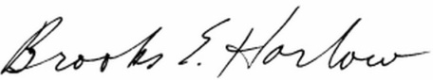
Brooks E. Harlow, P.C.

Enclosures

cc: David W. Wiley, Esq.
