Puget Sound Energy
2016 Annual Renewable Portfolio Standard Report
pursuant to RCW 19.285.070 and WAC 480-109-210

June 1, 2016

Required Contents: Checklist and Table of Contents
RCW 19.285.070 | WAC 480-109-210(2) | Section/Page
The utility's annual load for the prior two years | The utility's annual load for the prior two years | Section 1  Annual Load For Previous Two Years  Page 1
The amount of megawatt-hours needed to meet the annual renewable energy target | The total number of megawatt-hours from eligible renewable resources and/or renewable resource credits the utility needed to meet its annual renewable energy target by January 1 of the target year | Section 2  Renewable Energy Target  Page 1
The amount of megawatt-hours of each type of eligible renewable resource acquired,  the type and amount of renewable energy credits acquired | The amount (in megawatt-hours) of each type of eligible renewable resource used and the amount of renewable energy credits acquired | Section 3  Renewable Energy Acquired To Have Met Renewable Energy Target  Page 1
The percent of its total annual retail revenue requirement invested in the incremental cost of eligible renewable resources and the cost of renewable energy credits | Total incremental cost as a dollar amount and in dollars per megawatt-hour of renewable energy generated by all eligible renewable resources and multiply the dollars per megawatt-hour cost by the number of megawatt-hours needed for target year compliance. | Section 4  Incremental Cost Calculation and Revenue Requirement Ratio  Page 2
 | State whether the utility is relying upon one of the alternative compliance mechanisms provided in WAC 480-109-220 instead of fully meeting its renewable resource target. | Section 5  Alternative Compliance  Page 3
 | Describe the resources that the utility intends to use to meet the renewable resource requirements for the target year. | Section 6  2016 Compliance Plan  Page 3
 | A list of each eligible renewable resource that serves Washington customers, for which a utility owns the certificates, with an installed capacity greater than twenty-five kilowatts. | Section 7  Eligible Resources  Page 4
 | The number of certificates sold, their WREGIS certificate numbers, their source, and the revenues obtained from the sales. | Section 8  Sales  Page 4

Attachment 1: Memo dated December 18, 2015 Regarding Eligible Renewable Resources
Attachment 2: Appendix N from PSE’s Integrated Resource Plan filed with the Commission on November 25, 2015
Attachment 3: Reporting Tool
Attachment 4: REC Sales
Section 1. Annual Load for the Prior Two Years

 | 2014 | 2015
Delivered Load to Retail Customers (MWh) | 21,568,949 | 20,509,764
The source of this data is the Puget Sound Energy, Inc. (“PSE”) 2015 FERC Form 1, p. 301, line 10, columns d and e.

Section 2. 2016 Renewable Energy Target
This section provides the number of megawatt-hours from eligible renewable resources and/or renewable resource credits the utility needed to meet its annual renewable energy target by January 1st of the target year.

After Commission approval, PSE’s Renewable Energy Target for 2016 will be 1,848,542 MWh.
Calculation:
 | 2014 | 2015
Delivered Load to Retail Customers (MWh) | 21, 568,949 | 20, 509,764
Average Load | 20,539,357
9% of Average Load | 1,848,542

Section 3 Renewable Energy Acquired To Meet 2016 Renewable
Energy Target
This section provides the amount (in megawatt-hours) of each type of eligible renewable resource used, and the amount of renewable energy credits acquired to meet the 2016 target.

As demonstrated in Attachment 1, PSE has sufficient eligible renewable resources to meet its 2016 target. PSE plans to meet its 2016 target with a combination of incremental hydro along with other renewable energy certificates from qualifying resources as demonstrated in the following table:

Incremental Hydro Resources | 121,712
Eligible Wind Resources | 2,049,774

Section 4. Incremental Cost Calculation and Revenue Requirement Ratio

This section calculates the total incremental cost as a dollar amount and in dollars per megawatt-hour of renewable energy generated by all eligible renewable resources and multiplies the dollars per megawatt-hour cost by the number of megawatt-hours needed for target year compliance and provides the annual revenue requirement ratio.

Consistent with the requirements outlined in WAC 480-109-210 (2)(a)(i) (A) through (G), the calculation of incremental costs for each eligible resource is performed at the time of acquisition. PSE has not acquired any new resources since 2013 and therefore continues to utilize incremental cost calculations as documented in Attachment 2. The incremental costs along with the annual megawatt hour (MWH) for each eligible resource are as follows:
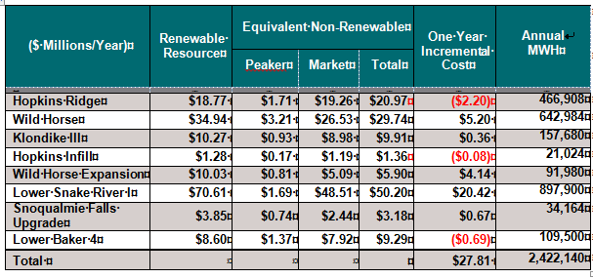
As demonstrated in the table above, the incremental cost of eligible renewable resources is $27.81M resulting in an average cost/MWh of $11.48. For the 2016 target year compliance, the incremental cost is $21.2M ($11.48 * 1,848,542 MWh).
The total annual retail revenue requirement for 2016 is $2040.615 million. The 2016 revenue requirement is based on the revenue requirement determined in PSE's last general rate case (UE-111048) and adjusted for the 2013 and 2014 PCORC (Dockets UE-130617, and UE-141141 respectively) and UE-130137 (Expedited Rate Filing).
The resulting ratio of this investment relative to the utility’s total annual retail revenue requirement is 1% (27.81M / 2040.615M = 1%).

Section 5. Alternative Compliance

This section states whether the utility is relying upon one of the alternative compliance mechanisms provided in WAC 480-109-220 instead of fully meeting its renewable resource target. A utility using an alternative compliance mechanism must use the incremental cost methodology described in this section and include sufficient data, documentation and other information in its report to demonstrate that it qualifies to use that alternative mechanism.

PSE is not utilizing an alternative compliance mechanism provided for in RCW 19.285.040(2)(d) or RCW 19.285.050(1) and WAC 480.109.220 instead of meeting its 2016 Renewable Energy Target.

Section 6. 2016 Compliance Plan
This section describes the resources that PSE intends to use to meet the renewable resource requirements for the target year.

PSE is positioned to meet its 2016 Renewable Energy Target with a combination of qualified hydroelectric upgrades and other renewable energy certificates from qualifying resources. The following table provides a summary of PSE’s expected 2016 compliance. Further details about this information can be found in Attachment 3.

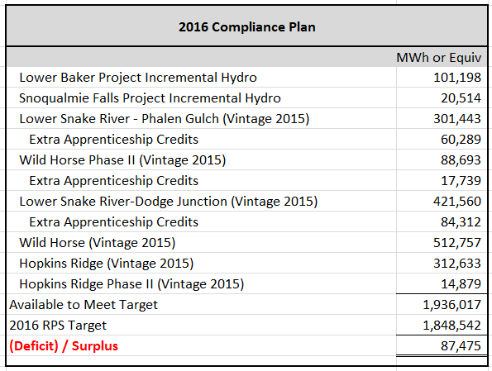

Data for 2016 provided above is an estimate and is subject to change.
Section 7. Eligible Resources

This section provides a list of each eligible renewable resource that serves Washington customers, for which PSE owns the certificates, with an installed capacity greater than twenty-five kilowatts and each resource's WREGIS registration status and use of certificates, whether it be for annual target compliance, a voluntary renewable energy program as provided for in RCW 19.29A.090, or owned by the customer; and eligible resources being included in the report for the first time and documentation of their eligibility.

PSE has acquired sufficient eligible renewable resources in its portfolio to supply at least nine percent of its estimated load for the year 2016, in advance of January 1, 2016. Eligible renewable resources that PSE may elect to use in whole or in part to meet its 2016 target include (but not limited to):

- Hopkins Ridge Wind Project;
- Wild Horse Wind Project;
- Wild Horse Expansion Wind Project (including extra apprenticeship credits);
- Lower Snake River Wind Project (including extra apprenticeship credits);
- Klondike III Wind Project (e.g. the output PSE purchases from Iberdrola);
- Snoqualmie Falls Hydroelectric Efficiency Upgrades;
- Lower Baker River Hydroelectric Efficiency Upgrades;
- Allocation of Hydroelectric Efficiency Upgrades that may be (now or in the future) a part of PSE’s Mid-C Contracts;
- Customer-Generator owned facilities taking service from PSE under PSE electric rate Schedule 91; and
- Any other eligible renewable resources that may become available in 2016 or 2017.

Please also see Attachment 1.

Section 8. Sales
This section reports on the number of certificates sold, their WREGIS certificate numbers, their source, and the revenues obtained from the sales.

The following table summarizes PSE’s REC sales by source and vintage year for 2012 through 2015 vintages. To date, the company has not transferred title to any Vintage 2016 RECs. Any Vintage 2016 REC sales will be reported in the 2017 report.

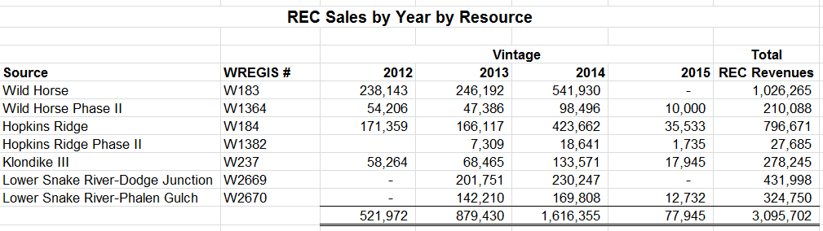
Reflects REC Transfers through 4/30/16

Confidential Attachment 4 provides transaction details including the revenue proceeds associated with those sales.

