BEFORE THE WASHINGTON UTILITIES AND TRANSPORTATION
COMMISSION

)
) DOCKET NO. UT-__________
In the Matter of State )
Certification of Support as ) ANNUAL ETC CERTIFICATION AND
Required by 47 C.F.R. § 54.314 ) REPORT OF UNITED STATES
………………………………….. ) CELLULAR CORPORATION

Pursuant to WAC 480-123-060, et seq., United States Cellular Corporation, 8410 West Bryn Mawr, Suite 700, Chicago, IL 60631 (“USCC”), seeks recertification as an ETC in the State of Washington based on the following:
1. USCC was designated as an eligible telecommunications carrier (“ETC”) by the Washington Utilities and Transportation Commission in Docket No. UT-970345 on December 23, 1997, as supplemented December 30, 1999 and January 27, 2000, May 14, 2008, and September 26, 2013.
2. During the calendar year 2013, USCC provided the services required by 47 U.S.C. § 214(e) consistent with the Commission Orders in Docket No. UT-970345. As certified in Exhibit A, funds USCC receives from the federal high-cost universal service support fund were and will be used only for the provision, maintenance and upgrading of the facilities and services for which the support was intended.
3. Exhibit B attached is intended to satisfy the requirements of WAC 480-123-070 (1)(a) – (b) “Report on Use of federal funds and benefits to customers”. - Confidential
4. Exhibit C attached is intended to satisfy the requirements of WAC 480-123-070 (2)(a) – (f) “Local service outage report”. - Confidential
5. Exhibit D attached is intended to satisfy the requirements of WAC 480-123-070 (3) “Report on failure to provide service”. - Confidential
6. Exhibit E attached is intended to satisfy the requirements of WAC 480-123-070 (4) “Report on complaints per one thousand handsets or lines”. - Confidential
7. Exhibit F certifies USCC is in compliance with the CTIA Consumer Code for Wireless Carriers. This statement is made in response to WAC 480-123-070 (5) “Certification of compliance with applicable service quality standards”.
8. In 2013: (a) each USCC cell site within the State of Washington was engineered to, and did, have at least four hours of back up battery power; (b) each USCC microwave hub within the State of Washington had a back up generator; and (c) each USCC switch within the State of Washington had at least five hours of backup battery power and a backup generator. This statement and the certification of compliance in Exhibit G are made in response to WAC 480-123-070 (6) “Certification of ability to function in emergency situations”.
9. During the calendar year 2013, USCC advertised the availability of supported services and the charges for them as required by 47 U.S.C. § 214(e), and the Commission Orders in Docket No. UT-970345. Outreach activities included newspaper advertising, informational postings at www.uscellular.com, advertising materials located in retail locations and the ability for potential Native American Lifeline customers in the Yakima, Washington area to sign up for service at select retail locations. Exhibit H certifies that USCC publicized the availability of supported services, including Lifeline Services. Details of outreach efforts and a sample of advertising are attached as Exhibits I and J. Attached as Exhibit K is a schedule of Lifeline ad insertion - Confidential. This paragraph is in response to WAC 480-123-070 (7) “Advertising certification, including advertisement on Indian reservations”.
10. Exhibit L, attached, details USCC’s intended investment and expenditures within its ETC boundaries in the State of Washington for the time period October 1, 2014 through September 30, 2015. This information is provided as a response to WAC 480-123-080. - Confidential
11. Pursuant to WAC 480-123-080(3), USCC filed a coverage map in 2013 and is next due to file in its 2016 annual report.
Respectfully submitted this 30th day of July, 2014.
Lukas, Nace, Gutierrez & Sachs, LLP
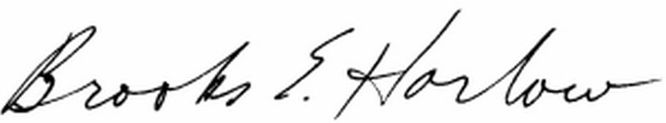
Brooks E. Harlow,
WSBA No. 11843

Attorneys for United States Cellular Corporation

