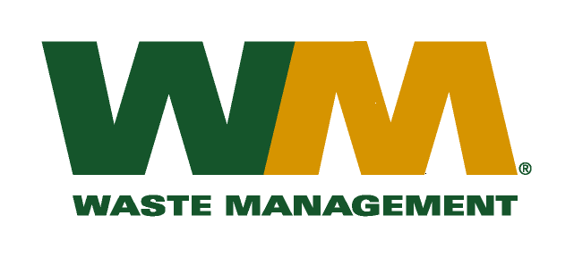
August 20, 2010
Washington Utilities and Transportation Commission
Chandler Plaza Building
1300 S. Evergreen Park Drive SW
P.O. Box 47250
Olympia, WA. 98504-7250

Dear Sirs:
Subject: Brem-Air Disposal, a division of Waste Management of Washington, Inc. (G-237); Tariff # 20; Docket TG-101248
Please find enclosed substitute tariff pages 2, 19, 21, 22, 23 and 24 to the above-referenced tariff. These pages are being re-submitted to reflect a revised effective date of October 1, 2010. The primary purpose of the revisions to these tariff pages is to reflect the adoption of Kitsap County Ordinance 453-2010 that expands the curbside recycling service to the entire County and adds compostable organics to the yard waste collection service.

In addition, enclosed is a draft of the customer notice that will be mailed to the affected customers on September 1, 2010 to inform them of this change to their service.

Please do not re-docket.
If you have any questions or need additional information, please contact me at (425) 814-7840.
Respectfully,

Michael A. Weinstein
Senior Pricing Manager, Pacific Northwest Market Area

cc: Alan York, District Manager. Waste Management – Brem-Air
Pat Campbell, Kitsap County Department of Public Works

