September 28, 2012

David W. Danner, Executive Director and Secretary
Washington Utilities and Transportation Commission
1300 S. Evergreen Park Dr. SW
P. O. Box 47250
Olympia, Washington 98504-7250

RE: Washington Utilities and Transportation Commission v. Pulse Telecom, LLC
Commission Staff’s Response to Application for Mitigation of Penalties
Docket TV-121002

Dear Mr. Danner:

On August 1, 2012, the Washington Utilities and Transportation Commission issued a $2,100 Penalty Assessment in Docket TV-121002 against Pulse Telecom, LLC, for 21 violations of Washington Administrative Code (WAC) 480-15-480, which requires permitted telecommunications companies to furnish annual reports to the commission no later than May 1 each year.

On August 10, 2012, Pulse Telecom, LLC wrote the commission requesting mitigation of penalties (Mitigation Request). In its Mitigation Request, Pulse Telecom, LLC does not dispute that the violation occurred. The company states, “We were in transition between compliance companies and our previous company. Thompson Reuters, dropped the ball on us. We no longer do business with them.”

It is the company’s responsibility to ensure that the regulatory fee and the annual report are filed by the May 1 deadline. On February 29, 2012, Annual Report forms and Regulatory Fee packets were mailed to all regulated telecommunications companies. In addition to other information, the cover letter informed the regulated company it must complete the annual report form, pay any regulatory fees and return the material by May 1, 2012 to avoid enforcement action. On May 14, 2012, the commission mailed a letter to those companies that had not yet filed an annual report notifying them that, to date, they had incurred a penalty of $800. The letter went on to explain that companies who filed their annual reports no later than May 25, 2012, would receive mitigated penalties of $25 per day, with an additional $25 per day for each instance in the previous five years that the company received a penalty for filing a late report.

Pulse Telecom, LLC filed its annual report on June 4, 2012. Pulse Telecom, LLC did not file its annual report by May 31, 2012, which is 21 business days past the deadline of May 1, 2012. The penalty is $100 per day for a total of $2,100. Pulse Telecom, LLC has never received a penalty for filing a delinquent annual report in the past. Pulse Telecom LLC, has been authorized to provide telecommunications service in the state of Washington since 2007.

Staff supports mitigating the assessed penalty from $2,100 to $1,050, which represents a 50 percent reduction because this is Pulse Telecom, LLC’s first late filing.

If you have questions regarding this recommendation, please contact Mathew Perkinson, Compliance Investigator, at (360) 664-1105 or at mperkinson@utc.wa.gov.

Sincerely,

Sharon Wallace, Assistant Director
Consumer Protection and Communications

Attachment A

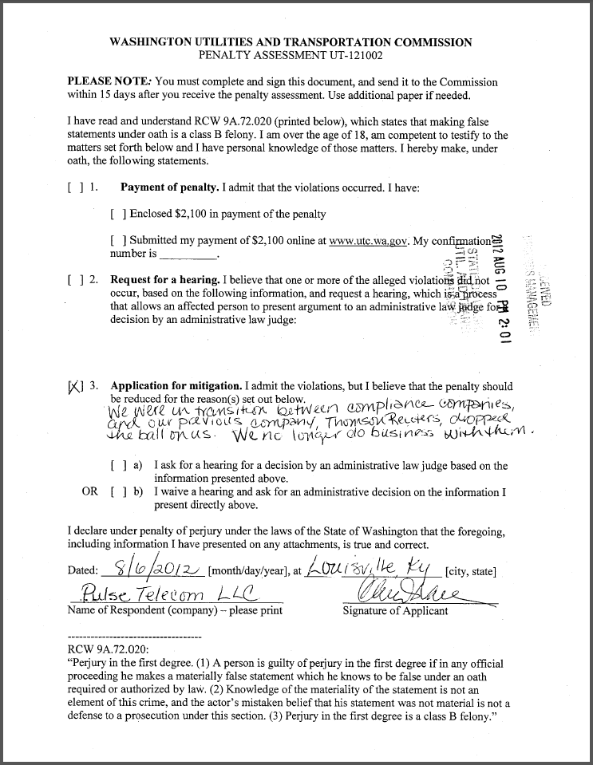
Attachment B

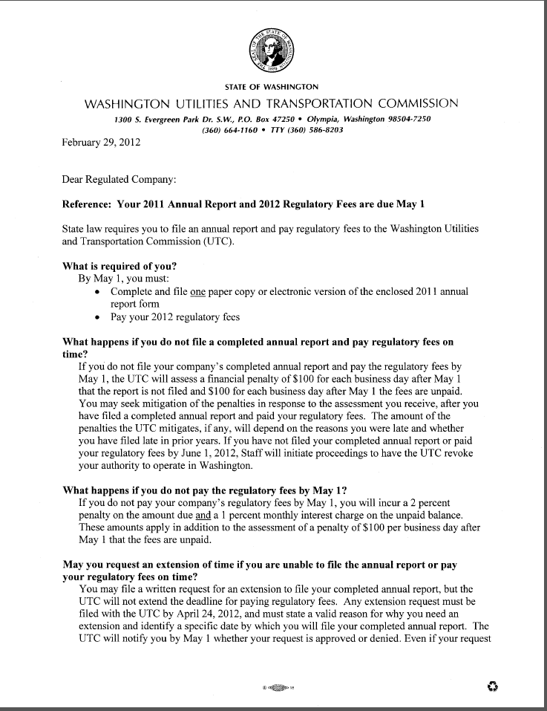
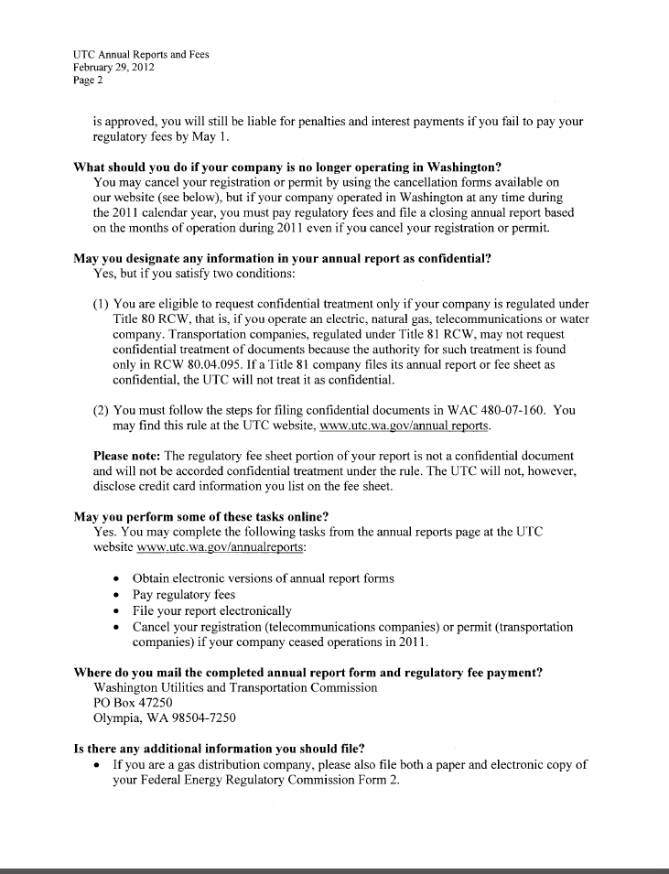
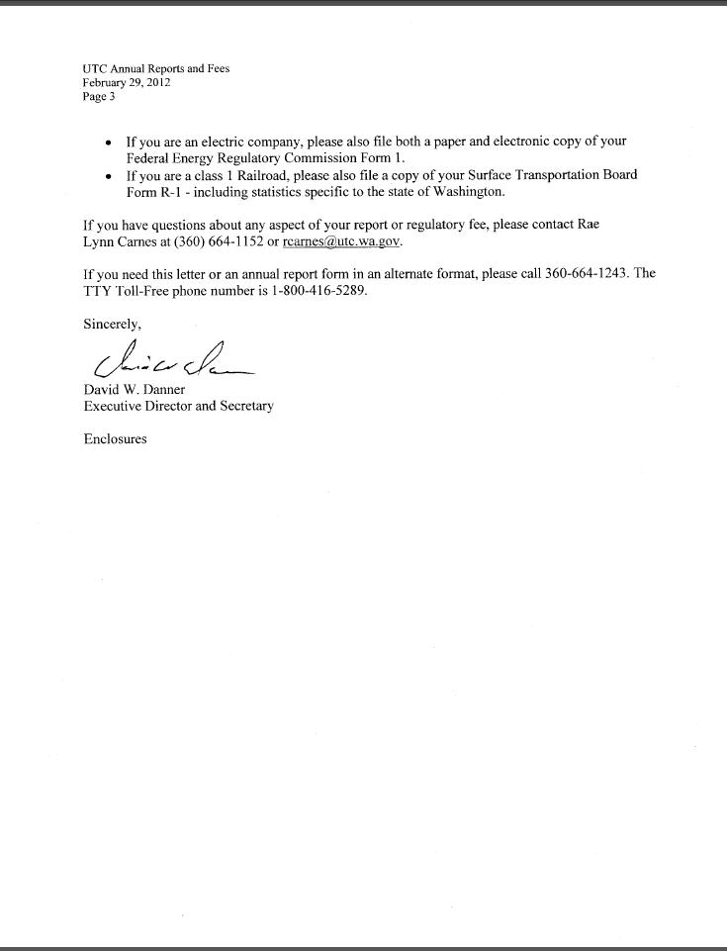
Attachment C

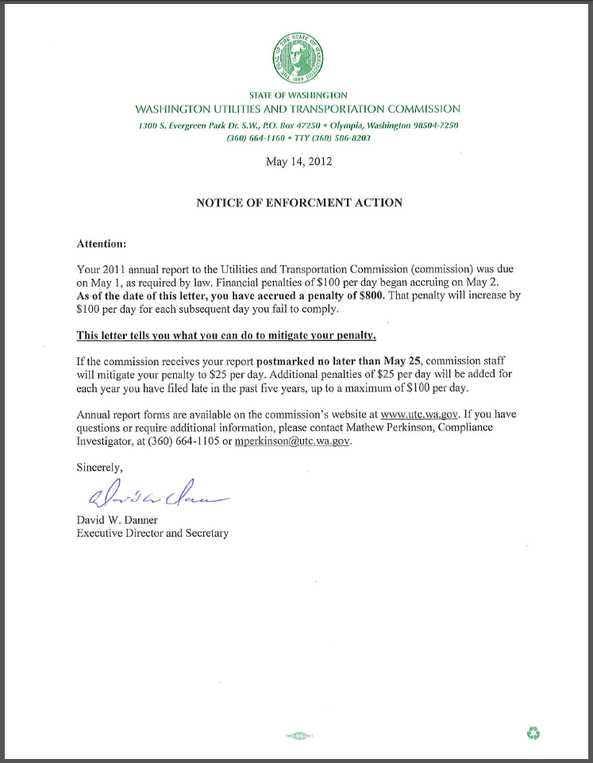

See attachment A for a copy of Pulse Telecom, LLC’s Mitigation Request.
See attachment B for a copy of the letter sent to all regulated companies on February 29, 2012.
See attachment C for a copy of the enforcement letter sent to the company on May 14, 2012.

