September 21, 2018

Mr. Mark Johnson
Executive Director and Secretary
Washington Utilities and Transportation Commission
P.O. Box 47250
1300 S. Evergreen Park Drive S.W.
Olympia, WA 98504-7250.

Re: Comments of Utility Conservation Services, LLC (UCONS)
Docket U-161024 Competitive Resource Acquisition by RFP, WAC 480-107

Dear Mr. Johnson:

Utility Conservation Services LLC (UCONS) is a national leader in the development and implementation of residential conservation programs, headquartered in Kirkland, Washington. UCONS has done or is doing business in Washington, California, Oregon, Idaho, Texas, Utah, and New York. We provide services under contract to a large number of utilities, both investor-owned and publicly-owned, as well as to major property management firms. Since 1992, UCONS has delivered direct-install energy efficiency programs to over 330,000 multifamily tenants and over 120,000 manufactured home utility customers. The aggregate energy savings from these efforts total nearly 500,000,000 kWh and 10,000,000 therms. In recent years, we have focused our work on hard-to-reach (HTR) markets.
UCONS has reviewed the draft Redline draft revisions provided by the UTC (WAC 480-107) and greatly appreciates the many areas the Commission has recognized the need to enhance the current process for acquiring resources through competitive bidding. We have addressed some additional areas in which we believe the mutual goals of the Council 7th Plan (regarding underserved ratepayers) can be addressed while also achieving the goals of I-937—to acquire all cost effective conservation resources.
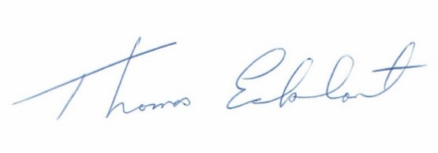
Sincerely,

Tom Eckhart, PE
CEO, UCONS, LLC
10612 NE 46th Street
Kirkland, WA 98033
(425) 576-5409 (office)
(425) 827-2489 (fax)
tom@UCONS.com
www.ucons.com
Enclosure

