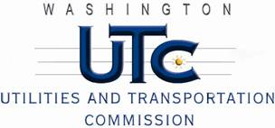

Memorandum
December 6, 2017

To: File

From: Betty Young, Transportation Planning Specialist, Rail Safety

Subject: TR-170938 – Central Washington Railroad
Completion of Grade Crossing Protective Fund (GCPF) Project
Sunnyside Avenue – USDOT 098571S

On October 6, 2017, the Washington Utilities and Transportation Commission (Commission) awarded a GCPF grant totaling $20,000 to the Central Washington Railroad (CWR) for a project involving upgrades to train detection at the Sunnyside Avenue crossing in Granger, identified as USDOT 098571S. The actual cost of the project was $20,815.58. CWR paid the $815.58 overage.

On November 22, 2017, CWR submitted a request for reimbursement. Rail Safety staff inspected the crossing on December 5, 2017, and confirmed that the upgrades were completed according to the specifications outlined in the order approving the grant.

Please close this docket.

