July 2, 2014

Steven V. King, Executive Director and Secretary
Utilities and Transportation Commission
1300 S. Evergreen Park Dr. SW
P.O. Box 47250
Olympia, WA 98504-7250

RE: Washington Utilities and Transportation Commission v. Record Hauling Service, Inc.

Commission Staff’s Response to Application for Mitigation of Penalties TV-140987

Dear Mr. King:

On June 6, 2014, the Utilities and Transportation Commission issued a $1,000 Penalty Assessment in Docket TV-140987 against Record Hauling Service, Inc. for 10 violations of Washington Administrative Code (WAC) 480-15-480, which requires household goods carrier companies to furnish annual reports to the commission no later than May 1 each year.¹

On June 18, 2014, Record Hauling Service, Inc. wrote the commission requesting mitigation of penalties (Mitigation Request).² In its Mitigation Request, Record Hauling Service, Inc. does not dispute that the violation occurred. The company states, “I did not receive the annual report form at all, and as a result of not receiving the form I just simply forgot to do the annual report and mail it in.”

It is the company’s responsibility to ensure that the regulatory fee is paid and the annual report is filed by the May 1 deadline. On February 28, 2014, Annual Report packets were mailed to all regulated household goods companies. The instructions for annual report completion page of the annual report informed the regulated company that it must complete the annual report form, pay the regulatory fees, and return the materials by May 1, 2014, to avoid enforcement action.

On June 13, 2014, Record Hauling Service, Inc. filed the 2013 annual report with no regulatory fees due. The company has been active since September 1, 2006. The company was delinquent

UTC Annual Reports
July 2, 2014
Page 2

in filing the 2012 annual report and received an automatic mitigation to $25 per day. Staff does not support the company’s request for mitigation due to prior violation of WAC 480-15-480.

If you have any questions regarding this recommendation, please contact Amy Andrews, Regulatory Analyst, at (360) 664-1157, or aandrews@utc.wa.gov.

Sincerely,

Sondra Walsh, Director
Administrative Services

ATTACHMENT A
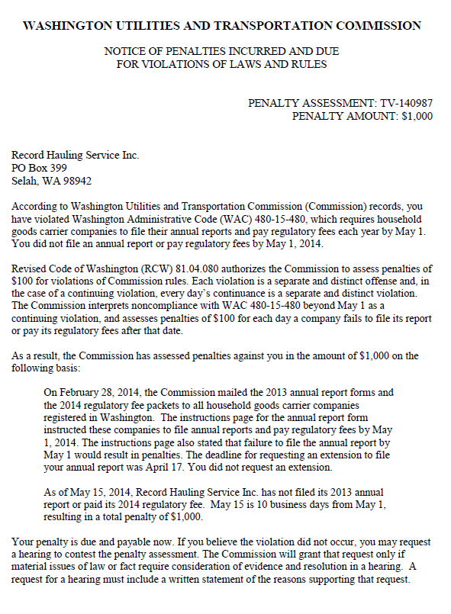

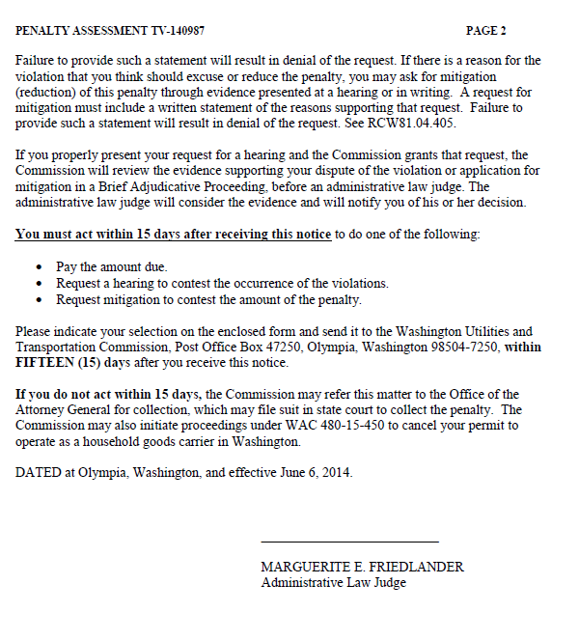

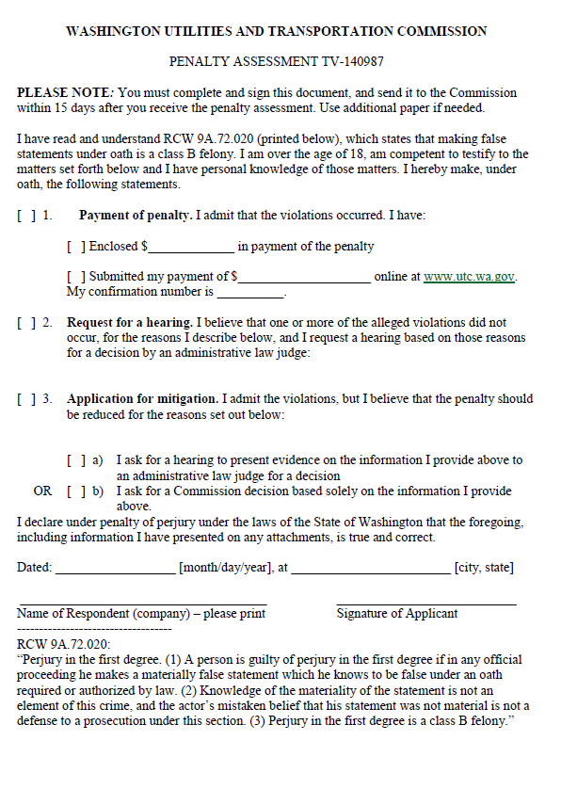

ATTACHMENT B
