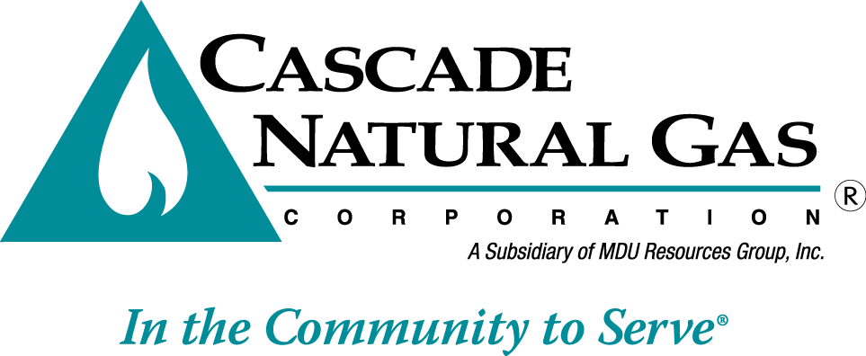
8113 W. GRANDRIDGE BLVD., KENNEWICK, WASHINGTON 99336-7166
TELEPHONE 509-734-4500 FACSIMILE 509-737-9803
www.cngc.com

October 6, 2016 CNG/W16-10-01

Mr. Steven V. King
Executive Director and Secretary
Washington Utilities & Transportation Commission
P.O. Box 47250
Olympia, WA 98504-7250

Re: Schedule 25, Decoupling Mechanism

Cascade Natural Gas Corporation (Cascade or the Company) files the following revision to its Tariff, WN U-3, stated to become effective with service on and after November 11, 2016:

Second Revision Sheet No. 25

The purpose of filing is to make a revenue neutral adjustment to the monthly authorized margin per customer established for Schedule 503, residential and Schedule 504, commercial customers in the Company’s Rule 21, Decoupling Mechanism. The changes made herein correct the expected volumes per month. These revisions do not impact the overall authorized revenue per year; rather the allowed revenue is redistributed over the twelve month period in alignment with corrected forecasted monthly volumes.

The attached work paper compares the authorized margin per rate schedule as approved for the decoupling mechanism in the Company’s last general rate case, UG-152286, with a corrected table where the revised volumes and adjusted authorized revenue per month is highlighted in yellow.

If you have any questions regarding this filing, please contact me at (509)734-4593

Sincerely,

Michael Parvinen
Director, Regulatory Affairs

Attachment

