September 21, 2012

David Danner
Executive Director and Executive Secretary
Washington Utilities and Transportation Commission
1300 S. Evergreen Park Dr. S.W.
PO Box 47250
Olympia, WA 98504-7250

RE: UG-121119, Avista Corporation Schedule 190 Revisions

Dear Mr. Danner,

The following comments are provided by the NW Energy Coalition (“Coalition”) in response to Avista’s Schedule 190 Revisions filed on June 29, 2012.

The Coalition appreciates Avista’s efforts to ascertain whether or not modifications to its avoided cost calculations would produce a portfolio that passes the Total Resource Cost (TRC) test. While we understand that low natural gas prices are negatively affecting utility avoided costs, we believe that an immediate phase out of natural gas conservation programs is shortsighted and represents an overly extreme course of action. Energy efficiency remains an important hedging mechanism against gas price volatility and a good investment for Avista and its customers. Avista has a positive track record of devising ways to continue support for low-income programs and similar creativity needs to be applied to their gas conservation portfolio.

Because these price pressures are being felt by all the investor-owned utilities and the Commission is discussing these very issues in its open Docket No. UG 121207, the Coalition recommends refraining from issuing a decision on this matter until the investigation into natural gas conservation programs concludes. Avista needs the full benefit of the Commission’s guidance first.

DISCUSSION

While natural gas conservation programs may not prove to be cost-effective over the short term given current market conditions, it is unadvisable to assume that they will remain so over the long term. Natural gas prices cannot remain as low as they are because they do not cover the current average cost of exploration and production. The lower than normal prices are attributable to an unusually warm winter that reduced demand and maximized storage capacity at the same time that lease terms created market pressure to produce more supply. Production has already declined in response to these conditions and industry analysts project that gas prices will rise to somewhere between $5-7 MMBtu over the next 3 to 5 years.

Cutting conservation programs prematurely would force utilities like Avista to incur extra administrative costs associated with ramping down and then restarting programs while placing additional strain on its trade ally network. It would also generate confusion for customers as programs are withdrawn and the message to conserve and increase efficiency goes away. These actions would also undercut one of the most beneficial aspects of conservation programs, which is providing customers with a hedge against gas price volatility. Natural gas prices have been volatile and are likely to remain so despite the advent of hydraulic fracturing. This is because natural gas is still subject to a number of vulnerabilities, including interruptions from accidents, weather changes, pipeline disruptions, storage constraints and pending environmental regulations. A complex array of price dichotomies such as access to global markets and alternative fuel prices further add to the confusion. As the graph below demonstrates, forecasting prices is often trickier than it looks:

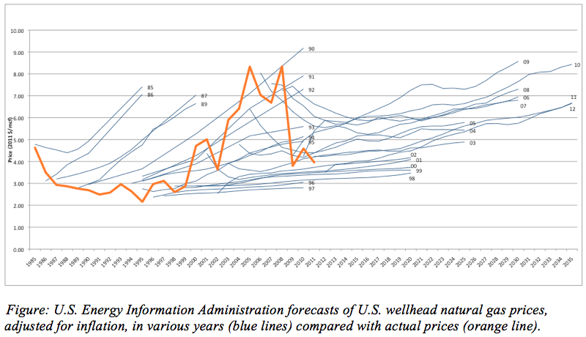
Rocky Mountain Institute, RMI Outlet, September 6, 2012

In contrast, energy efficiency programs are a lot more stable. At least 95% of the time, conservation ends up being a better deal for customers and the utility on a levelized life-cycle basis. This concept was recently illustrated by the Northwest Power and Conservation Council in a graph contrasting the average cost of utility acquired savings with wholesale market electricity prices. While natural gas is not depicted explicitly below, it expresses a similar pattern due to its influence on electric prices:

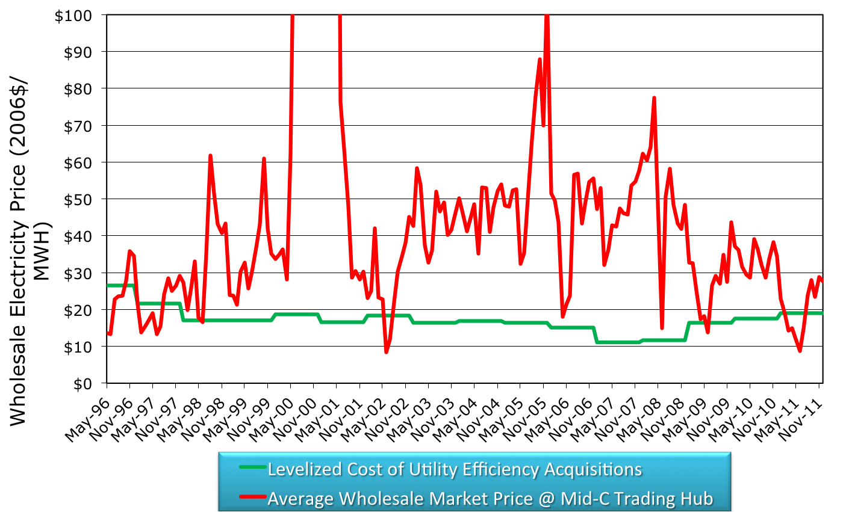
NW Power and Conservation Council, Progress Towards the 6th Plan's Conservation Goals, 2012

This stability confers critical risk hedging benefits for both utilities and their customers. Conservation programs also incur less financial risk than supply-side resources because they typically do not require utilities to raise capital. One possible way to better reflect these benefits within the guise of the TRC would be to lower the discount rate being applied. The Coalition supports the use of a low-risk, long-term customer/societal cost discount rate when evaluating the costs of conservation.

Avista might also wish to consider applying to its gas program TRC the 10% conservation adder that is recommended by the Northwest Power and Conservation Council. While the Coalition appreciates Avista’s consideration of carbon cost adders, distribution capacity cost values, and different applications for net-to-gross-ratios and realization rates, there are still other factors worth investigating. In addition to the issues mentioned above, a robust cost-benefit analysis should also address the following components:

Utility costs and benefits
- Peak demand reduction
- Reduced customer arrearages
- Reduced bad-debt write-offs
- Improved customer service

Customer benefits
- Lower bills
- Co-benefits in reduced water, fuel oil, etc. usage
- Increased productivity
- Increased safety and comfort
- Reduced rate volatility resulting from Purchase Gas Agreement adjustments

In its cover letter for this filing, Avista mentioned that it intends to propose an increase in fuel switching incentives in a future filing since lower natural gas avoided costs make the direct use of natural gas more cost effective. The Coalition agrees that fuel switching to high efficiency gas equipment is always an important program to offer as it reduces electric loads, provides efficient direct use of a fuel and supports investment in high efficiency equipment. That said, it is not appropriate to push for increased use of natural gas without energy efficiency programs to ensure that customers have opportunities to lower their bills over the long-term.

CONCLUSION

Despite recent low gas prices, energy savings remains a valuable long-term resource. It would be counterproductive to prematurely ramp down all gas conservation programs based on short-term prices that are likely unsustainable. In recognition of these conditions, both Oregon and British Columbia have taken steps to ensure the viability of their natural gas programs. The Energy Trust of Oregon has proposed a 2-year waiver from the TRC and British Columbia has instituted a Modified TRC. Because the UTC has opened a separate docket to investigate its own approach to these issues, the Coalition feels that the Commission should refrain from approving Avista’s Schedule 190 revisions until the investigation into natural gas programs concludes.

Thank you for the opportunity to file these comments. The Coalition will attend the Open Meeting on September 27 and will be available for questions. Any questions regarding this submission should be directed to Lynne Dial, 206-621-0094 or lynne@nwenergy.org.

Sincerely,

Lynne Dial
Policy Associate

Businessweek, Is Natural Gas too Cheap to Drill?, April 17, 2012
American Council for an Energy-Efficient Economy, Saving Money and Reducing Risk: How Energy Efficiency Enhances the Benefits of the Natural Gas Boom, September 13, 2012
American Council for an Energy-Efficient Economy, Saving Money and Reducing Risk: How Energy Efficiency Enhances the Benefits of the Natural Gas Boom, September 13, 2012
Center for Climate and Energy Solutions, The Looming Natural Gas Transition in the United States, May 2012
On August 2, 2012, the Energy Trust of Oregon (ETO) filed a request for exceptions to cost effectiveness standards for natural gas weatherization programs (UM 1622). ETO requested a two-year suspension of its 1.0 benefit/cost ratio requirement for several natural gas measures, citing “lower-than expected savings from evaluations, higher than expected project costs for several measures, and lower avoided cost forecasts due to changes in market fundamentals.” In doing so, the ETO aims to maintain program stability while working on solutions to manage these challenges.
“Adventures in Tweaking the TRC: Experiences from British Columbia”, 2012 ACEEE Summer Study on Energy Efficiency in Buildings.

