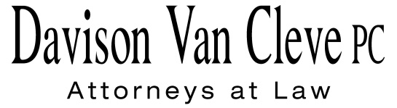
TEL (503) 241-7242 ● FAX (503) 241-8160 ● mail@dvclaw.com
Suite 400
333 SW Taylor
Portland, OR 97204

August 16, 2013

Via Electronic Mail

Mr. Steven V. King
Acting Executive Director and Commission Secretary
Washington Utilities & Transportation Commission
1300 S. Evergreen Pk. Dr. S.W.
P. O. Box 47250
Olympia, WA 98504-7250

Re: PacifiCorp’s 2013 Integrated Resource Plan
Docket No. UE-120416

Dear Mr. King:

Attached for filing in the above-referenced docket, please find the Comments of Boise White Paper, L.L.C.

Thank you for your assistance, and please don’t hesitate to call our office with any questions.

Sincerely,

/s/ Jesse Gorsuch
Jesse Gorsuch
Enclosures

