July 28th, 2017

Mr. Steven V. King, Executive Secretary
Washington Utilities and Transportation Commission
1300 South Evergreen Park Drive SW
Olympia, WA 98504-7250

Re: Petition to receive support from the Universal Service Communications Program

Dear Mr. King:

Pursuant to WAC 480-123-110, Please find enclosed a petition for The Toledo Telephone Company, Inc. to receive funds under the Universal Service Communications Program.

Sincerely,

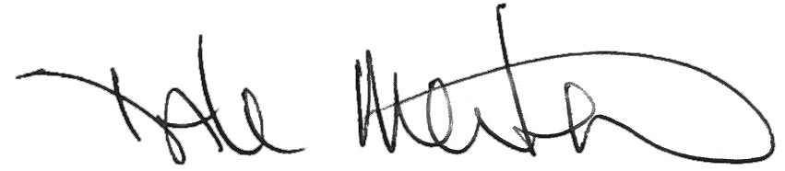

Dale Merten
Chief Operating Officer

Encl/

