January 30, 2017

Mr. Steven King
Executive Director and Secretary
Washington Utilities and Transportation Commission
1300 South Evergreen Park Drive SW
Olympia WA 98504-7250

RE: Tariff Revision - Ellensburg Telephone Company d/b/a FairPoint Communications (WN U-4)

Dear Mr. King:

Pursuant to the procedures established for tariff filing by WAC 480-80-134, please find enclosed the following replacement tariff pages. The requested effective date for these pages is March 1, 2017.

- First Revision Sheet No. 131
- First Revision Sheet No. 132

The purpose of this filing is to request the elimination of 1) busy line interrupt and 2) busy line verification services from the Company's tariff. These services have been rarely used by customers in recent history. Therefore, the Company is requesting to discontinue them from our service offerings as of March 1, 2017.

Customers have been provided with notice of this proposed change and a copy of the customer notice accompanies this filing.

Please contact me at the number below or Beth Westman at 207.535.4249 or bwestman@fairpoint.com with any questions or concerns regarding this filing.

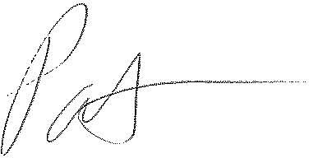
Patrick L. Morse
Senior VP Governmental Affairs
FairPoint Communications
P: 620-227-4409
F: 620-227-8576

