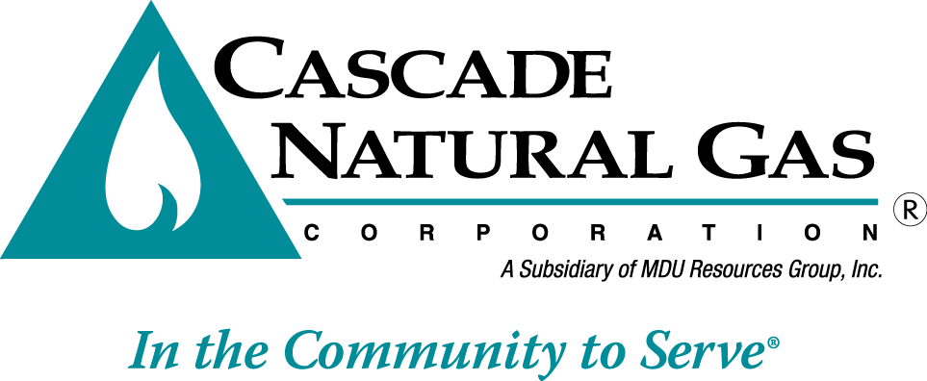
8113 W. GRANDRIDGE BLVD., KENNEWICK, WASHINGTON 99336-7166
TELEPHONE 509-734-4500 FACSIMILE 509-737-9803
www.cngc.com

January 13, 2017

Records Center
Washington Utilities and Transportation Commission
1300 S. Evergreen Park Drive SW
Olympia, WA 98504

Re: Washington Energy Assistance Fund (WEAF) Program 2015-2016 Annual Report
UG-152286 Compliance Filing

In compliance with the terms established in the Company’s last general rate case (UG-152286) as well as Cascade Natural Gas Corporation’s (Cascade or the Company) Schedule 303, Cascade herewith files its Washington Energy Assistance Fund (WEAF) Program 2015-2016 Annual Report. The programmatic changes adopted in UG-152286 became effective at the beginning of the 2016-2017 program year--- not the 2015-2016 program year, which is the timeframe of the attached report.

If you have any questions regarding this filing, please contact Jennifer Gross at 509-734-4635.

Sincerely,

Michael Parvinen
Director, Regulatory Affairs

Attachment

