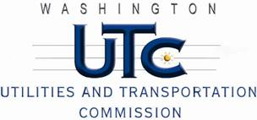

Memorandum
May 20, 2011

To: TR-110540 - File

From: Kathy Hunter, Deputy Assistant Director Transportation Safety

Subject: TR-110540 Eastern Washington Gateway Railroad
Grade Crossing Protective Fund (GCPF) Project at the Intersection of
State Route 902 (SR-902) and Eastern Washington Railroad’s Tracks in the City of Medical, Washington

On April 8, 2011, the Washington Utilities and Transportation Commission (Commission) awarded a GCPF grant totaling $5,574.14 to install flashing LED lights and power off indicator and replace the cross-bucks at the SR-902 crossing in the City of Medical Lake. The USDOT number assigned to this crossing is 066331W.

On May 2, 2011, the applicant, Eastern Washington Railroad submitted a request for reimbursement pursuant to Commission order. On April 26, 2011, Commission staff conducted a site visit and verified that the project is completed according to the specifications outlined in the order approving the grant.

Please close this docket.

