CenturyLink
1600 7th Avenue, Room 1506
Seattle, Washington 98191
(206) 345-6224
(425) 301-8411 (cell)
Email: phil.grate@centurylink.com

Philip E. Grate
State Regulatory Affairs Director
Public Policy

April 30, 2018
Via Web Portal
Mark L. Johnson
Executive Director and Secretary
1300 S. Evergreen Park Dr. S.W.
P.O. Box 47250
Olympia, Washington 98504-7250

Re: Docket No. UT-170042
Compliance Filing; Condition 5.1

Dear Mr. Johnson:

Attached for filing is a copy of the confidential and redacted versions of the analysis of CenturyLink’s maintenance expenses required by Condition 5.1 of the Settlement Agreement between CenturyLink, Commission Staff and Public Counsel. The confidential information is designated pursuant to the protective order in this docket.

Please do not hesitate to contact me at should you have any questions regarding this filing.

Sincerely,
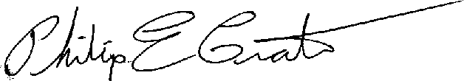

Philip E. Grate

Enclosure

