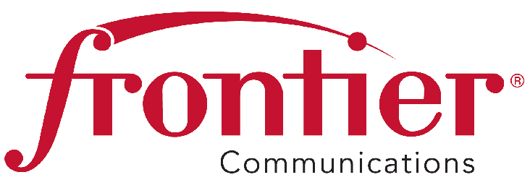
Frontier Communications Northwest Inc.
1800 – 41st Street
Suite N-100
Everett, WA 98203
Fax: 425-261-5262

May 5, 2014 VIA ELECTRONIC FILING

Mr. Steven V. King
Secretary and Executive Director

Washington Utilities and Transportation Commission

1300 S. Evergreen Park Drive SW

P. O. Box 47250

Olympia, WA 98504-7250

Re: Frontier Communications Northwest Inc. Comments on Proposed Rulemaking in
Docket Nos. UT-131239 and 971140

Dear Mr. King:

Enclosed for filing are comments from Frontier Communications Northwest Inc. regarding the Rulemaking related to the new State Universal Program and more specifically, the proposed termination of the traditional Universal Service Fund access rate element. Please let me know if you have any questions.

Sincerely,

Carl Gipson
Manager, Government and External Affairs
Frontier Communications NW
1800 41st Street
Everett, WA 98201
425-261-6380
Carl.Gipson@ftr.com

Attachments

