CenturyLink
931 14th Street, Suite 1230
Denver, Colorado 80202
303-992-5823

July 18, 2018

Steven King
Executive Director and Secretary
1300 S. Evergreen Park Dr. S.W.
P.O. Box 47250
Olympia, Washington 98504-7250

Re: Advice No. WA 18-03A for United Telephone Company of the Northwest Withdrawal

Dear Mr. King:

On July 12, United Telephone of the Northwest d/b/a CenturyLink filed two pages in docket UT 180452 that were inadvertently left out of CenturyLink’s May 18, 2018 filing to implement the seventh step of Terminating Switched End Office Access Service reductions mandated in the Federal Communications Commission's November 18, 2011 Report and Order and Further Notice of Proposed Rulemaking in WC Docket Nos. 10-90, etc. (FCC 11-161) (Transformation Order). The Terminating – Tandem End Office rates on these two pages reflect the mandated rate reduction to $0.000000.

CenturyLink now respectfully requests that this filing be withdrawn do to procedural issues and will be refiled later today.
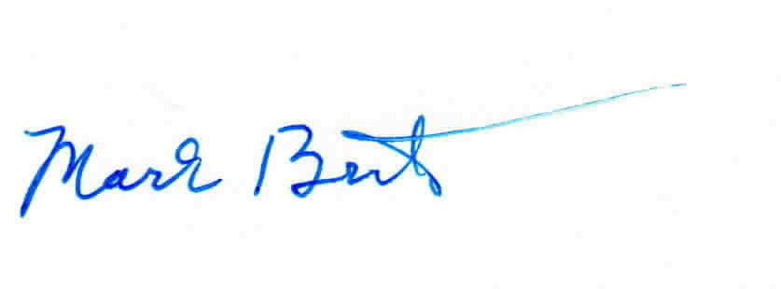
Sincerely,

Mark Brinton
Manager Regulatory Operations
Office: (303) 992-5832
e-mail: Mark.Brinton@CenturyLink.com

Attachment A

