July 28, 2014

Steven V. King, Executive Director and Secretary
Utilities and Transportation Commission
1300 S. Evergreen Park Dr. SW
P.O. Box 47250
Olympia, WA 98504-7250

RE: Washington Utilities and Transportation Commission v. TeleDias Communications, Inc.

Commission Staff’s Response to Application for Mitigation of Penalties UT-140919

Dear Mr. King:

On June 2, 2014, the Utilities and Transportation Commission issued a $1,000 Penalty Assessment in Docket UT-140919 against TeleDias Communications, Inc. for 10 violations of Washington Administrative Code (WAC) 480-120-382, which requires telecommunications companies to furnish annual reports to the commission no later than May 1 each year.¹

On July 8, 2014, TeleDias Communications, Inc. wrote the commission requesting mitigation of penalties (Mitigation Request).² In its Mitigation Request, TeleDias Communications, Inc. does not dispute that the violation occurred. The company states, “TeleDias filed two Annual Reports online. The first report was filed on 4/25/14. However, TeleDias was contacted and informed that the online report appeared blank. TeleDias then re-filed the Annual Report on 4/28/14; however, in the second filing, Part C. #2, regarding access to E-911 lines was not completed. TeleDias offers only resold long distance. Therefore, the answer to question Part C. #2 is Not Applicable. Another completed copy of the 2013 Annual Report is attached.”

It is the company’s responsibility to ensure that the regulatory fee is paid and the annual report is filed by the May 1 deadline. On February 28, 2014, Annual Report packets were mailed to all regulated telecommunication companies. The instructions for annual report completion page of
the annual report informed the regulated company that it must complete the annual report form, pay the regulatory fees, and return the materials by May 1, 2014, to avoid enforcement action.

UTC Annual Reports
July 28, 2014
Page 2

On April 25, 2014, TeleDias Communications, Inc. filed a blank annual report via online filing number 432. On April 28, 2014, TeleDias Communications, Inc. filed an incomplete annual report via online filing number 443. Staff contacted the company following the second filing via email on April 28, 2014 notifying the company of the required information.³ On July 3, 2014, TeleDias responded via telephone and verbally reported no E-911 access lines due to long-distance service only. The company has been active since October 31, 2002. No previous violations of WAC 480-120-382 are on commission record. Staff supports the company’s request for mitigation as this is the first delinquent filing and the company’s response which confirms the missing information is not applicable to the company operation and their understanding this information must still be reported as such. Staff recommends a reduced total penalty of $200.

If you have any questions regarding this recommendation, please contact Amy Andrews, Regulatory Analyst, at (360) 664-1157, or aandrews@utc.wa.gov.

Sincerely,

Sondra Walsh, Director
Administrative Services

ATTACHMENT A
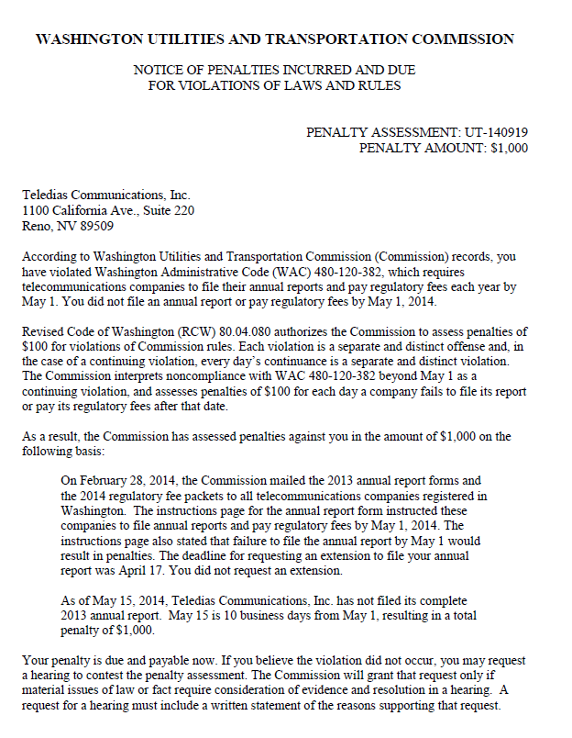

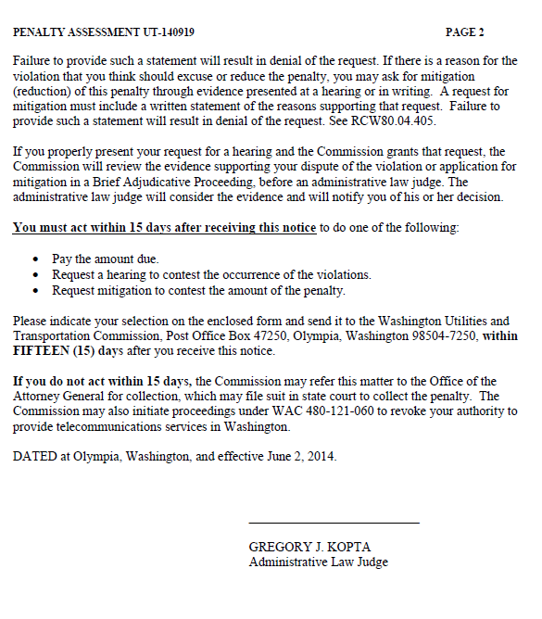

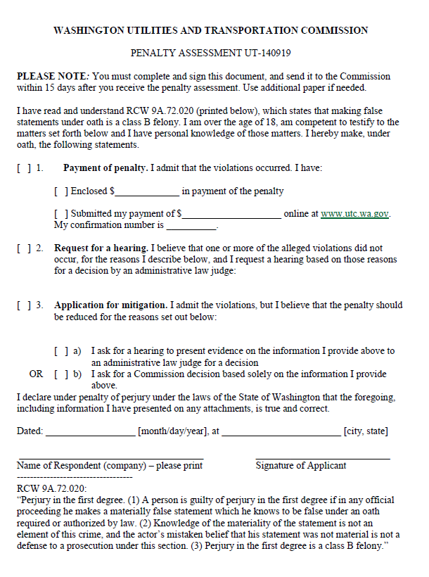

ATTACHMENT B
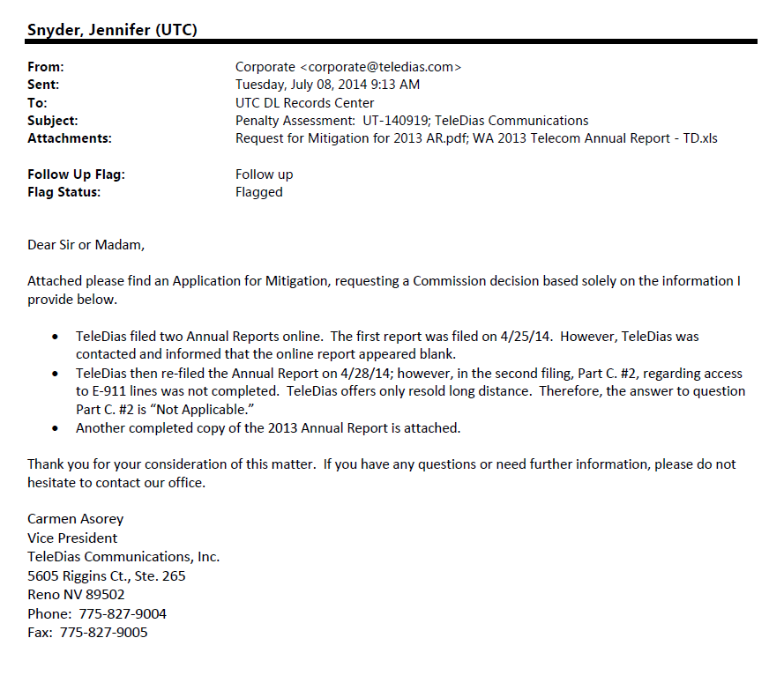

ATTACHMENT C
