July 7, 2014

Steven V. King, Executive Director and Secretary
Utilities and Transportation Commission
1300 S. Evergreen Park Dr. SW
P.O. Box 47250
Olympia, WA 98504-7250

RE: Washington Utilities and Transportation Commission v. National Moving & Storage, Inc.

Commission Staff’s Response to Application for Mitigation of Penalties TV-140974

Dear Mr. King:

On June 6, 2014, the Utilities and Transportation Commission issued a $1,000 Penalty Assessment in Docket TV-140974 against National Moving & Storage, Inc. for 10 violations of Washington Administrative Code (WAC) 480-15-480, which requires household goods carrier companies to furnish annual reports to the commission no later than May 1 each year.¹

On June 20, 2014, National Moving & Storage, Inc. submitted to the commission a signed application requesting mitigation of penalties (Mitigation Request).² In its Mitigation Request, National Moving & Storage, Inc. did not provide a written statement of the reasons supporting the request.

It is the company’s responsibility to ensure that the regulatory fee is paid and the annual report is filed by the May 1 deadline. On February 28, 2014, Annual Report packets were mailed to all regulated household goods companies. The instructions for annual report completion page of the annual report informed the regulated company that it must complete the annual report form, pay the regulatory fees, and return the materials by May 1, 2014, to avoid enforcement action.

As of June 30, 2014, National Moving & Storage, Inc. has not filed its 2013 annual report or paid any subsequent regulatory fees due. The company has been active since August 29, 2011. National Moving & Storage, Inc. has previously been delinquent in filing the 2010 and 2012

UTC Annual Reports
July 7, 2014
Page 2

annual report. Staff does not support the company’s request for mitigation as no written statement was provided for consideration as required.

If you have any questions regarding this recommendation, please contact Amy Andrews, Regulatory Analyst, at (360) 664-1157, or aandrews@utc.wa.gov.

Sincerely,

Sondra Walsh, Director
Administrative Services

ATTACHMENT A
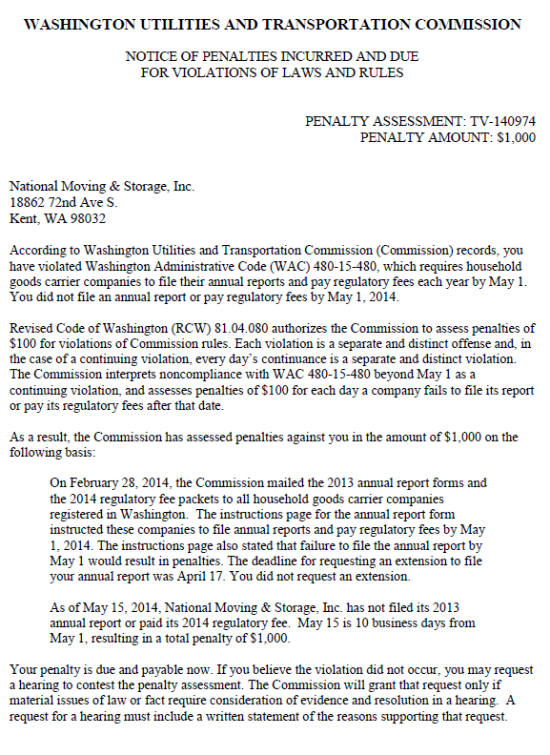

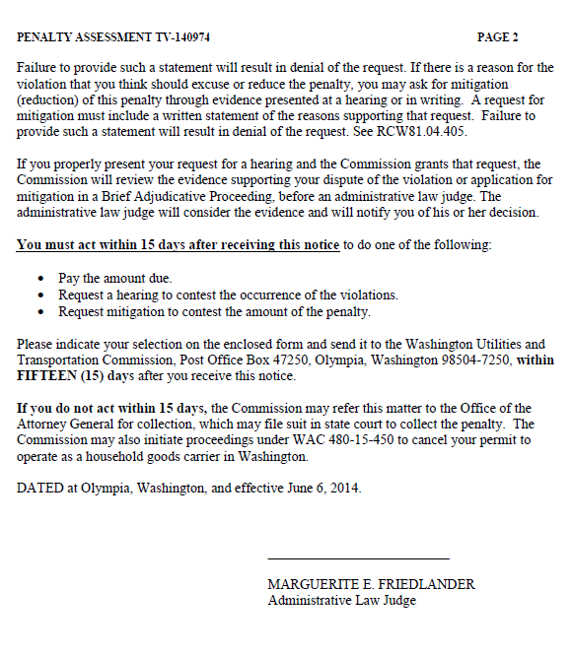

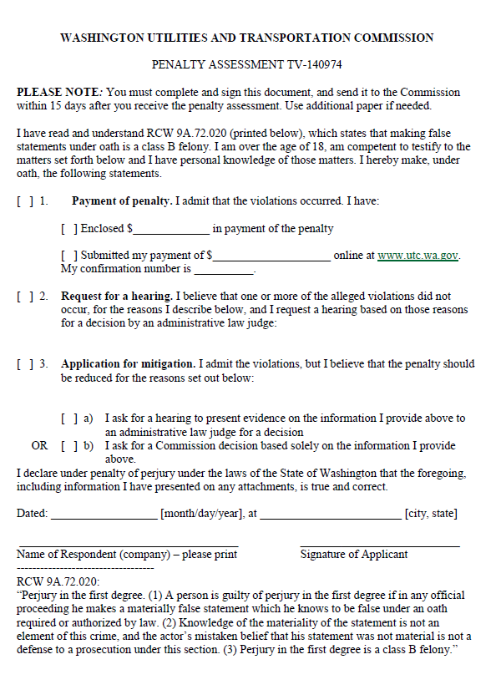

ATTACHMENT B
