WUTC Hearing Valentinetti’s Explanation of Evidence book submitted & Closing Statement that was cut short. SV provided the Evidence books for both Airline Shuttle & AMI Coaches to Judge Pearson and 2 additional copies to the WUTC/AAG.
TE-161295 4-20-2017 @ 09:00 – 12:00
4-27-2017 @13:30

Administrative Law Judge Rayne Pearson
Assistant Attorney General (AAG) Jeff Roberson
WUTC’s Mathew Perkinson Motor Carrier Safety Supervisor
Commissioners at the Washington State Utilities and Transportation Commission.

This Case or Hearing isn’t about safety, it’s about discrimination and cover-up, for Steve Valentinetti filing complaints of discrimination against the WUTC/FMCSA/DOT sparked the retaliation we continue to see today. TE-161295 on record verbiage is an additional retaliatory, racial attack on Steve Valentinetti by the WUTC.

Why do you think the Assistant Attorney General Jeff Roberson is at a “New applicant” hearing? His office is aware of the discrimination, differential treatment and cover-up that has been in place by WSDOT. His role in these hearings is assess the liability and potential damage to the State of Washington as a party to the actions named above.
- AAG Jeff Roberson changed the direction of hearing by telling Administrative Law Judge Rayne Pearson that these matters have already been found and decided trying to block Steve Valentinetti’s goal of operating or putting correct truthful information on the record and challenge of all violations listed. The WUTC letter states “These allegations, if not satisfactorily rebutted, support findings that GO VIP is not fit to operate as a charter or excursion carrier” Because of this mistaken, without merit statement by AAG Roberson, Valentinetti was unable to completely address every violation. Thanks to Judge Pearson doing her job we were allowed to briefly address each violation except Operating without Authority.
- In Docket TE-161295 page 2 under Factual Allegations (9,10) AAG Roberson tries to indirectly discredit the testimony and future business opportunities of Steve Valentinetti by writing in Docket TE-161295 “Mr. Valentinetti was listed as both the owner and manager of AMI Coaches who made a fraudulent or intentionally false entry then later stating on record during the hearing “these violations have been discovered and found”. (see below e-mail from FMCSA Chief Counsel Amanda Slater Burgie)

- Steve Valentinetti stated under oath “the violations assessed by the DOT (WUTC & FMCSA) are knowingly false against AMI Coaches & Airline Shuttle” who has never been given an opportunity to challenge or dispute, present witnesses, industry professionals or evidence against the false violations in the past 3 years. (Differential Treatment) Yes Judge Pearson, we asked for Administrative Review and or Adjudication from the beginning even before we were shut down just because of the nature of the violations.
Mr. Valentinetti, April 26th 2017 @ 09:42

I received your voicemail inquiring about Judge Sullivan’s decision in FMCSA-2014-0389 that we went to hearing on in March. I have not received a decision and, to my knowledge, none has been issued.

Amanda Slater Burgie
Office of Chief Counsel
Federal Motor Carrier Safety Administration
Western Service Center
12600 West Colfax Avenue, Suite B-300
Lakewood, CO 80215
303-407-2357

Concealment and Cover Up – the Attorney General’s office knows the “Cover Up” accusation is true as the State continues to engage. Docket TE-161295 NOTICE OF INTENT TO DENY APPLICATION FOR CERTIFICATE, Pages 2 & 3 list violations against AMI and Airline Shuttle however the AAG office seemed to forget and omitted the largest violation ($25,000 Fine) and the violation they used to shut down AMI Coaches false violation #15 49 CFR 392.9a(a)(1) Operating without the required authority trip date 4-7-2013. (see WUTC evidence MP-2 page 5 of 8, AMI Compliance Review) WUTC David Pratts letter to Amtrak (see SV-GOVIP evidence #12) falsely stating AMI Coaches does not have Authority to Operate (vetting process during Amtrak Federal Contract) (proved false by Valentinetti at hearing TE-161295)
- AMI did have Authority and WUTC’s Pratt refused to retract the letter
- Emergency Service was being provided April 7th 2013 but AMI Coaches had Authority anyway.
- A letter from Pratt to Amtrak Headquarters in Pennsylvania is outside the scope of David Pratts position and beyond the scope of the WUTC. The letter and follow-up was purely intentional by the WUTC to discredit AMI Coaches and Steve Valentinetti in favor of other bus companies.
Sullivan and Burgie’s hearing is also without merit as FMCSA’s Chief Counsels first words to DOT Judge Sullivan was “the fmcsa moves to block all Steve Valentinetti’s Evidence, Witnesses, Industry Professionals” …Sustained.
FMCSA Investigator Nolan Rice first stated he remembered everything about SV and Airline Shuttle but when questioned, (Rice purported he will finish us with the airport video) Rice was unable to state why he couldn’t produce the SeaTac Airport video that clearly would validate or dismiss all violations assessed to Airline Shuttle.
Rice had no exterior photos of the vehicle or vehicles violated.
Rice was unable to identify which vehicle he wrote the violations on……the AMI Coaches 24 passenger bus or the Airline Shuttle 14 passenger bus when presented photos from SV Rice still couldn’t remember.
Rice when questioned about FMCSA’s Jurisdiction over Airline Shuttle he stated he didn’t know.
Jeff James when questioned about FMCSA’s Jurisdiction over Airline Shuttle he stated at first he didn’t know then later admitted “I guess it’s possible AS is exempt if you are only moving airline crew”.

Tanya Fletcher, (Port of Seattle Ground Transportation Supervisor) Testified
- The 9-28-2013 video is or was available to the DOT.
- Airline Shuttle was the longest operating transportation company at Sea Tac International Airport (1989)
- SeaTac Airport Ground Transportation agent check a carrier for proper authority and proper levels of insurance.
- Airline Shuttle was in compliance of all SeaTac Airport rules and regulations including operating authority and insurance.

In 2000 when Seattle Super Shuttle applied and was awarded the Certificate of Convenience in addition to Evergreen Trails, to move Passengers from SeaTac Airport to downtown hotels and back. The decision was overturned in appeal stating there is no need for additional transportation to downtown Seattle. 6 months later the WUTC announces “Lite Rail” will be built and completed in 2009 because of the need for more transportation to Seattle. Jeff James FMCSA Division Administrator

2004 the WUTC stood with Evergreen Trails again against Steve Valentinetti when Evergreen Trails (Grayline of Seattle) 25 year old buses would break down the hotels would immediately give out Airline Shuttle’s number for dependable transportation to SeaTac Airport. In 2004 in addition to WUTC Charter & Excursion permits Airline Shuttles vans also had State Patrol authority with limousine permits. Grayline and the WUTC stated that we were operating outside of our authority range “moving passengers to the airport from the hotels”, ripped our office apart passing valuable secure information to Evergreen Trails attorneys and fined Steve Valentinetti $50,000 which we paid and moved on.

2014 - David Pratt trying to help his bus company friends writes a derogatory May 15th 2013 letter to Amtrak stating AMI Coaches doesn’t have authority to operate in an attempt to thwart AMI Coaches ability to obtain a second Amtrak Transportation Contract. After attempts to get Pratt to recant the letter were unsuccessful we hired lawyers “Williams Kastner & Gibbs who ended up being Evergreen Trails attorneys.

The GO VIP team wonders how far will the DOT continue to go of falsification of evidence and cover up to try to hide racial, deferential treatment mistakes of the WUTC management and staff. Does it make anyone take notice when;
- The Assistant Attorney General of Washington State Jeff Roberson comes to a hearing to testify against a transportation company’s application?
- SV proves and gets admission from the Mathew Perkinson, that the FMCSA and the WUTC’s Motor Carrier Safety Supervisor “The WUTC doesn’t have Jurisdiction over Airline Shuttle” yet Airline Shuttle was closed 3 years ago by the DOT without allowing a hearing or adjudication but dismissing 6 CAP’s.
- SV has gone 3 years without a Civil Rights investigation or hearing.
- SV besides proving NO Jurisdiction of AS by the DOT SV also proved all violations to be false
- The Assistant Attorney General or WUTC’s Mr. Perkinson could not prove or challenge even 1 violation against Airline Shuttle or AMI Coaches
- Per the DOT, of all the trucks and buses, Steve Valentinetti’s 24 year accident free companies are the worst in the in the United States and can’t be allowed on the road.

When Steve Valentinetti stood up to WUTC’s & FMCSA’s John Foster about his threats of the loss of “student visa’s and up to deportation of themselves and or family members Foster states “stick to Town Cars like the rest of your people” or “If you don’t change your attitude I will have you deported also” etc. Two weeks later Foster calls and states ”I think you can get through this if you play your cards right” Valentinetti asked “what do you mean, we have everything correct”. Foster states “if you don’t complain about me, I’m retiring soon and stay away from the big contracts you might be ok”. “Nobody in this state gets contracts without going through me first” Foster – “My Navy buddy Steve (Journey Lines) runs a clean operation…..through me”.

Mr. Foster was looking for payment from AMI Coaches at the end of his dismal career thinking we are foreigners. (ask Tom McVey)

When Steve Valentinetti states the DOT is corrupt he really means it.
Steve Valentinetti (SV) calls the DOT corrupt and accuses the DOT of now trying to “Cover-Up” as well as personally and business filed Civil Rights complaints against the DOT (WUTC & FMCSA) which have been ignored and dismissed as they believe SV is a foreigner.

Complaints and statements, accusations of this type are very serious, disturbing and hard to handle when the defendant is your co-worker, your teammate or in this case your boss. We should take note that the DOT has not investigated, denied or responded to any of Steve Valentinetti’s statements as if they do he can easily prove what they have done. They just keep hiding and talking behind our back to insurance companies and our ex-customers.

The arrogant DOT has now shown its true intention which is “Stop Steve Valentinetti from Operating a Transportation Company at any cost”
Steve Valentinetti and CR Attorneys consider this action a continued discrimination including but not limited to age, color, differential treatment, color of law, intentional falsification, defamation, slander etc.

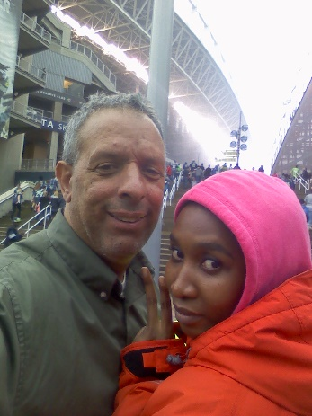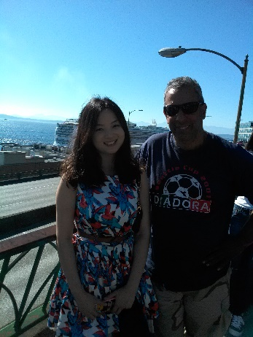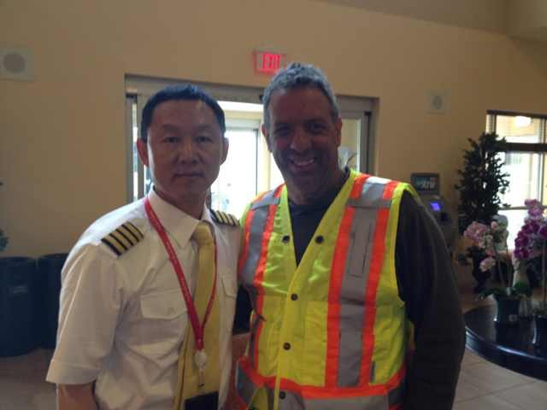
However the facts are;
- The States verbiage in the TE-161295 letter is continuous slanderous and damaging against Steve Valentinetti and without merit on record statements.

- At TE-161295 Hearing Steve Valentinetti clearly made points that cannot be overlooked

- Doug Ferguson’s first opportunity to speak in behalf of Airline Shuttle was TE-161295 where he proved both AMI Coaches and Airline Shuttle had the proper insurance levels and proof.

- With only 2 days’ notice and preparation the DOT now sees what happens when the DOT allows industry professionals like Doug Ferguson or even the WUTC’s Mathew Perkinson Motor Carrier Safety Supervisor testify under oath.

- Mathew Perkinson, Motor Carrier Safety Supervisor for the State of Washington testified in his position he knows and understands both State and Federal Law regarding Transportation. (WAC’s & RCW’s CFR’s & USC’s)

- Mathew Perkinson, Motor Carrier Safety Supervisor for the State of Washington testified the State laws (WAC’s & RCW’S) parallel the Federal Laws (CFR’s & USC’s).

- Mathew Perkinson, Motor Carrier Safety Supervisor for the State of Washington testified that the WUTC does not have Jurisdiction over Airline Shuttle. WAC 480-30-011

- Mathew Perkinson, Motor Carrier Safety Supervisor for the State of Washington testified it would not appear or according to his knowledge the FMCSA has Jurisdiction over Airline Shuttle. 49 USC 13506 FMCSA’s Western Service Center Chief Safety & Compliance Officer Ray Gassaway stated verbally and in e-mail the FMCSA has no Jurisdiction over Airline Shuttle. FMCSA (now withdrawn from case because he was embarrassed about Judge Sullivan’s corruptness and didn’t want to be involved) Chief Counsel Miloud stated “if Airline Shuttle is only operating the 14 passenger van Mr. Valentinetti may have a legal defense”. FMCSA Washington Division Director Jeff James stated “I don’t know if we have jurisdiction” “It’s not me who is after you but I think you should admit all violations, tell them you are sorry or they will not let your new company operate”.

- It is clear and admitted the WUTC and the FMCSA does not have Jurisdiction over Airline Shuttle.

- Mathew Perkinson, Motor Carrier Safety Supervisor for the State of Washington testified that Airline Shuttle, jurisdiction or not, does not have to Drug & Alcohol test for is 14 passenger van (even though we did anyway with both an Airline Shuttle program & AMI Coaches program) 49 CFR 382.305 How do you get safer than that?

- Mathew Perkinson, Motor Carrier Safety Supervisor for the State of Washington testified Airline Shuttle does not have to prepare (Driver Vehicle Inspection Reports) DVIR’s. 49 CFR 396.11(a) Non CMV/CDL

- Mathew Perkinson, Motor Carrier Safety Supervisor for the State of Washington testified Airline Shuttle does not have to prepare Records of Duty Status ROD’s 49 CFR 396.3(b) Non CMV/CDL

- Mathew Perkinson, Motor Carrier Safety Supervisor for the State of Washington testified Airline Shuttle does not have to mark its 14 passenger van with DOT#, GVW#, Name of company, etc. Non CMV/CDL

- Insurance Broker & Industry Professional Doug Ferguson testified AMI Coaches had 5 million and a MCS-90b from November 2011 until AMI was shut down by the DOT. 49 CFR 387.31(a)(d)

- Insurance Broker & Industry Professional Doug Ferguson testified Steve Valentinetti also had 5 million on all the buses. (double insured) 49 CFR 387.31(a)(d)

- Insurance Broker & Industry Professional Doug Ferguson testified Airline Shuttle had 1.5 million

- Even if the violations were true and correctly assessed (and they are not) both State and Federal Laws allows Corrective Action to allow a company to come into compliance without shutting them down for 3 years or keeping them out of business however in this case the DOT has assessed a “Triple Life Sentence” by putting both AMI Coaches & Airline Shuttle out of business forever without review as per law and continuing by keeping GO VIP out of business. (for violations that are easily proven false) 7 Corrective Action Plans for AMI Coaches & 6 Corrective Action Plans for Airline Shuttle all failing without even 1 violations corrective action correct. By the DOT, every CAP, every violation, were not addressed to their satisfaction.

- Evergreen Trails, Horizon Coach lines (now Discover Alaska Tours), and Ride the Duck have all been given immediate hearings and kept in business after incidents or accidents that kill 1 or more passengers or people in other vehicles. (white owners or just retaliation?) Steve Valentinetti’s 2 companies (24 years accident free) both shut down without allowing a hearing to dispute the false violations. We could name 100 more companies that have accidents involving deaths and are still operating. (but not any colored people)

- The WUTC’s Mathew Perkinson, Motor Carrier Safety Supervisor did not testify that the WAC’s, RCW’s, CFR’s & USC’s are different for different people so we are confused and can only draw the conclusion that because the DOT’s demographics’ don’t accurately reflect the demographics of the industry hence the regulators have become racist in nature and regulatory assessment. ALJ Judge Rayne Pearson reflected Assistant Attorney General Jeff Roberson naively stating on record “these violations have been gone over and decided, we aren’t going through this again” when in fact TE-161295 was the first hearing were allowed Testimony, Evidence, Witnesses and Industry Professionals. Do to only 2 days’ notice of the hearing we were not allowed time to request discovery.

AAG Jeff Roberson‘s job is protect the State of Washington
ALJ Judge Rayne Pearson’s job is listen to testimony, examine the evidence and make a decision according to the law.
WUTC’s Mathew Perkinsons job is to protect the citizens of Washington State with a vetting process that removes or disallows lawless dangerous companies. (not get involved in past discrimination)
- The WSDOT has no Civil Rights Dept. or they have been continually ordered to “Step Down”

- Although the individual violations are false and are not applicable to a decision Assistant Attorney General Jeff Roberson pressures Mathew Perkinson in his response “should the WUTC allow GO VIP to operate. NO
The continued facts are;
- The WUTC’s Hearing letter states “These allegations, if not satisfactorily rebutted, support findings that GO VIP is not fit to operate as a charter or excursion carrier” however at the hearing the Assistant Attorney General objected and stated we are not going to revisit the violations as they have already been found to be true. NOT TRUE

- SV stated to the Commission that the violations and shut-down of Airline Shuttle was purely retaliation for making Civil Rights complaints as he proved one by one the violations to be false.

- Jeff Roberson Attorney General’s Office stated SV’s intentions are to engage in relatively the same operations that AMI Coaches and Airline Shuttle did in the past. Yes we intend to. Moving flight attendants with a non CDL vehicle and cruise ship passengers with motor coaches, moving students to and from sports activity’s, Yes, that is exactly what we are going to do. Is something about that in violation of the law, are those operations illegal or just stealing work from the white people?

- Mathew Perkinson (MP), the WUTC’s Motor Carrier Safety Supervisor stated his training included both State and Federal law (RCW’s, WAC’s, CFR’s USC’s). MP also stated the state law parallels the federal law. After uncomfortable dialog MP admitted under oath the State of Washington does not have Jurisdiction over Airline Shuttles operations. WAC 480-30-011 and that it seems like the FMCSA does not have jurisdiction either 49 USC 13506(3)
- Judge Rayne Pearson allowed a minor dialog into the violation of Insurance where witness Doug Ferguson, 39 year Commercial Insurance Broker & owner of DW Ferguson & Assoc. testified under oath that AMI Coaches and Airline Shuttle both had the proper amounts of insurance and proof including MCS 90b. The WUTC or the FMCSA were unable to dispute or show proof against Mr Ferguson’s testimony. The Assistant Attorney General Jeff Roberson’s defense was did Doug Ferguson see SV hand the documents over to the DOT? Closing argument by SV that was cut short – No Mr. Ferguson didn’t personally see AMI Coaches or Airline Shuttle hand the insurance documents to the DOT investigator nor did he personally see the 7 Corrective Action Plans for AMI Coaches or 6 Corrective Action Plans by Airline Shuttle over 3 years that provided the MCS-90b. This is the DOT’s “Dumb Foreign N&#$r” defense. “If SV had the documents he should have presented them to our inspector”.

- Although Mr. Perkinson, the WUTC’s Motor Carrier Safety Supervisor admitted the WUTC & the FMCSA does not have Jurisdiction over Airline Shuttle, both AMI Coaches & Airline Shuttle had the proper amount of insurance and both had Drug and Alcohol testing, (pre-employment, random & suspicion) he then stated for the record with pressure from Assistant Attorney General Jeff Roberson, he suggests not allowing GO VIP to operate in the future.
Overlooking but not forgetting what has happened in the past, this verbiage both by Assistant Attorney General Jeff Roberson and WUTC’s Mathew Perkinson & David Pratt is in itself proof of differential treatment and shows that this is a personal attack against SV and has nothing to do with operating safety.

- The only violations not addressed because of time are, didn’t retain records (DVIR, employment application and driving records from 1989) or put stickers on our van that are not applicable to Airline Shuttle even if there was jurisdiction.
During the March 2014 audit that produced the unsatisfactory safety rating, FMCSA discovered that Airline Shuttle did not have the necessary substance and alcohol testing program 49 CFR 382.305 Steve Valentinetti produced documents that rebut this violation found in section 1 of our evidence book presented to the Judge Pearson, the Assistant Attorney General Jeff Roberson and WUTC’ Motor Carrier Safety Supervisor Mathew Perkinson.
- U.S. Health Works documents dated 10-22-2013 – Statement of Drug and Alcohol Testing Services. AMI Coaches/Airline Shuttle is a member of RSS Random Drug and Alcohol program. 800-340-3810
- Certificate of Completion, Supervisor Compliance, Supervisor Course for Steve Valentinetti, Test Score 100% dated 3-26-2013 49 CFR 382.603
- DOT Mandated Urine Drug test Results for Steve Valentinetti – negative, 8-31-2013
- DOT Mandated Urine Drug test Results for James Mondry – negative, 9-5-2013
- Declaration of Nolan Rice FMCSA Special Investigator – During his 2014 investigation of Airline Shuttle mentions Vin #1725 (AS 14 passenger van) and never mentions the clearly marked AMI 24 passenger bus Vin #6629 (bottom photos)
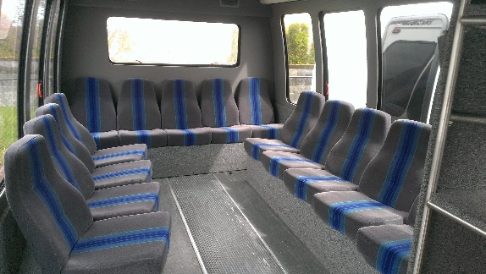 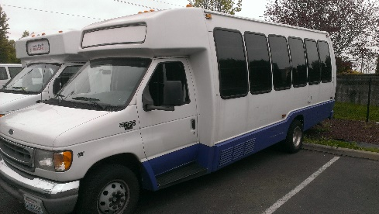 s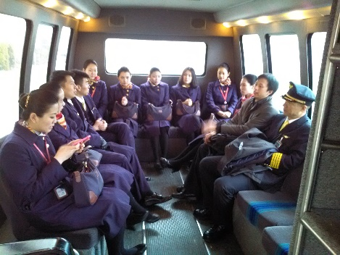
Top photo= Airline Shuttle Non-CMV, Non CDL 14 passenger hotel van insured for 1.5 million. VIN #1725
WUTC and the FMCSA now admit this van does not require a CDL, does not require Drug & Alcohol testing, does not require exterior Federal markings, does not require RODS like an over the road cross country semi truck. It’s a hotel van for flight crew only.
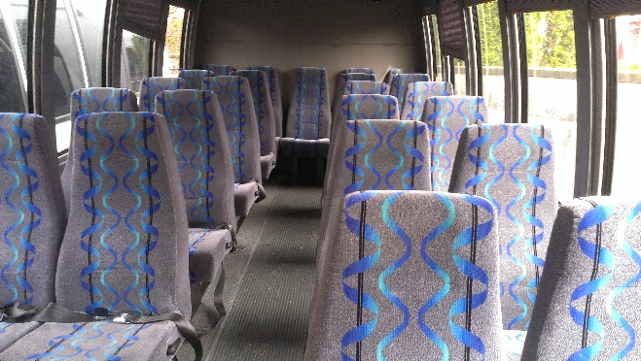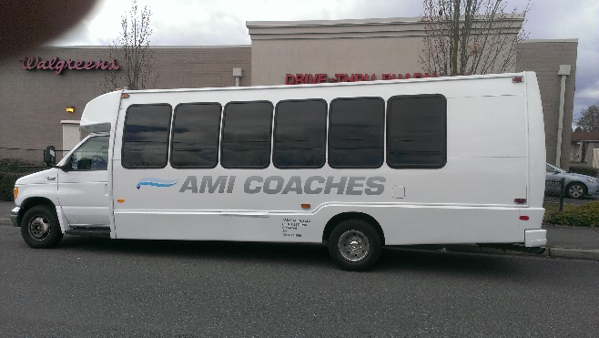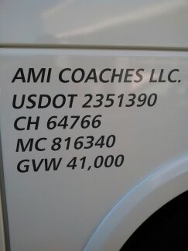
Legal Owner Steve Valentinetti = AMI Coaches 10,000 gvw, 24 passenger bus, VIN# 6629 had full authority to operate - CDL required, Drug & Alcohol in place, 5 million insurance in place, MCS 90b in place for both AMI Coaches & Steve Valentinetti. Double insured! See markings forward of rear wheel (AMI Coaches name. USDOT 2351390, Charter 64766, MC 816340, GVW)
(2) failed to maintain proof of insurance at its principle place of business 49 CFR 387.31(d) Steve Valentinetti produced as a witness 39 year Insurance Broker and owner of D.W. Ferguson Commercial Insurance who testified his company provided and he wrote the insurance, 5 million for AMI Coaches and 5 Million for Steve Valentinetti, 1.5 Million for Airline Shuttle and including a MCS 90b. Section 3 of evidence book is AMI Coaches
- MCS 90b
- Certificate of Liability Insurance 5 million
- Insurance Identification card for AMI Coaches bus Vin #6629 insured by both AMI Coaches & Steve Valentinetti
- British Columbia Financial Responsibility Certificate dated May 7th 2013
(3) operated a passenger carrier vehicle without the necessary levels of insurance 49 CFR 387.31(a) Steve Valentinetti produced as a witness 39 year Insurance Broker and owner of DW. Ferguson Commercial Insurance who testified his company provided the insurance, 5 million for AMI Coaches and 5 Million for Steve Valentinetti, 1.5 Million for Airline Shuttle and including a MCS 90b. Section 3 of evidence book is AMI Coaches
- MCS 90b
- Certificate of Liability Insurance 5 million
- Insurance Identification card for AMI Coaches bus Vin #6629 insured by both AMI Coaches & Steve Valentinetti
(4) failed to make records of duty status 49 CFR 395.8(a) Airline Shuttle is a Not a Commercial Motor Vehicle CMV and does not require a Commercial Driver’s License CDL. It is a 14 passenger hotel van (see photo with crew, section #2) and is not required to keep ROD’s like a long distance over the road truck but if it were it would also use the 100 mile exemption.
(5) failed to maintain driver qualification files. 49 CFR 391.31(d) Airline Shuttle does not operate a Commercial Motor Vehicle and isn’t required to have federally compliant driver’s files…….even though we did. Airline Shuttle and AMI Coaches both had separate Driver Qualification Files. Steve Valentinetti redacted the year of his birthday in both his DQF’s and the WUTC investigator wrote the violation as our companies didn’t have DQF’s. Airline Shuttle is unregulated by the WUTC or FMCSA and doesn’t require DQF’s as it is a 14 passenger non-CDL hotel van.
(6) failed to keep inspection and vehicle maintenance records 49 CFR 395.8(k) Not required by a hotel van or a Non CMV, Non CDL company. Airline Shuttle doesn’t have any CDL vehicles.
(7) failed to require drivers to prepare driver vehicle inspection reports 49 CFR 396.11(a) Not required by a hotel van or a company operating only 1 vehicle 14 passengers. Airline Shuttle didn’t have any CDL vehicles.
(8) operated motor vehicles which were not periodically inspected 49 CFR 396.3(b) Airline Shuttle had annual inspections every December 1st to 30th. Airline Shuttle did not have a FMCSA or a WUTC inspection since 2009. We did have an annual inspection on Vin# 1725. AMI Coaches did Federal Annual Inspections December 1st to December 30th each year. To be exact from the dealer when we bought them and November 2012 and again in November 2013
(9) failed to update its MCS-150 form - Not required by a hotel van or company. Airline Shuttle didn’t have any CDL vehicles in Interstate Commerce.
(10) operated motor vehicles without the required marking. Not required by a hotel van or a company. Airline Shuttle didn’t have any CDL vehicles. Admitted by Mathew Perkinson, the WUTC’s Motor Carrier Safety Supervisor
WAC 480-30-011(6)(9)(11) - The commission does not regulate the following passenger transportation operations under this chapter:
(6) Persons owning, operating, controlling, or managing taxi cabs, hotel buses, or school buses, when operated as such. (9) Transporting transient air flight crew or in-transit airline passengers between an airport and temporary hotel accommodations under an arrangement between the airline carrier and the passenger transportation company. and (11) Transporting passengers who have had or will have had a prior or subsequent movement by air under a through ticket or common arrangement with an airline or with a connecting out-of-state passenger transportation company.
49 USC 13506(3) - Neither the Secretary nor the Board has jurisdiction (3) a motor vehicle owned or operated by or for a hotel and only transporting hotel patrons between the hotel and the local station of a carrier;
Even though Airline Shuttle had everything listed above except an MCS-150 we didn’t need it because the WUTC or the FMCSA doesn’t regulate hotel vans per WAC 480-30-011 & 49 CFR 13506
During the November 2013 safety audit that produced the unsatisfactory rating, FMCSA discovered that AMI Coaches
(1) did not have the necessary substance and alcohol testing program 49 CFR 382.305
- WUTC document dated 6-20-2013 stating “Has the carrier (AMI Coaches) the drivers have undergone testing for controlled substances prior to performing a safety sensitive functions - YES”. 49 CFR 382.301(a)
- WUTC document dated 6-20-2013 stating “The carrier (AMI Coaches) implemented an alcohol and/or controlled substance program - YES”. 49 CFR 382.115(a)(b)
- U.S. Health Works documents dated 10-22-2013 – Statement of Drug and Alcohol Testing Services. AMI Coaches/Airline Shuttle is a member of RSS Random Drug and Alcohol program. 800-340-3810
- Certificate of Completion, Supervisor Compliance, Supervisor Course for Steve Valentinetti, Test Score 100% dated 3-26-2013 49 CFR 382.603
- DOT Mandated Urine Drug test Results for Steve Valentinetti – negative, 8-31-2013
- DOT Mandated Urine Drug test Results for James Mondry – negative, 9-5-2013
(2) Knowingly allowed, required, permitted, or authorized an employee to operate a passenger carrying vehicle without the proper endorsement or intrastate restrictions during an interstate trip; ??? Without merit Speculation
(3) made a fraudulent or intentionally false entry on an annual inspection form; SV bought a used bus from the Motor Coach Industry Dealer in Chicago and had it delivered (fully insured as it traveled across the country). When the coach arrived it was dirty and in need of attention. We had an annual inspection done by our contracted mechanic who stated the tires are close to needing to be replaced and have the chrome tip welded on. We ordered tires, a new P.A. cordless mic, a sway bar kit, engine belts and a new chrome exhaust tip and other parts. When the WSDOT / WUTC inspector (Don Ross) inspected this bus was OOS out of service and had never been placed in service while the upgrades and repairs were being completed. Mr. Ross violated the bus because the old dirty tail pipe was off while we were waiting for the welding guy to firmly attach the new chrome tip. This is what the DOT calls “made a fraudulent or intentionally false entry on an annual inspection”
(4) permitted drivers to make trips before receiving negative drug testing results; Without Merit false statement. Our drivers came from Graham Trucking and a local School Dist. All had pre-employment & Random Drug & Alcohol testing in place multiple times.
(5) permitted drivers to make trips without a valid medical certificate; SV didn’t have his Med card on person at a random airport check.
(6) failed to inquire about the driving records of drivers; We had current driving records but not the driving record from 24 years ago when Jim Mondry (Hired in 1999) and Steve Valentinetti (Hired in 1987) were hired.
(7) failed to make records of duty status; We didn’t keep the fuel receipts, we have the Credit card statement.
(8) Operated motor vehicles which were not periodically inspected as required. – We presented the “Annual Inspections”
WAC 480-30-121
The Commission alleges that Go VIP’s owner, Steve Valentinetti AMI Coaches LLC (AMI) and Airline Shuttle Inc. (Airline Shuttle), both of which were engaged in providing substantially the same service that Go VIP seeks to provide. The Commission alleges that companies owned and operated by Mr. Valentinetti have a history of violating federal regulations governing safe operations and insurance requirements. Further, the Commission alleges that Mr. Valentinetti incorporated Go VIP to evade the orders forbidding AMI and Airline Shuttle from operating and to mask or conceal the history of noncompliance by those companies. AAG is stating that S. Valentinetti is Evading, Masking & Concealing by using his own name, the same phone number, the same business address, some of the same vehicles and incorporating as before just like AMI and Airline Shuttle.
After listening to SV testify, viewing the evidence and listening to just 1 witness for Steve Valentinetti’s two 24 year accident free companies do you start to wonder why the Attorney General and WUTC are trying so hard to shut down and discredit Steve Valentinetti with false safety violations. He is trying to protect the State of Washington from a Civil Rights lawsuit as he already aware of and has personally seen the undisputable evidence. Has the Attorney General’s office ever been to a New Applicate hearing before? NO.
Attorney General office Jeff Roberson did his job at the TE-161295 brief hearing by stopping a plethora of damaging evidence from getting on the record by telling ALJ Pierce “these violations have already been found and decided, we are not going to listen to them again”. This statement is untrue and without merit. There has been no hearing for 3 years because the DOT knows they are wrong. This is the DOT’s “Dumb foreign N&#%r” defense again.
- Steve Valentinetti or attorneys didn’t ask for a hearing???
- ALJ Pearson naively stated you have 45 days to contest……….True ALJ Pearson, everyone else does except Steve Valentinetti
- SV has tried to get a hearings for 3 years but people in the DOT try to block our Administrative procedure Act rights. (We will produce witnesses from within the DOT when the time comes)
- Remember this is 2 accident free companies the DOT has shut down, AMI Coaches in November 2013 and Airline Shuttle in March 2014.
- The WUTC continues to endorse “Ride the Duck” after 400+ violations and killing 5 people, injuring 30 and then not paying the medical bills. The DOT gets mad when the differential treatment issue is brought up.
- Airline Shuttle had 9 violations all proven false including NO JURISDICTION
- AMI Coaches had 24 total violations and 3 big violations like Drug & Alcohol, Insurance and Operating Authority all proven wrong. Small violations not allowed to address at the hearing.
Why does the DOT stand their ground with the violations after Valentinetti proves them false? The DOT knows they are wrong but hope in the meantime they discredit and try to ruin SV’s life, run SV out of money, hope because of age SV gives up, hope they find something damaging they can use to discredit.
The WUTC is trying to cover up discrimination & DOT officials accepting payments to place motor carriers out of business or at least damage their safety history enough so they are unable to get insurance, operate, obtain Federal Contracts or Large Private Contracts such as Microsoft, Amazon, professional Sports teams, Colleges and Universities. In AMI and Airline Shuttle case they thought it would be easy to intimidate and scare the companies away from bidding on large contracts as the DOT (WUTC & FMCSA) naively perceived these companies to be foreign owned and operated.
- Does it sound crazy? Why would they shut down and keep down 2 companies that have never had an accident in 24 years?
- Why is the Washington State Attorney General trying to stop GO VIP from operating “GO VIP would engage in substantially the same business that AMI did” YES, is that a problem?.......oh, are we taking the white peoples work
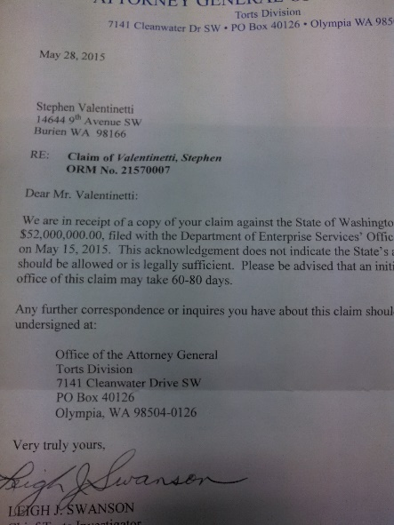
- Is it true that the Attorney General’s office is in the same building less than 250 feet from WUTC’s David Pratt? YES
Insert & attachment
- WUTC’s David Pratts May 15th 2013 letter to Amtrak’s Ron Eaton Director of Amtrak Safety (Pennsylvania)
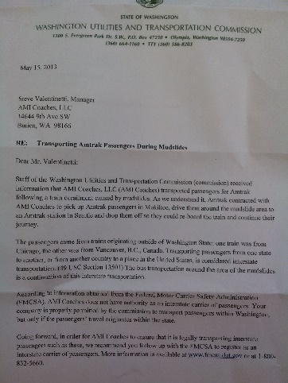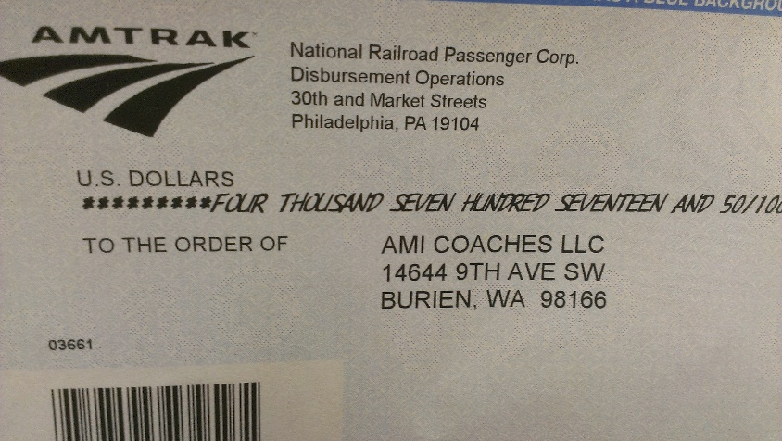
- WUTC’s John Foster’s May 20th 2013 WUTC Notice of Safety Audit….on WUTC letterhead
- WUTC’s John Foster’s May 20th 2013 FMCSA Notice of Safety Audit….on WUTC letterhead
- WUTC’s David Pratts May 23rd 2013 letter to Amtrak’s Ron Eaton Director of Amtrak Safety (Pennsylvania)

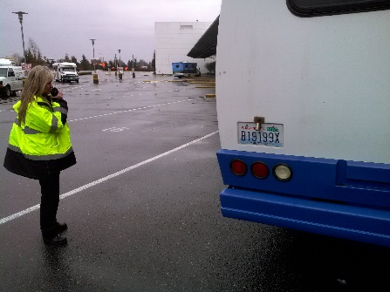
1-8-14

Steve Valentinetti’s Evidence Book Table of Contents
- Drug & Alcohol evidence for both AMI Coaches & Airline Shuttle (unneeded)
- Hotel General Manager Testimony, FMCSA Overview of Federal Regulations Interstate 9 to 15 Passenger Vehicles, Nolan Rice e-mails trying to establish jurisdiction with Amtrak (Interstate Commerce) and the need for Drug & Alcohol testing. You see the answer!
- Authority to Operate February 25th 2013
  - AMI Coaches Interstate Jurisdiction letter from DOT
  - Invitation to bid on Amtrak X092 Federal Contract
  - Photos of AMI Coaches 24 passenger bus
  - WUTC audit 6-18-2013 AMI Coaches audit stating AMI has 5 million and proof with an MCS 90b
  - Certificate of Liability Insurance AMI Coaches for $5 million
  - Bus Card showing $5 million insurance for AMI Coaches Bus Vin #6629 (white 24 pax bus photo)
  - British Columbia Financial Responsibility Certificate
- Declaration of FMCSA Inspector Nolan Rice – talking about Airline Shuttles audit, mentions AS 14 pax non CDL/non CMV van 5 times and never mentions AMI Coaches 24 pax bus Vin #6629
- Nolan Rices Exibit E trying to show AS doesn’t keep (RODS) Records of Duty Status. The fax that Hainan Airlines sends to Airline Shuttle is if the flight arrival is early or late and is not send daily.
  - Invoice to LJK Company for crew transport 1.5 miles, within the city limits of Tukwila to the Chinese restaurant (Mizuki Southcenter) Not Interstate, Not Intrastate, No FMCSA Jurisdiction, No WUTC Jurisdiction
  - Checks from LJK Company for lunch and dinner
- Table of violations
- Federal Register page 4996 Vol. 75 No. 20 Febuary 1st 2010 excluding 9 to 15 passenger vans in Interstate Commerce (to lunch & dinner is not Interstate Commerce)
  - E-mail to Nolan Rice from the State of Washington stating Airline Shuttle’s 14 passenger van is not a CMV by legal definition (and not subject to D & A or any FMCSA Regulations) even though we followed them anyway
  - Excel document with DOT forged writing stating Steve Valentinetti wrote this. Where is bus #1? The 24 passenger bus is intentionally missing by whoever built this document and imposed Steve Valentinetti’s signature on the bottem.
  - Schedule of Liability Limits – 5 million = 16+ and 1.5 million is less than 16.
- Washington State Limousine permit for Vin #1725 Airline Shuttles 14 passenger Non CMV/ Non CDL crew van. Registration for the same 14 passenger van. Vin #1725
  - State of Washington definition of Executive Van (14 passengers)
  - State vehicle search shows Steve Valentinetti as owner of Vin #1725 (back in 2005)
- Driver Files, WUTC and FMCSA files
  - Letter from General Manager of the hotel
  - Fax from 9-28-2013 from the hotel to Airline Shuttle pick up time 20:35
  - Port of Seattle Transaction report showing AMI bus Vin #6629 making 2 pick ups for “Travel with Allen”
  - 5 Million insurance for AMI Coaches
  - 1.5 million insurance for Airline Shuttle
- Secretary of Transportation stating “if the 24 passenger bus is not used there is no jurisdiction because the 14 passenger van is not a CMV per law.
  - Definition of Commercial Motor Vehicle 49 CFR 390.5 but also look at 49 CFR 390.3 which exempts 9 to 15 passenger vans
  - Definition of Compensation for Interstate – passengers pay or group leader. In our case only the hotel pays for to and from the airport. Hainan pays, LJK pay, the hotel who pays Airline Shuttle. That is not even indirect compensation per definition and “Direct Payment” is a requirement for Interstate Commerce or Compensation. If not I guess we can shut down the WUTC because there would be “No such thing as Intrastate”
  - AMI Coaches registration showing 10,000 lbs (not a CMV) but 24 seats (yes a CMV)
  - Oral Interview Form – Nolan Rice false statement about Airline Shuttles back up 13 passenger van.
  - AMI Coaches MCS 90b effective October 1st 2012
- Office staff threatened about student visas and possible deportation
- SV and office staff at Seahawks game.
  - David Pratt’s May 15th 2013 letter to Amtrak – “AMI Coaches does not have the authority as an Interstate Carrier”. May 18th 2013 AMI Coaches staff contacted the WUTC. Pratt was afraid to answer our calls so he had Betty Young answer. When we asked Betty Young to retaract the letter and explain it was a mistake she stated “We are the State of Washington, we will do whatever we want and we don’t want to retract the letter”
  - May 20th 2013 John Fosters WUTC Safety Audit letter.
  - May 20th 2013 John Fosters FMCSA Safety Audit letter.
  - May 23rd 2013 David Pratt again now knowingly stating AMI Coaches didn’t have authority to operate.
  - Steve Valentinetti’s 1982 ENDOR COMB license – can drive any commercial vehicle, doubles and triples, school bus
- Airline Shuttle Compliance Review (modified) Parts B & C are completely false
- AMI Coaches Compliance Review
- Mathew Perkinson January 11th 2017 letter to David Pratt
  - “Mr. Valentinetti marked the vehicles with AMI Coaches because “they look pretty”.
  - “Both companies were given an opportunity to take action within 45 days to improve the safety rating”. This statement is false. Both companies have waited over 3 years for a hearing and March 16th 2017 the FMCSA had a hearing and Sullivan stated she had already decided, without evidence, witnesses, testimony, industry professionals the outcome of 8 of the 9 false violations in favor of the DOT.
The last and only remaining violation not ruled on in the DOT’s back room is Drug & Alcohol for Airline Shuttle and SV proved with CFR’s & USC’s that;
    - Airline Shuttle doesn’t require Drug & Alcohol testing – Non-CMV, Non-CDL
    - Airline Shuttle had Drug & Alcohol testing anyway
    - The FMCSA doesn’t have Jurisdiction ruled on without case law, testimony, Industry Professionals….like Mathew Perkinson.
  - 3 years was the question, it has been 3 years…..If we were trying to hide our past relationship with 24 year accident free Airline Shuttle we would use a different Name, address, phone number etc.

I Steve Valentinetti business and personally take offense to statements of falsification or Mr. Valentinetti wasn’t aware of D & R testing etc. Our international office staff knows the CFR’s & USC’s better than the DOT investigators. 24 years accident free company doesn’t happen by accident. Our team laughs at the insinuation that the DOT could teach us anything about safety even though we politely listen.
Steve Valentinetti is proud of the workers and history of Airline Shuttle and AMI Coaches. We were the best in the country and will never admit violations our 2 companies didn’t commit regardless of the treats of deportation or never being able to work again.
We are ashamed of the WUTC for its selective enforcement, self-serving interoperations of law, continued in 2017, differential treatment.
Thank you

Steve Valentinetti
GO VIP
steve@GO-VIP.us
206-242-2000
206-423-5000 mobile

Certificate of Service
4-27-2017
Rayne Pearson rpearson@utc.wa.gov
Administrative Law Judge

Jeff Roberson jroberso@utc.wa.gov
Assistant Attorney General (AAG)

WUTC Commission Staff records@utc.wa.gov

Mathew Perkinson mperkins@utc.wa.gov
Motor Carrier Safety Supervisor WUTC 360-644-1236 office
360-701-1601 mobile

Steve Valentinetti steve@GO-VIP.us
GO VIP 206-242-2000 office
206-423-5000 mobile

X_________________________
Steve Valentinetti
4-27-2017 @ 13:30

The first words out of DOT/FMCSA Chief Counsel Amanda Slater Burgie was “your honor, the DOT moves to block all Steve Valentinetti’s Evidence, Witnesses and Industry Professionals” DOT Judge Sullivan……”sustained”.

