Green Mountain H2O LLC
+a water company+

David Danner, Executive Director and Secretary
Washington Utilities and Transportation Commission
1300 S. Evergreen Park Drive SW
Olympia, WA 98504-7250

Re: Tariff Filing Schedule 2 metered Rates

Dear Mr. Danner:

Attached is the 1st Revision to the Original sheet No. 22 for Green Mountain H2O LLC.

Effective 8-10-09, this revision changes the text reflecting the units of measure for the water usage. The original defined the usage measured in cubic feet. The revision defines the usage measured in gallons. There is no change that affects the customer. The customers have always been billed in gallons.

In addition, several lines were deleted for base rates for service delivery larger than ¾”. No customers have service larger than ¾”.

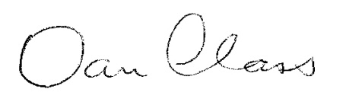
________________________________________________
Dan Class

Serving Columbia View Estates, Columbia Crest Estates, & The View Estates
759 Varsity Rd, Kalama, WA 98625 ph360.225.0999 fax360.225.0998 classdan@aol.com

