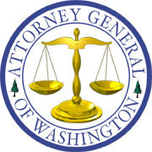
Bob Ferguson
ATTORNEY GENERAL OF WASHINGTON
Utilities and Transportation Division
PO Box 40128 • Olympia WA 98504-0128 • (360) 664-1183

Via Electronic Mail

November 15, 2018

Mark L. Johnson, Executive Director and Secretary
Washington Utilities and Transportation Commission
1300 S. Evergreen Park Dr. S.W.
P.O. Box 47250
Olympia, Washington 98504-7250

RE: WUTC v. Puget Sound Energy (PSE 2018 ERF)
Dockets UE-180899 and UG-180900

Dear Mr. Johnson:

Enclosed for filing in the above-referenced docket is the original Notice of Appearance on Behalf of Commission Staff and Certificate of Service.

Sincerely,

/s/ CHRISTOPHER M. CASEY, WSBA No. 46733
Assistant Attorney General
Office of the Attorney General
Utilities and Transportation Division
P.O. Box 40128, Olympia, WA 98504-0128
(360) 664-1189
chris.casey@utc.wa.gov

CMC:klg
Enclosures
cc: Parties

