BEFORE THE WASHINGTON UTILIES AND TRANSPORTATION COMMISSION

In the Matter of the Penalty Assessment Against BREMERTON-KITSAP AIRPORTER, INC., in the Amount of $600 | DOCKET NO. TC-100147  DECLARATION OF  JOHN FOSTER

JOHN FOSTER, under penalty of perjury under the laws of the state of Washington, declares as follows:

- I am over 18 years of age, a citizen of the United States, a resident of the state of Washington, and competent to be a witness.

- I am employed by the Washington Utilities and Transportation Commission (Commission) as Transportation Specialist 4 in the Motor Carrier Safety Section. I have been employed at the Commission for 23 years, holding various positions. As a Transportation Specialist, my responsibilities include performing safety inspections and other related motor carrier activities in a Commission program which regulates transportation activities.

- On February 18, 2010, Bremerton-Kitsap Airporter, Inc. (Bremerton-Kitsap or Company), through its President, Richard Asche, filed with the Commission an application for mitigation (Mitigation Request) in Docket TC-100147. I have read the Mitigation Request. In the Mitigation Request, Bremerton-Kitsap waives a hearing and asks for an administrative decision.

- The Mitigation Request arises from a Notice of Penalties Incurred and Due for Violations of Laws and Rules issued by the Commission on February 3, 2010, in Docket TC-100147. In that Notice, the Commission issued a penalty of $600 for six violations of WAC 480-30-216(5), which requires that no passengers be permitted to stand unless the vehicle is equipped with devices designed and permanently installed to provide stability and safety for standing passengers. The rule also requires that even if the vehicle is properly equipped, no passenger will be permitted to stand for a distance exceeding thirty-five miles.

- As part of my job, I conducted an investigation of a safety complaint concerning Bremerton-Kitsap on January 21, 2010. A passenger traveling with Bremerton-Kitsap on December 29, 2009, complained of the bus being loaded beyond capacity with passengers standing in the aisles. My investigation resulted in an investigation report dated February 1, 2010. I identified the violations based on my investigation of trip records and inspection of the Company vehicle used on December 29, 2009.

Specific Issues Addressed by Bremerton-Kitsap in its Mitigation Request

The Company states that it did transport 30 passengers in a 24-passenger capacity cutaway bus, which has no devices permanently installed to provide stability and safety for standing passengers. The Company states that he has never seen such devices installed on cutaway airporter buses or vans.

- Attachment B shows pictures of three buses equipped with hand holds mounted on the back of the aisle seats. These pictures were readily available on the Internet. The buses are the same type as those used by Bremerton-Kitsap. As a part of my job, I have observed that other passenger carriers in the Puget Sound region operate these same types of buses, properly equipped for standees.

The Company states that passengers from SeaTac are boarded first-come, first-served and that in order to preclude overloading buses, boarding passes are color coded (limit 24). When 24 boarding passes are issued, a different colored pass is issued to the next group of 24 passengers who must then wait until the next departure.

The Company states that during the evening of December 29, a large number of returning holiday travelers requested transportation from SeaTac airport, and 30 passengers were waiting to board the bus. When the driver realized he was overloaded, he was ready to depart the airport. Although the driver could have insisted that the standing passengers remove themselves from the bus, there would have been anxiety and anger from the removed passengers. Moreover, there was the matter of ticket refunds and removal of baggage already stowed.

- First and foremost, Bremerton-Kitsap is responsible for the safety of its passengers. If this bus had been in an accident or had made a sudden stop, the danger and potential harm to the standing passengers would have been much greater, due to the lack of required safety equipment.

- The Company’s ticketing procedures, as explained in the Mitigation Request, appear to be designed to avoid overloading buses. If the 30 waiting passengers had color-coded boarding passes and understood that the service provided is first-come, first- served, the first group of 24 passengers should have been transported and the second group of passengers should have been made to wait for the next departure.

- The driver should have advised the passengers that the bus could only transport 24 passengers and that standees are not permitted by regulation. The driver should not allow on board, nor collect fares from, any passengers that cannot be legally transported.

- Finally, WAC 480-30-216(6) requires that carriers have standby equipment available “to ensure the reasonable operation of established routes and fixed time schedules.”

Bremerton-Kitsap states that it would support strengthening the “gotcha” provisions of WAC 480-30-216(5) to allow for the removal of any standing passengers regardless of when they presented themselves to the driver for boarding the bus.

- WAC 480-30-216(5) already restricts carriers from overloading an improperly- equipped bus. The rule also states that even if the vehicle is properly equipped, no passenger will be permitted to stand for a distance exceeding 35 miles. On this route, the first stop was in excess of 35 miles, so no standees would have been allowed, regardless of the type of equipment operated.

- In addition, WAC 480-30-451 lists the circumstances under which a carrier can refuse service, including those where the company deems that providing the service would be hazardous, unsafe, or dangerous to persons or property.

Staff Recommendation

- The Commission’s passenger carrier rules exist to ensure that the public is protected when traveling with a carrier regulated by the Commission. Bremerton-Kitsap transported passengers in an unsafe manner in violation of Commission rules. Therefore, Staff opposes mitigation and recommends the penalty stand.

Dated March 3, 2010, at Olympia, Washington.

John Foster
Attachment A

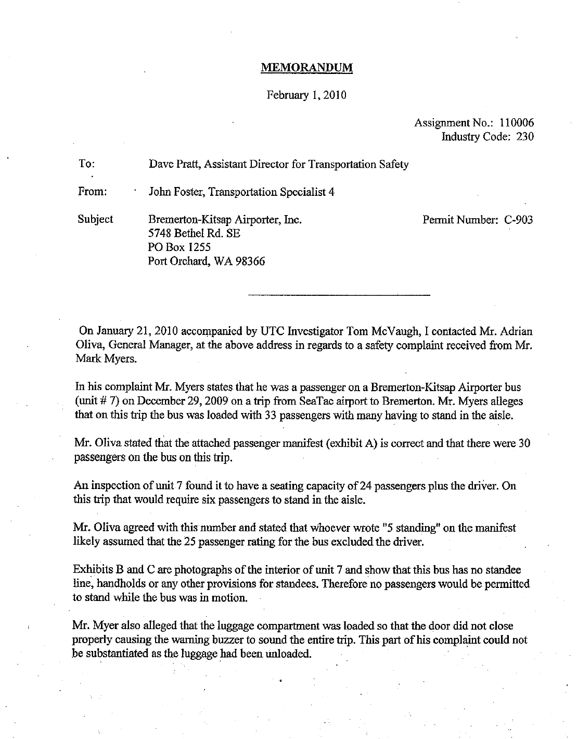
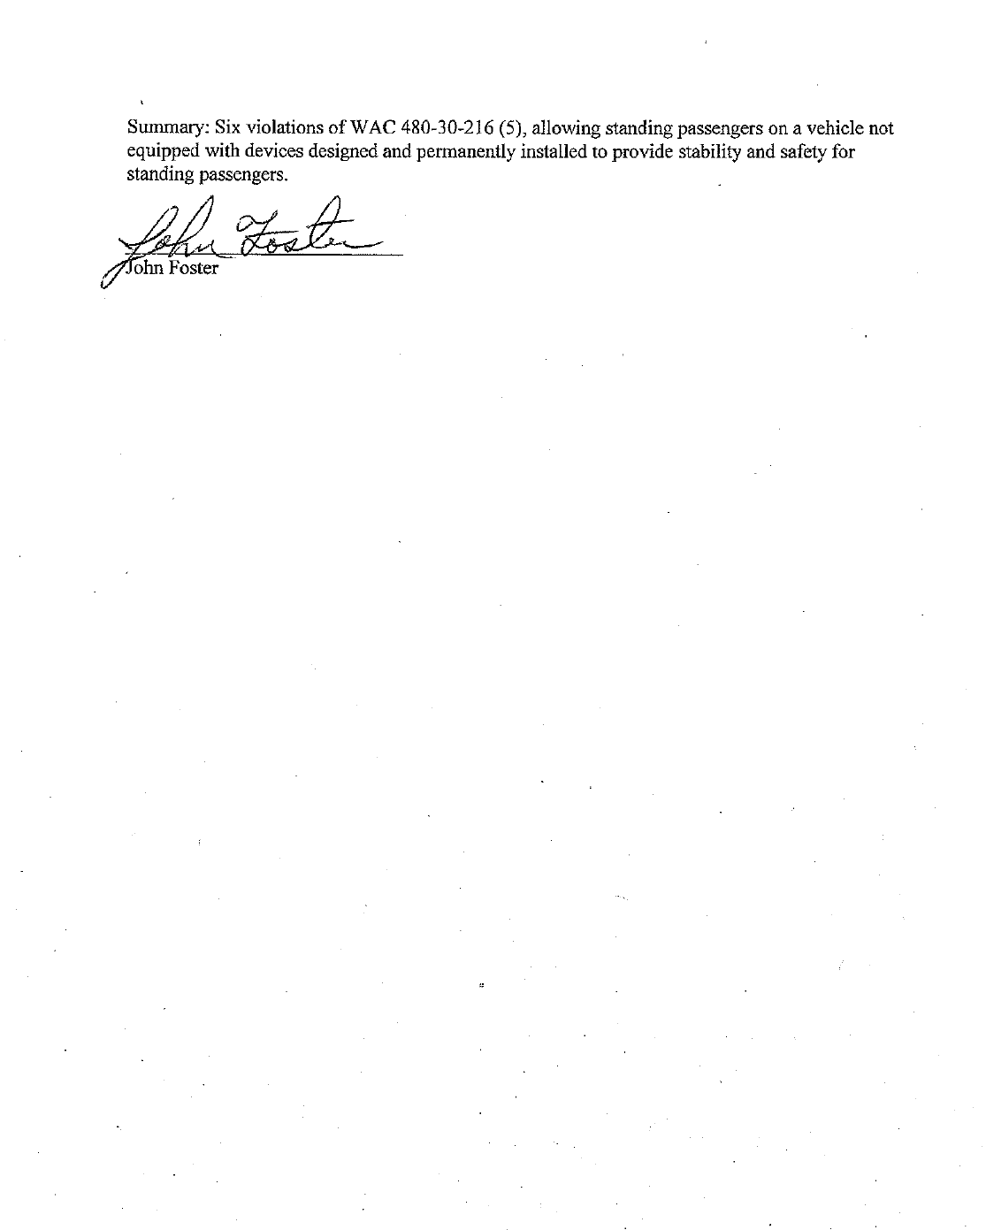
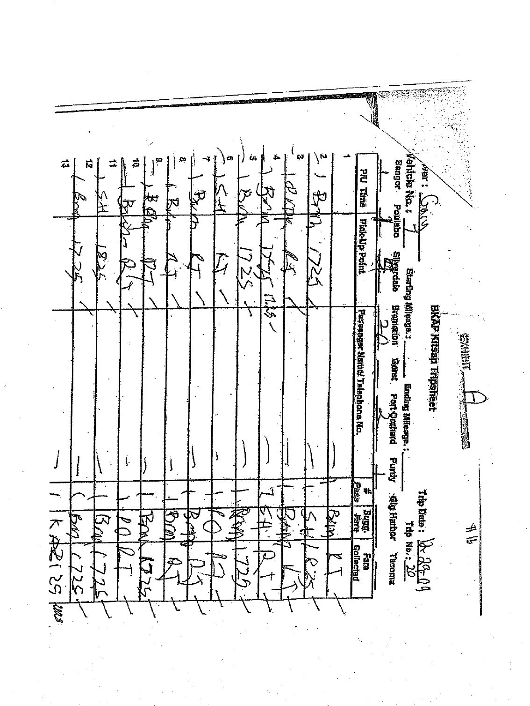
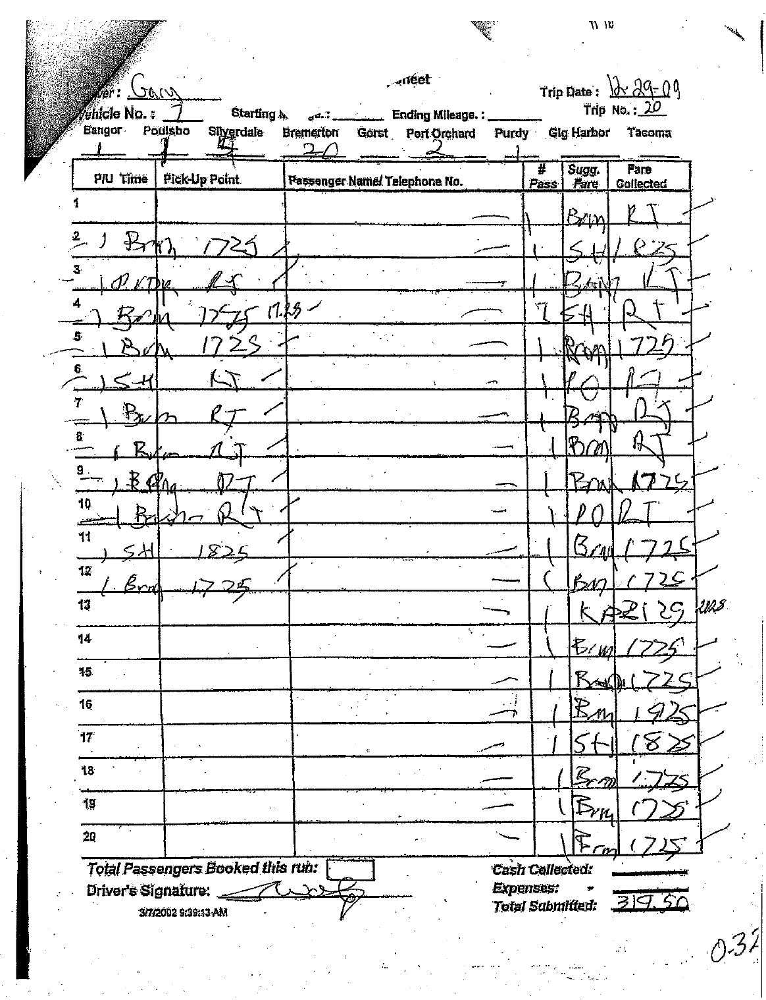
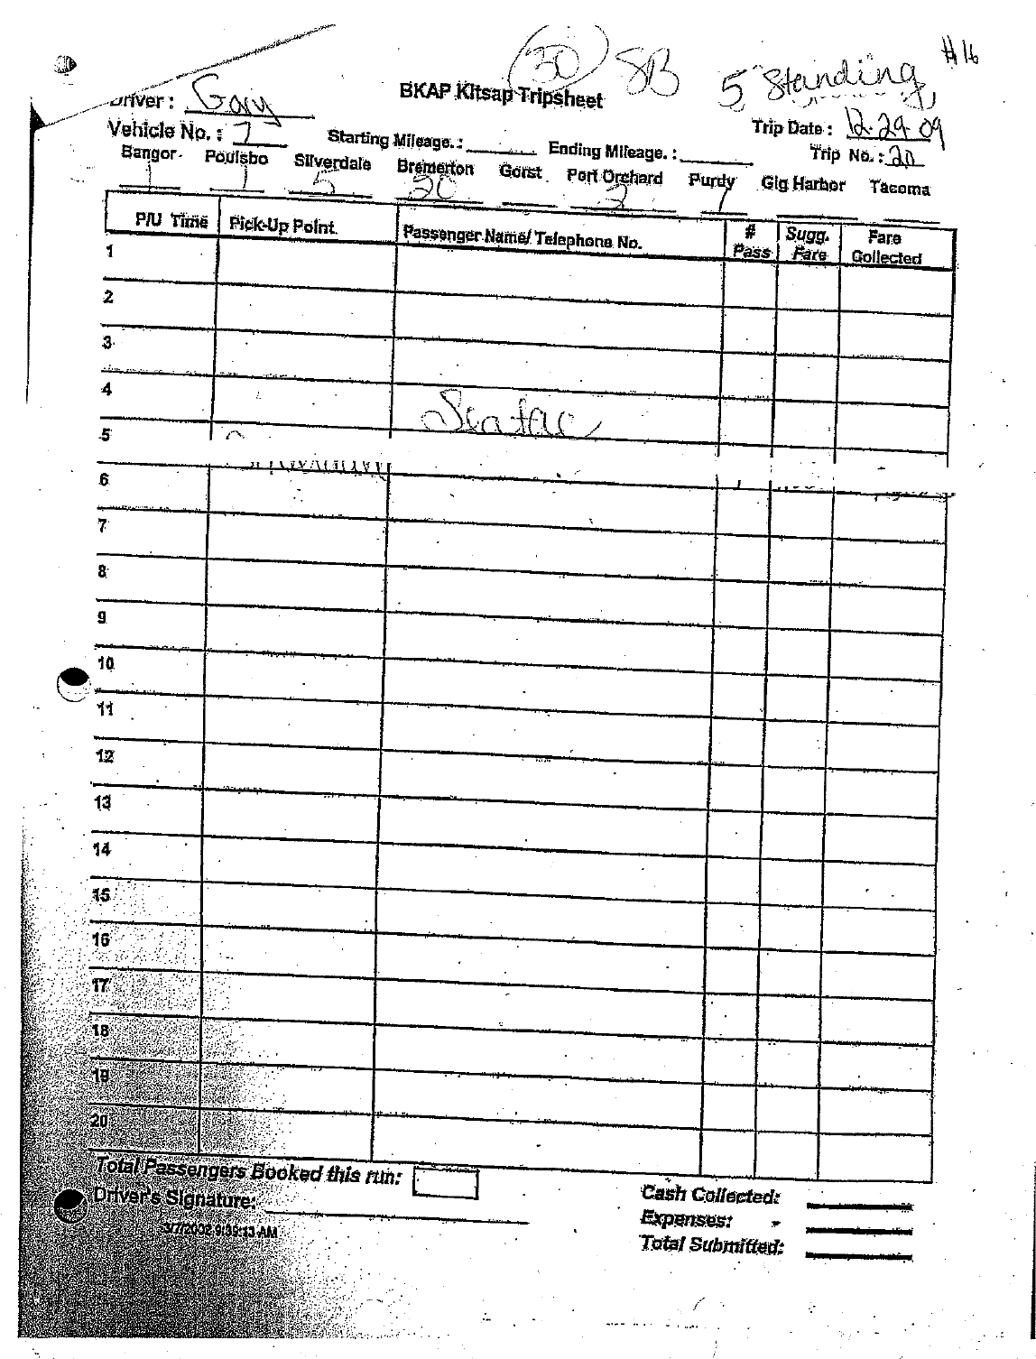
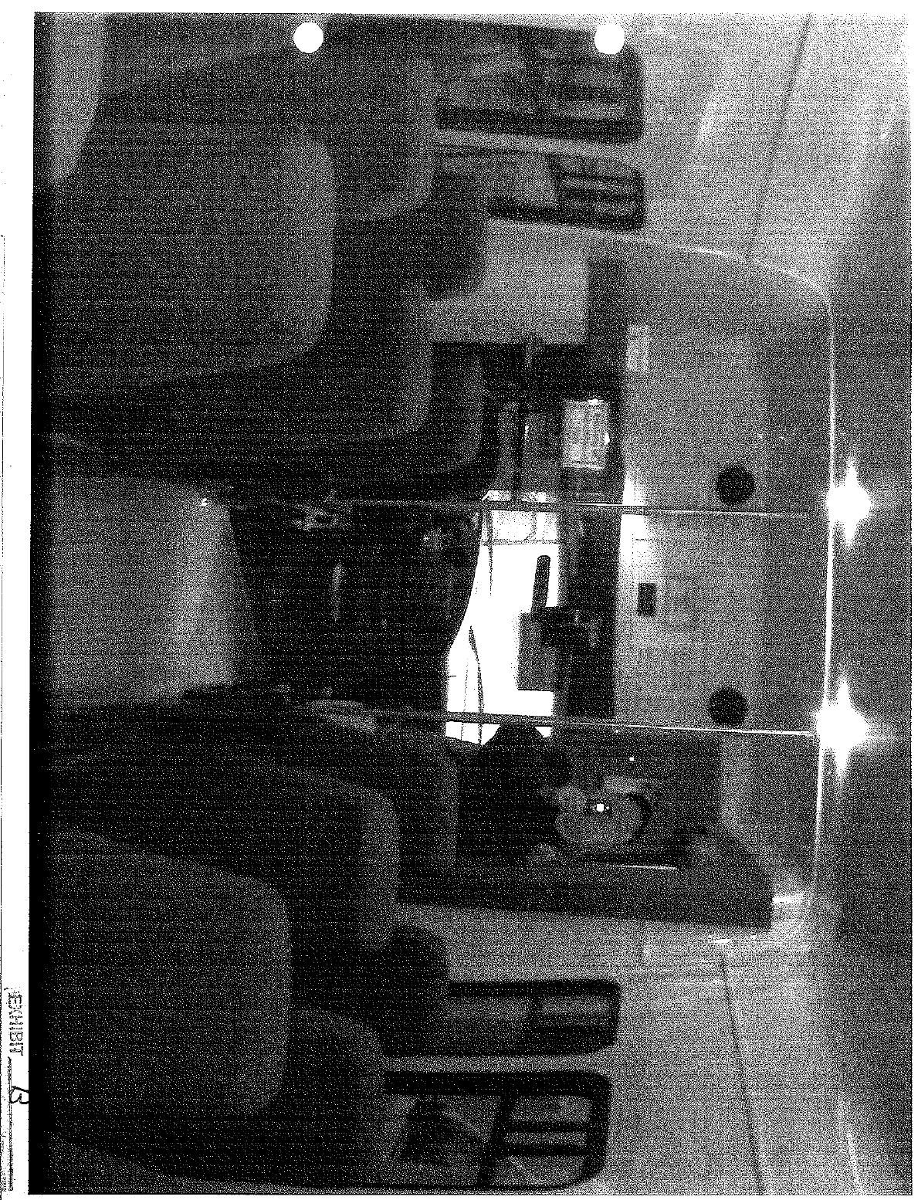
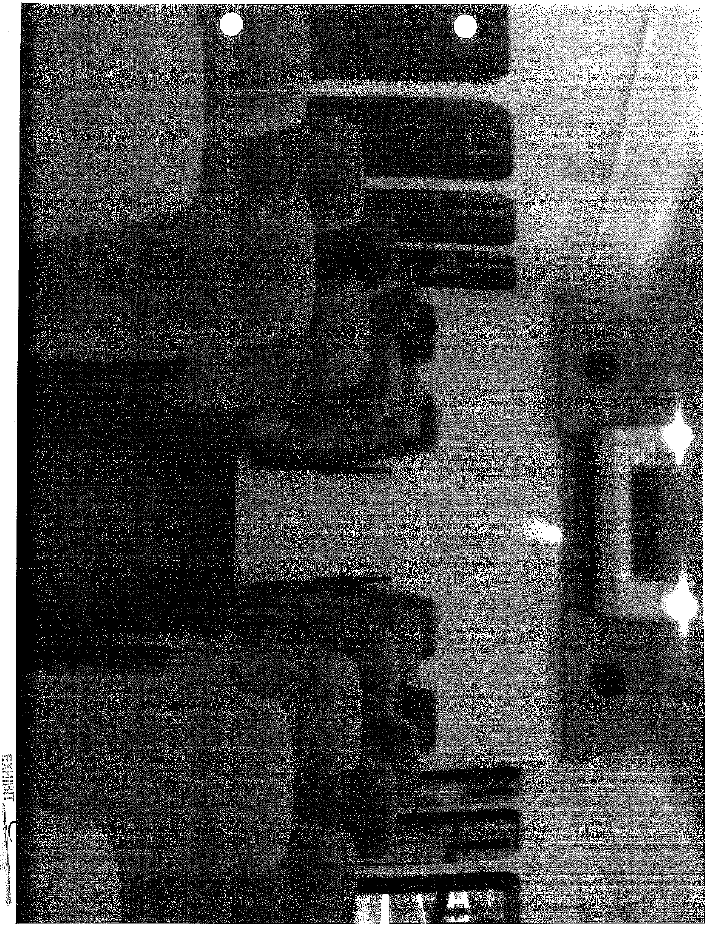
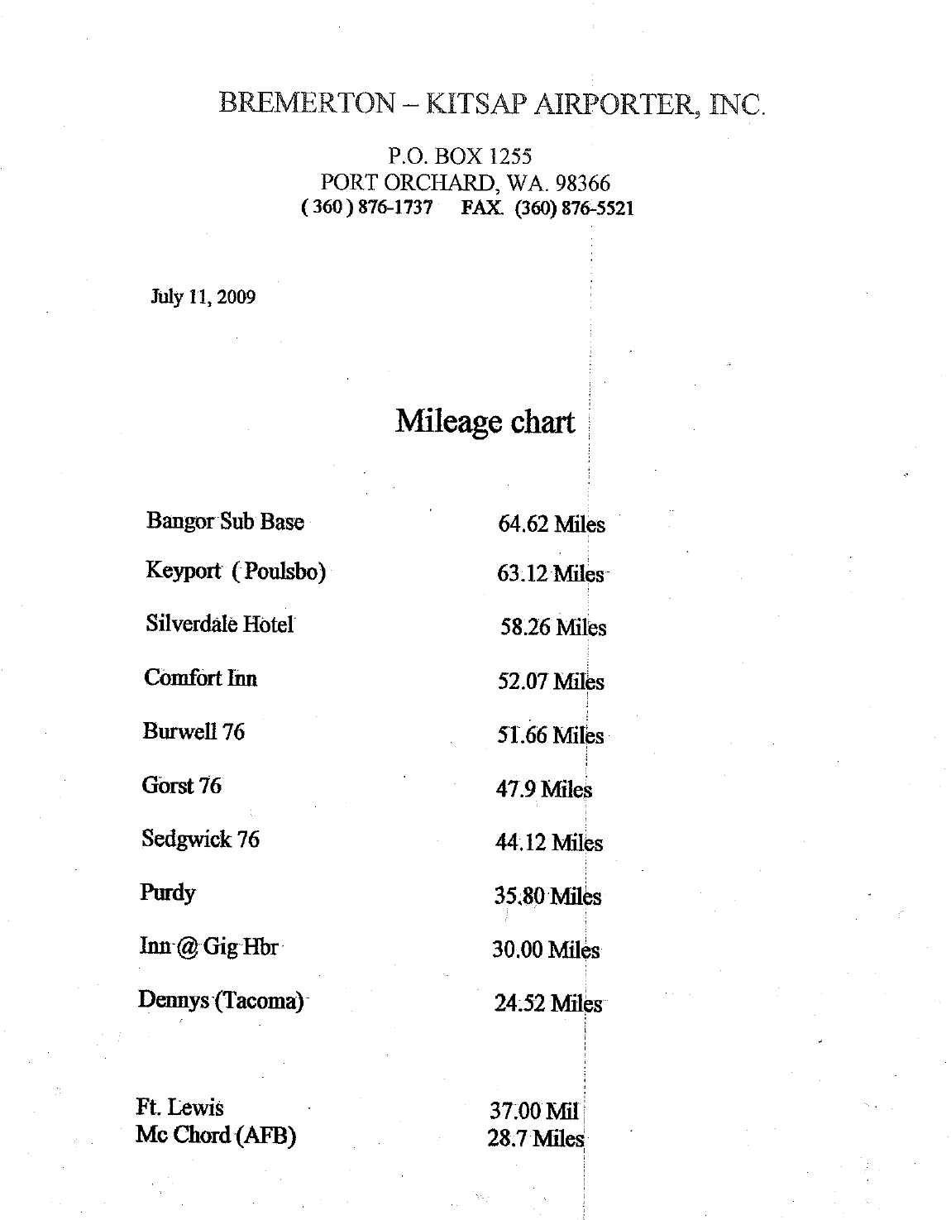
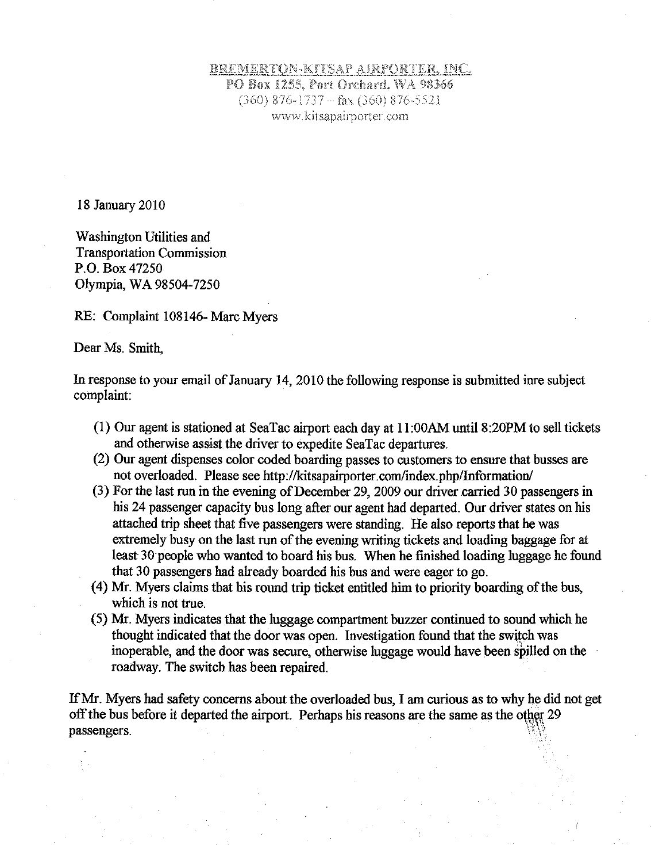
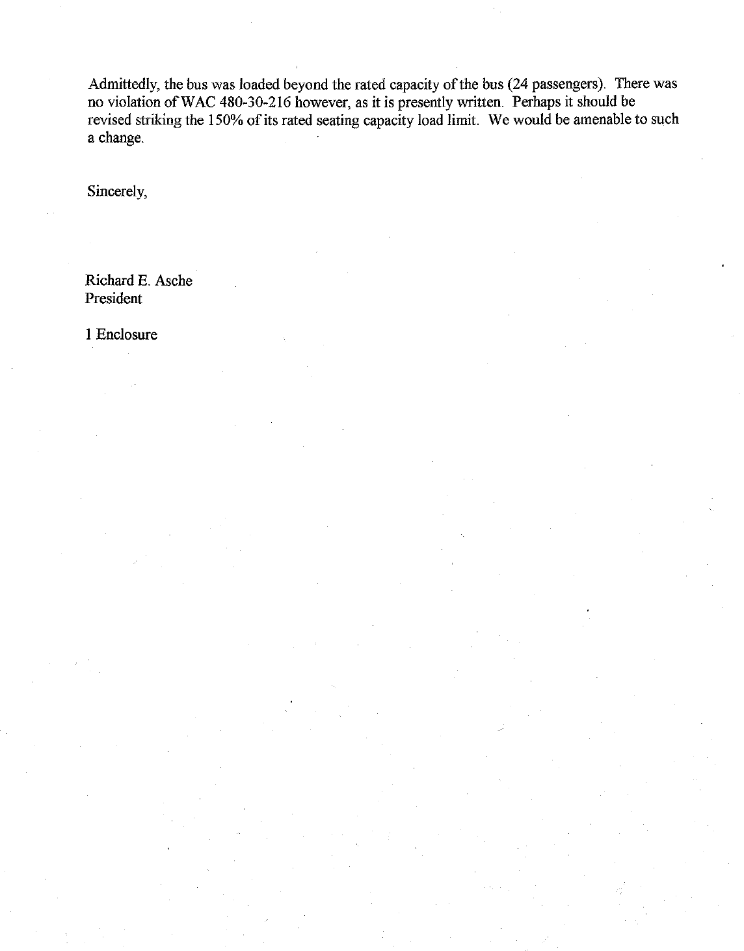
Attachment B
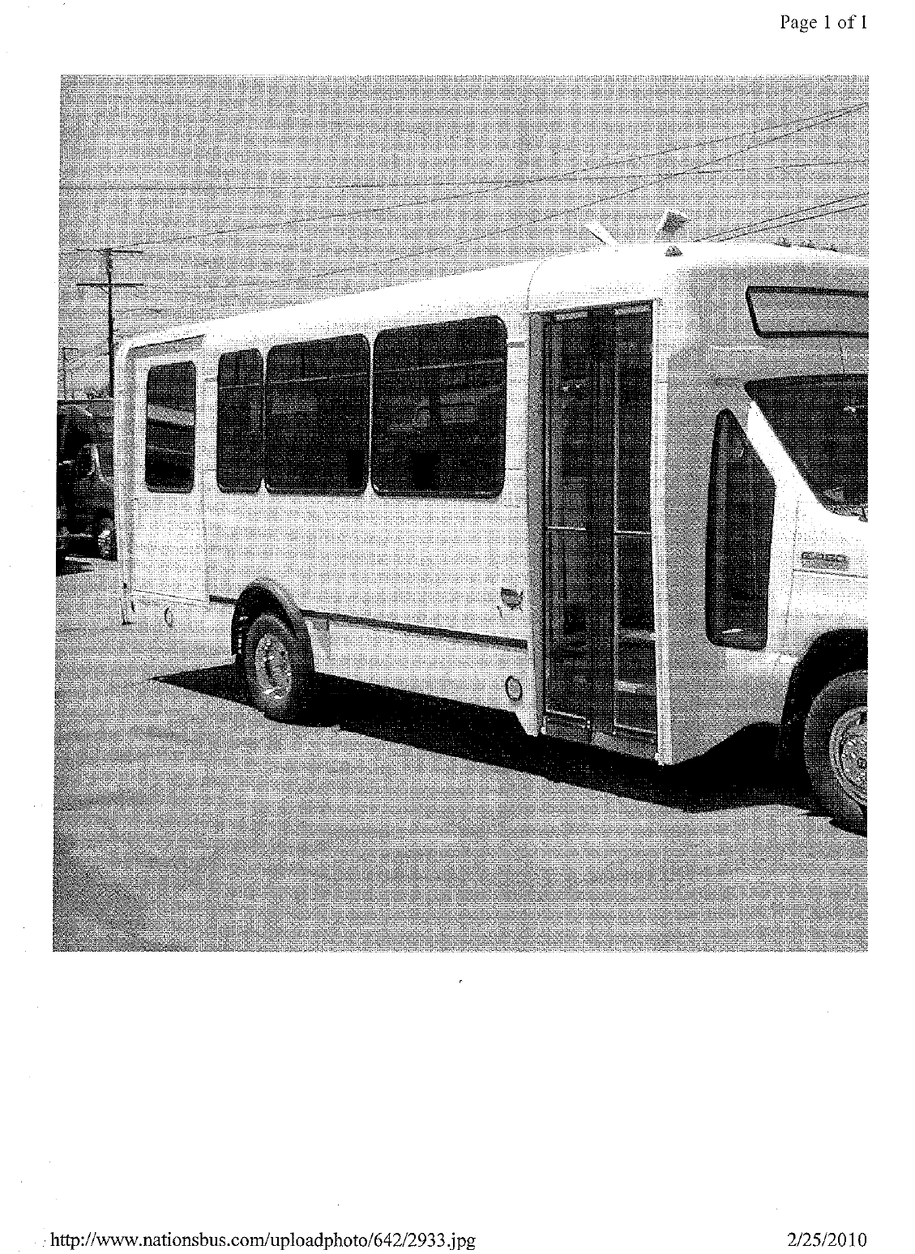
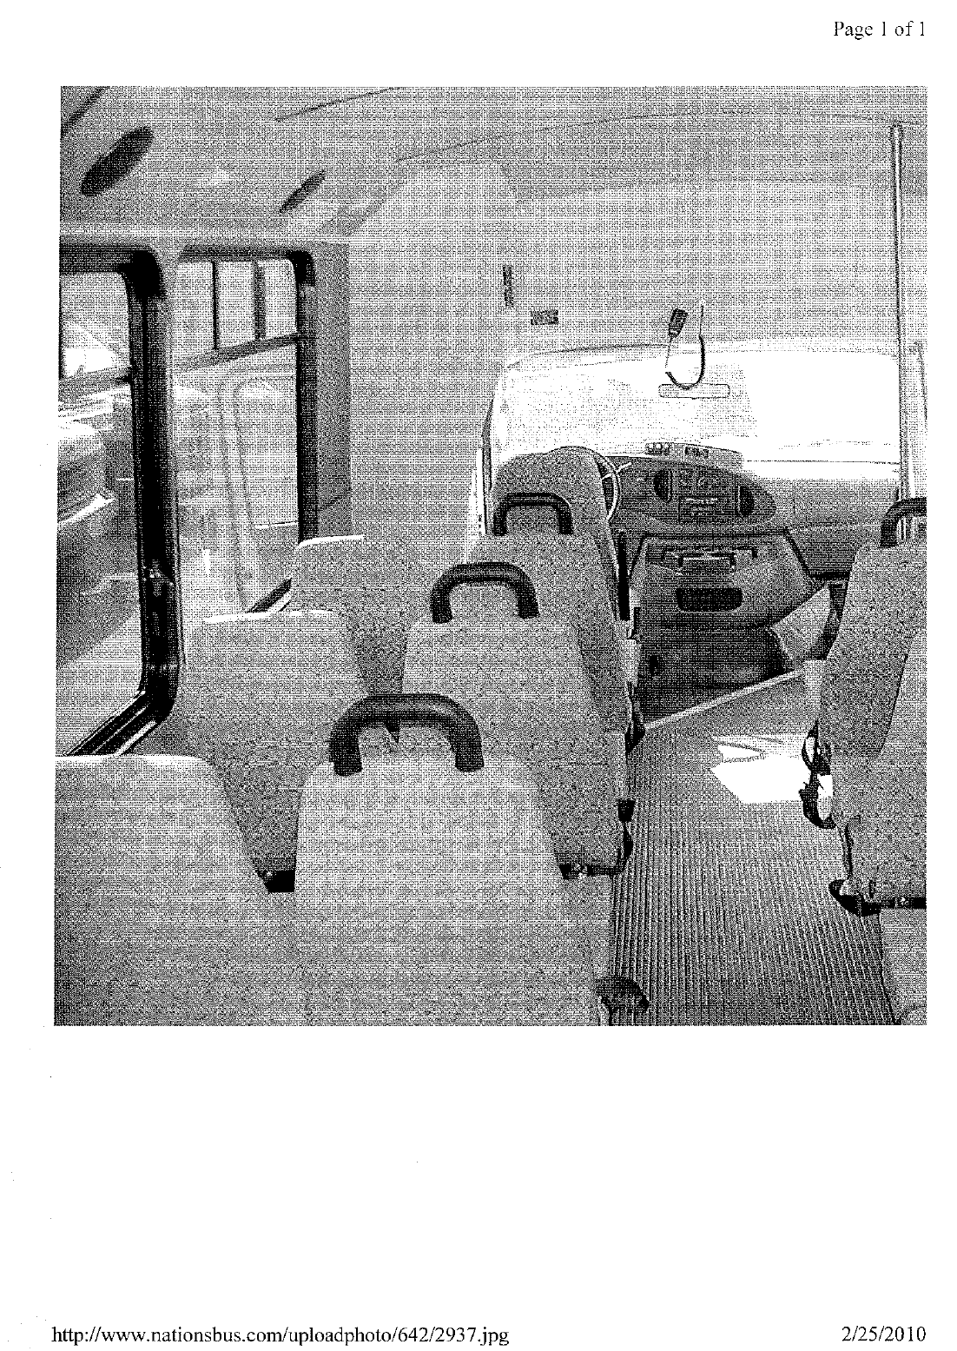
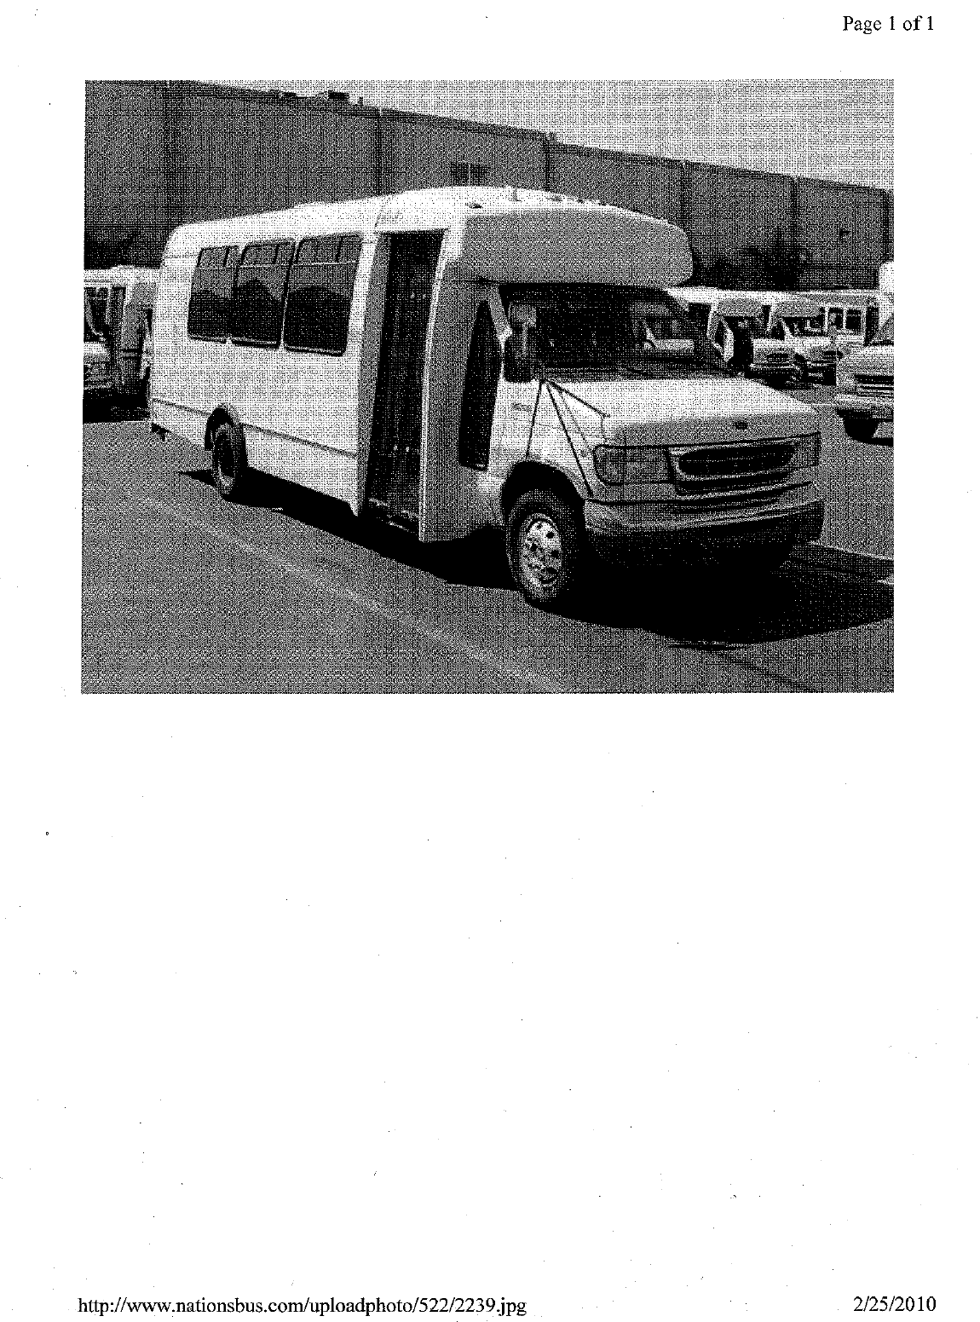
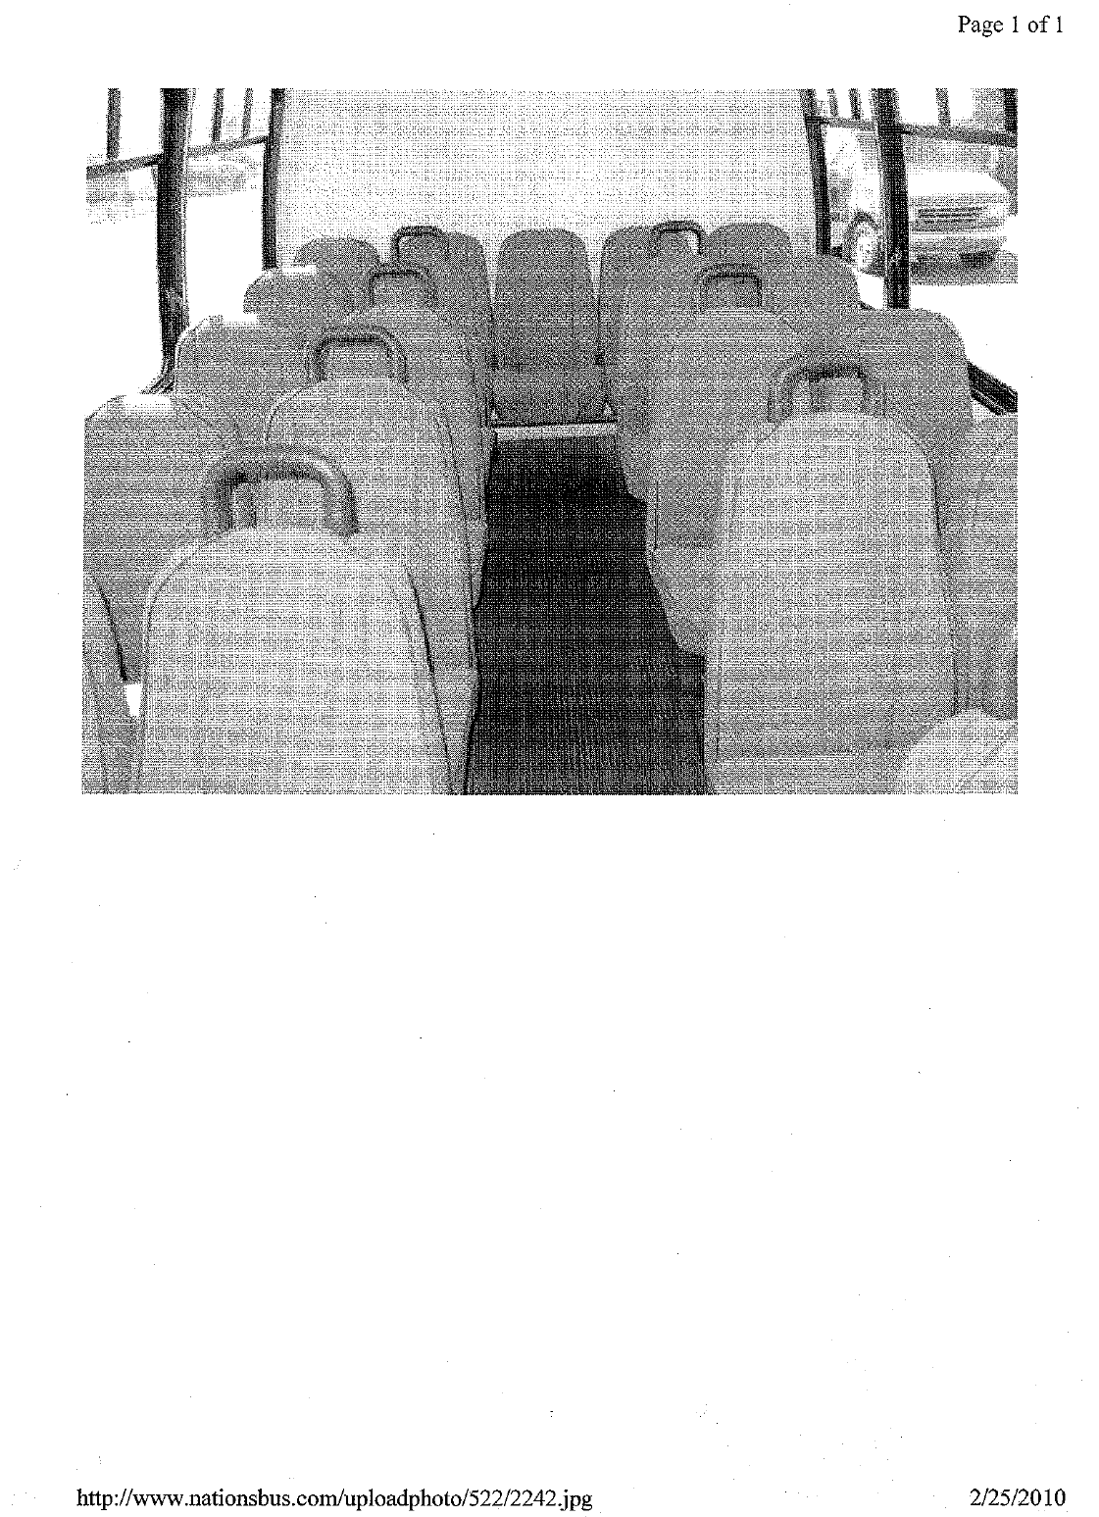
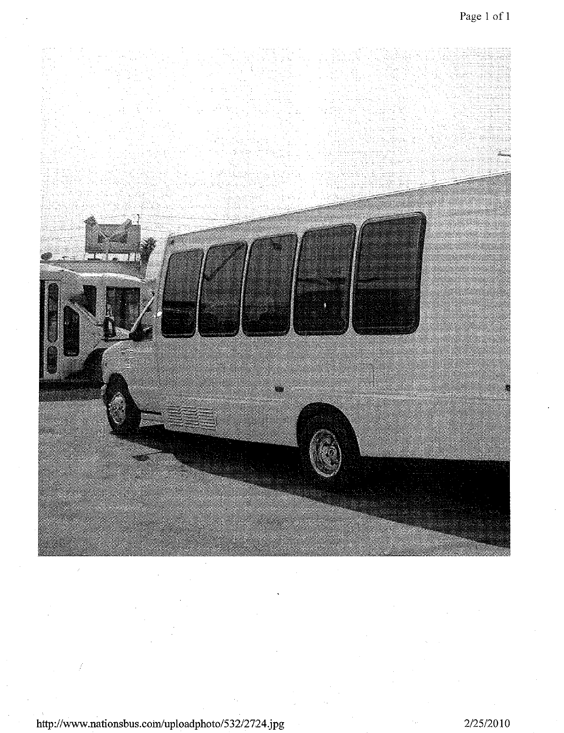
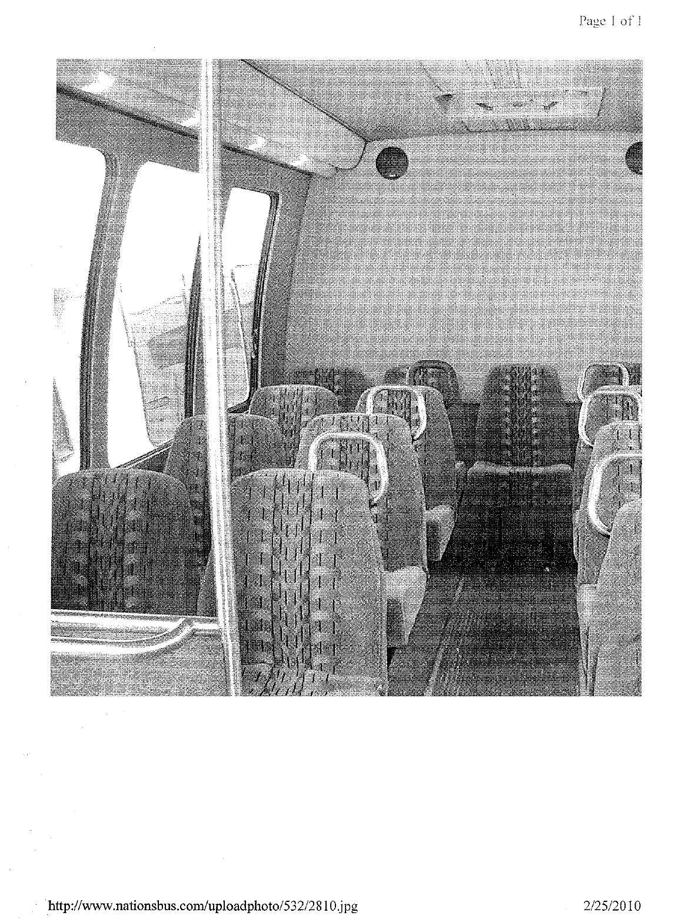

A true and accurate copy of the investigation report is attached to this declaration as Attachment A.
A true and accurate copy of pictures of three passenger mini-buses with mounted hand holds found on the Internet are attached to this declaration as Attachment B.
WAC 480-30-216(6)
See Attachment A. Documents obtained during the complaint investigation show that the first stop on the route was in Purdy, which according to the company’s mileage chart is 35.80 miles.

