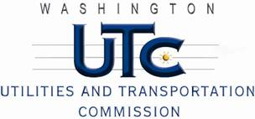

Memorandum
February 4, 2011

To: TR-100544 - File

From: Kathy Hunter, Deputy Assistant Director Transportation Safety

Subject: TR-100544 Thurston County Public Works
Grade Crossing Protective Fund (GCPF) Project at the Intersection of
143rd Avenue Southeast and BNSF Railway Co.’s Tracks in Thurston County, Washington

On May 13, 2010, the Washington Utilities and Transportation Commission (Commission) awarded a GCPF grant totaling $19,800 to replace the existing median barriers, install enhanced signage (chevrons) and rumble bars at the 143rd Avenue Southeast crossing in Thurston County. The USDOT number assigned to this crossing is 085780M.

On February 4, 2011, the applicant, Thurston County Public Works submitted a request for reimbursement pursuant to Commission order. Along with the request for reimbursement the Thurston County Public Works provided photographic documentation that the project is completed according to the specifications outlined in the order approving the grant. In the spring of 2011, Thurston County Public Works will pave the shoulders near the crossing. The paving will be fully funded by the County.

Please close this docket.

